ACAS
(Applewood Computers Accounting System)

Sales Ledger

Reference Manual

30 April 1980

Rewritten: 10th April 2013 – In Process.
Copyright © 1980 – 2013 Applewood Computers

Sales Ledger © 1980 – 2013, forms part of the ACAS (Applewood Computers Accounting System)
Which includes the following elements:

* IRS (Incomplete Records System)
* Nominal / General Ledger
* Sales Ledger
* Purchase Ledger
* Stock Control
Order Entry
E-Shop Data Transfer System
Payroll

Items identified by a star (*) are now Open Source packages.
This and the accompanying documents relate, to these Open Source packages.

Applewood Computers
17 Stag Green Avenue
Hatfield
Hertfordshire
AL9 5EB
United Kingdom
Phone: 44+1707-263712 (10:00 to 21:00 GMT/UTC local)

Lead Programmer Email: vbcoen@gmail.com

For Technical Support Contracts contact: vbcoen@btconnect.com

WARNING: This manual is still under change as the ACAS package is being updated and it needs to be updated for the current Cobol based system. In other words it is NOT an accurate reflection of the current version of Sales Ledger. Also this manual will be used to build the manual for Purchase Ledger when completed. This source is from a very old version!

Just a part of various jobs to do.

Author: Vincent B Coen, The author asserts his copyright over this document.
Document update: 10th April, 2013
Revision: 18
Software Version Date: July 2012
Software Version 3.0.00
Word Processor: LibreOffice 3.5.7 or later

1 3 5 7 9 2 4 6 8

Contents
1. Overview 4
1.1. Using the Documentation 4
1.2. Facilities Overview 6
1.3. Operating Summary 10
1.4. Using the Entry modules 13
1.5. Using the Print modules 14
2. System Set Up 15
2.1. The System and Parameter Files Set up 15
2.2. Sample ACAS Parameter File Set up Report 26
2.3. The General Ledger Interface 28
2.4. The Customer Files 28
2.5. The Customer Print modules 30
a) CUSTOMER REPORTS TO BE INSERTED HERE in landscape: 31
b) Alphabetical Customer List 32
c) Customer file dump 33
3. Transactions 34
3.1. The Invoice Batch 34
3.2. The Invoice Proof 39
3.3. Posting the Invoice Batch 41
3.4. The Payment Batch 42
3.5. The Payment Proof. 44
3.6. Posting the Payment Batch 45
4. Pre-Apply Reports 46
4.1. The Aged Trial Balance Reports 46
4.2. The Sales Report 47
5. Appendix 1. 140
6. Appendix 2. 141
7. Appendix 3 – Sample Reminder Letters. 142

Section One--Overview
1. Using the Documentation
2. Facilities Overview
3. Operating Summary
4. Using the Entry modules
5. Using the Print modules

Section Two--Set Up
6 The Parameter Files
7 The Account File
8 The General Ledger Interface
9 Billing Cycles
10 The Customer Files
11 The Customer Print modules

Section Three--Transactions
12 The Invoice Batch
13 The Invoice Proof
14 Posting the Batch
15 The Cash Batch
16 The Cash Proof
17 Posting the Cash Batch
18 Recurring Sales

Section Four--Pre-Apply Reports
19 The Aged Trial Balance Reports
20 The Sales Report

Section Five--Cash Application
21 The Cash Apply modules
22 Generating Statements
23 Formatting the Statements
24 Dunning/Reminder Letters
25 On-Line Enquiry

Section Six--Utilities and Error Procedures
26 Sorting
27 Full Disk Backup
28 Disk Drive Allocation
29 Error Recovery Procedures
30 Altering System Standards
31 Display Management System Setup

Appendices

A. File Specifications
B. Error Messages

Overview

Using the Documentation

The first section of this manual presents an overview of the system and an explanation of how to run the various modules. The remainder devotes a chapter to each individual process or module in the system.

Read the overview before moving on to the rest of the manual. Read all the documentation thoroughly before running any of the modules.

After reading the documentation decide how many billing or charging cycles you will use and which of the optional features you desire. If you need more than one billing cycle you must choose the number of open item files and the cycles they will hold. After making these decisions, re-read the operating summary before you begin entering real data. You may find it beneficial to create a practice set of data first, before you invest time keying in real data. A practice company could consist of 10 to 15 customers and 25 to 30 invoices. Running through one or two accounting cycles with this data helps to clarify the operating procedures.

If you encounter difficulties, please, examine the documentation carefully before contacting us to make sure your questions are not answered there. While we are happy to discuss constructive ideas and welcome your comments and opinions, we cannot act as a substitute for our written documentation. If however you spot omissions or inaccuracies in these documents that do not reflect with the current version of the software please report it via email Attn: ACAS Technical writer to vbcoen@gmail.com mentioning the software version.

The Operating System.

The ACAS Ledger systems uses the facilities of the O/S (operating system) regardless of the type eg, Linux, Windows, OSX. Questions relating to the O/S should be referred directly to your IT department or the original supplier.

Cobol

All of the ACAS modules are written in the 2002+ dialect of the Cobol programming language using the GNUCobol a free to use and own, compiler. This needs to be installed (and built if needed) on the computer used to build the system which may also be the same as used for running the ACAS system. Note that if you are using one computer for building (compiling the source code) the ACAS system and others to run it, then the version of the operating system MUST be the same eg, using Mageia v3 Linux to build then it should also be installed on systems running the ACAS system. Failure to do so could result in a range of error messages saying that some elements of the system can not be found. See the separate manual or the appendix for instructions for obtaining the GNUCobol compiler and for installing it on your computer. This must be done first along with compiling the ACAS source code into a form that can used, again see the appendix for more details on how to do it.

Note that the GNUCobol compiler is not the only compiler that can be used eg, Micro Focus Cobol can also be used but some changes may be needed to the ACAS source code in order to compile without errors, again see the appendix for more details. The changes needed will vary depending on the compiler used. Note that use of the OpenCobol variant 'sold' by Cobol-IT is an older version of the free Open Cobol compiler and some functions may not be available in it that are used within ACAS and this will need to be addressed. The same could apply with any other compiler. These changes will require Cobol Programming experience and If this is an issue then you can contact us for support to resolve such issues. This is a chargeable service.

Facilities Overview

System Configuration

The ACAS system runs on any computer system under the control of one of the operating systems that can run the GNUCobol Compiler (or a commercial alternative). The system must have the following minimum hardware components:

- 1 Gb Random Access Memory (RAM).

- One hard drive with at least 256 Mb free space but a lot more is seriously recommended to improve speed of the ACAS system on your computer.

- A suitable printer that can be an Inkjet or laser type that has been set up using the CUPS printer spool system or similar.

- Any monitor type eg, led, lcd and including an older CRT.

- Any processor type from Intel, AMD or ARM.

Most if not all computers these days, match and exceed these requirements but systems can usually be expanded or adapted to meet these requirements. Your IT department or local dealer can give you specific information regarding hardware availability..

Using the System

It cannot be stressed too strongly that computers are liable to break and that computer operators are liable to make mistakes instructing the computer. Because such errors cannot be completely avoided, they must be provided for. The way to protect data from accidental loss is to make copies of your data and store them in a safe location. Every time the ACAS data go through a major transition, such as every time cash is applied, all data files should be copied onto another medium. The value of your data is always worth more than the media itself whether it is a CD, DVD or an external hard drive.

Always keep at least one full copy of the ACAS system but it is recommended to keep at least three generations of backup. If running standard Cobol data files the sizes are quite small and if running the system using a rdbms (Relational DataBase Management System) such as Mysql they are not much larger

Responding to the System

All sub-systems (eg Sales, Purchase, Nominal/General, IRS & Stock etc), in ACAS are interactive, which means the modules display requests for information on the console and the user types in the desired response. The response. The response is checked instantly, and if found to be invalid, an error or warning message is displayed and the request re-issued. All responses may be made with either upper or lower case characters. After the proper response has been typed in, the RETURN key must be depressed. Return must follow every response since it signals the system that the data has been entered and the modules may proceed. It cannot proceed until return is detected. In many cases described in the manual, hitting only the return key is a valid response.

All the modules that make up Sales Ledger (or for that matter any of the others) must be run from the system menu eg, 'sales''. Figure 2.0 shows the SL menu. To select a function you simply type in the letter of that function and press RETURN. Selection can be upper or lower case ie, A or a.

The menu is called via a terminal modules by typing:

sales.

at the command prompt. The same applies to the other ledgers or sub systems (for example, "sales", purchase, irs, general, stock, oe, payroll). Of course you may set up a desktop link to a bash script that also calls 'sales' having moved to a suitable directory if needed although the system is set up to use a specific directory for all data files regardless of where it is run from. After selecting a specific function, a fresh screen appears and the module name and its version number is displayed in the top left hand corner along with the system date which might not be today's date. This can be changed by the first selection offered on the menu (option A), but for normal processing would be today's date.

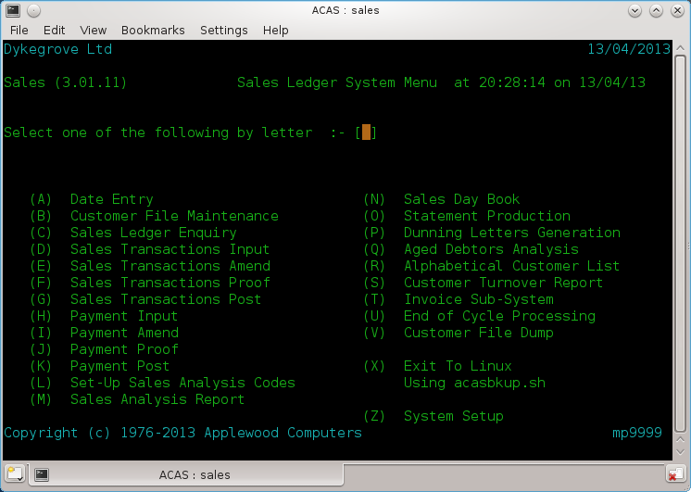
Figure 2.1

SL System Facilities
The Sales Ledger system is designed for use by accountants and business people who need to maintain control over their outstanding sales invoices. The package is very generalised so that it can be adapted to a wide range of business applications. The system is primarily an open item invoice system but it has features that allow it to function as a balance forward system if desired but for audit control this, is not recommended.

The following section describes briefly the advanced facilities listed in Figure 2.2 that are available with the SL system.
Itemised Statements Invoice / Statement / Late letter Masters.
Aged Trial Balances Cycle Billing
On-line Enquiry Credit limit
Sales Analysis & Statistics General Ledger (or IRS) Interface
Line Item Accounting Sales Reporting
Late· Charges Late Payment / Reminder (Dunning) Letters
Balance Forward Adjustments / Credit Notes
Invoice Production.

Figure 2.2

Itemised Statements
Individual periodic statements may be generated for some or all customers. Statements are normally generated once per billing period. The format of the statements may be modified to suit the requirements of the user. See source code.

Invoice / Statement / Late Letter Masters
Artwork is distributed with the system that may be used for printing Invoices. Statements and Late Letters. Space is left for the company name and address to be preprinted at the top. Forms with the company name area left blank may also be used. The system will automatically print the company's name at the top of the form and the stub. Continuous Statement forms are available in limited volume from Applewood Computers. In addition all three forms can be produced using a word processor such as LibreOffice that uses a template for creating any logo, company name and address etc..at the top of each document that can be linked in to mail merge.
In addition, all three document types can be sent via Email instead of by post therefore reducing costs and warranting definitive delivery to each recipient assuming the email address has been set up on each customer record where available and setting up the correct flags for each form type.

Aged Debtor Analysis / Trial Balances
Aged Debtors Analysis or Trial Balance, is available from the system: where you can select from various criteria.

Cycle Billing
If the number of customers or the need to spread the periodic workload requires it, the system can support cycle billing. Processing can be broken into logical parts based on the cycle. Each cycle is represented by a single letter of the alphabet and zero through nine. Thus, up to 36 cycles may be defined for use which with a customer number in the form of A12345n where A = cycle, n = check digit. Gives 99,999 x 36 as a total customer count of 3.600,000 – 36. Changing the system to also accept lower case a-z as separate values from A–Z would increase it to 6.2M.

On-Line Enquiry
Information on the sales or debtor status of any customer can be retrieved instantly by the on-line enquiry modules. All information, including un-applied cash and un-billed invoices can be displayed on request.

Credit Limit
Each customer may be given a specific currency credit limit. All printouts will flag any customer whose outstanding debtors balance exceeds his stated credit limit. The limit can be changed at any time. A credit limit check also occurs when creating an invoice.

Sales Analysis & Sales Statistics
For each customer, yearly sales figures broken down by three monthly quarters is maintained in round robin effect. These figures are net eg, no Tax / Vat etc, post and packing figures are included.

General Ledger / IRS Interface
If the ACAS GL or IRS system is also used, the system will feed summarised sales and debtors information into the GL or IRS system. The collection of data is automatic but the actual transfer between systems is handled by a special module that may be run at any desired interval.
Note that General Ledger is also known as Nominal Ledger.

Line Item Accounting
If the sales entry level 2 option is enabled during initial system setup, any invoice may be entered into the system in line item format. This allows an invoice to be entered as a series of individual component items rather than as a single unit. Items such as Vat and shipping may be accounted for separately in this fashion. Also, product sales data can be entered in separate analysis codes this way.

Sales Reporting
If line item accounting is used, the information entered can be reported using the sales analysis feature. This report shows the accumulated sales data on an analysis code basis for the current period, last period, and year-to-date. For audit purposes this is the recommended method.

Late Charges
This option allows the system to automatically levy late charges on customers who fall behind in their payments. This feature can be specified in a variety of different ways.

Late Payments & Reminder (Dunning) Letters
If specified, the system will automatically print dunning or reminder letters to any customers who fall behind in their payments. Up to three letters may be defined using either the text supplied by the system or any message you desire. The letters can be issued with increasing severity every billing cycle (normally 30 days) starting at either 30, 60, or 90 days. Individual customers can be exempted from receiving them. The system produces files for each period (30, 60 & 90) which can then be input to the mail merge function within a word processor such as LibreOffice Writer.

Balance Forward
If requested, all invoices will be summarised into a balance forward debtor to suppress invoice detail. This can take place on invoices 30, 60, or 90 days old. While this option is available it is NOT recommended to be used as you will not have invoice data showing what is outstanding in the event of a dispute and more importantly for audit purposes.

Adjustments / Credit Notes
Adjusting entries in the form of credit notes can be made through the normal Invoice entry modules. Credit adjustments can be made for individual customers or for individual invoices.

Invoice Production
Invoices can be created in a variety of differing ways to cater for the range of different businesses. These include batched input and printing or adhoc as well as input via the Order Entry sub system.

Operating Summary
The 9 sections in this chapter correspond to the 9 major processing steps in the Sales Ledger system (Figure 3.1). The text describes when each step can or must be run from the viewpoint of a computer operator. If the printer is required, and other operational concerns are also discussed. The modules mentioned in this chapter are described in greater detail in the remaining chapters. This section is an operational guide only.

Some steps will only be run once or twice, such as the Set up's eg, System, Invoicing or Analysis Codes. Other steps are run on an irregular basis with no relationship to billing cycle timing, such as Customer File Maintenance. Others are run very regularly, yet not necessarily on a one to one relationship with the billing cycle such as the invoice or payment input steps.

Even modules in the individual steps need not be run at the same time. For example, you might run the invoice entry modules more often than the invoice posting modules, yet both of these modules are considered part of the invoice entry step.

Steps 1, 2, 3 are preliminary steps that are run infrequently normally on the initial set up of the system where steps 1 is the same for all of the ACAS sub-systems and step 2 for both Sales & Purchase Ledgers which in itself is tied to IRS or General Ledger as the accounts need to be set up in order to provide account numbers to link to each Analysis code.

Step 4 is used to create the data for each customer, so after initial loading is only required for new customers or to modify information on existing customers such as address changes, credit data etc.

Steps 5 and 6 are the main financial transaction steps in the system and are used most often. These steps may be run often, depending on the volume of transactions. There is no sequential relationship between invoicing entry and payments entry. The payment receipts modules may be run as many times as necessary without regard for the number of times the invoicing entry modules has been run. Most of the data entry work is in these two steps.

Note that if you are using the Order Entry sub-system or the E-shop Data Transfer program, then both of these create invoicing or payments data as well as passing information to the stock control system and this in turn will cause additional report information in the Sales and even the Purchase ledgers. Simply put, all of the ACAS sub-systems pass data between themselves which is stored onto the correct files for further processing where required.

Step 7 is the one step required by the system to be run on some fairly fixed schedule. The cash apply modules must be run one time per cycle per billing period. In fact, for all of the other modules in the S/L system, the running of the cash apply modules defines the billing period. The operator should check to make sure this modules is not accidentally run at the wrong time.

Steps 8 and 9 are optional steps. Reports may or may not be generated on a specific schedule.

- System Setup & Parameter Entry
- Set-Up Sales Analysis Codes
- Invoice Setup
- Customer Entry
- Invoice Entry
- Payment Entry
- End of Cycle
- Producing Reports
- General Ledger Extracting

Figure 3.1: Processing Steps

Step 1: System Setup & Parameter Entry

The system setup step must be performed once before any other modules in the S/L system are run, except for the menu module 'sales', from which the System setup module is automatically run if no system files exist. If you need to rerun this it is always option 'Z' from any of the main menus in sales, purchase, general, stock, The IRS system has it's own separate setup, system parameter file and data files. The System Setup step may be run any number of times after its initial execution.

A printed report on the current system parameters is available from this module. The report serves as a backup and should also be considered part of the audit trail.

Step 2: Set-Up Sales Analysis Codes

This step is normally only done once and after having set up IRS or G/L accounts that will retain the totals from the analysis codes. On first entry it will create predefined codes for Vat / sales tax etc. Any others required can be added. This step can be used at any time if you need to create more codes. This function is available for S/L and P/L.

Step 3: Invoicing Setup

This function is usually only needed to be done once and is selected via menu option 'T' and defines the basic processes that Invoice Entry will adopt eg, invoice number generation, discounts etc along with invoice entry level and this defines: do you only require a total amount for entry or a line by line entry for each product or service. The second option is the one recommended for most business types.

Step 4: Customer Entry

Customer entry must be performed at least once before any higher numbered steps. It may be run any number of times at any point after step 2.

The customer entry step consists of a data entry step, an optional printing step that may precede the others. The print module normally prints the customers in customer number order however other options are also available.

Step 5:Invoice Entry

This step may take place any time after steps 1, 2 &,3.
The Invoice Entry step consists of four modules: entry, amend, proof and post and can be run as many times as desired independently of each other. A function exists that allows you to create a new customer should the need arise instead of using step 4.

Step 6: Payment Entry

The payment entry step may be run any time after steps 1,2, 3, 4 and 5. You cannot process payments if invoices do not exist.

This step consists of four modules: the entry, amend, proof, and posting. The entry, amend and proof modules may be run as many times as desired independently of each other. These modules can build, modify, and report on a batch of payment transactions until that batch is posted.

You may proof a batch any time during its development and a proof report must be processed before posting. A proof is part of the audit trail assuming it is taken immediately before posting (i.e., no intervening executions of Payment Entry). If run before an execution of Payment Entry or Amend, the proof is considered a work sheet only. The final audit proof must be taken just before posting.

Once the current batch is complete and accurate and has been proofed for the final audit report the batch can be posted to the open item file.

Step 7: End of Cycle

This step normally run at the end of the last business day of the month and processes statistical data for the monthly cycle and passes data to the IRS or G/L systems. It precedes this with a Analysis and Day Book report for S/L and similar for P/L and the other sub-systems then updates all system files for end of month. Note: This is done for all of the sub systems, Sales, Purchase, General (if used over IRS) Stock etc at the same time but the user can specify. Prior to running this step is is recommended to always carry out a back up of all of ACAS (and IRS if used) data files as there is no recovery from this action other than restoring the files. The same applies if you are running a rdbms system in place of the standard Cobol data files but note that if you are the system file is always maintained in the ACAS data directory.. The system unless changed when installed will make a back up of the cobol data files after the user selects 'X' for exiting the system.

In the event that this process is run after the last day of the month eg a few days into the new month because of holidays or weekend, then the date set function which is menu option 'A' should be set to reflect the last day of the preceding month before running End of Cycle if only for the date printed on the reports.

Step 8: Producing Reports

Any of the report modules can be run at any time after step 1, but the results will not be meaningful until the appropriate steps have been completed and normally step 6 has also been run, and the various Sales reports after steps 5 etc).

The Sales Day Book and the Aged Debtors Analysis report should be considered part of the audit trail.

Step 9: General Ledger Extracting

The GL extracting step is a non selectable process. It applies for both IRS and GL It is done automatically during the End of Cycle processing in Step 8..This step is taken only if the GL or IRS interface is requested during Step 1 System Setup.

Step 10: Auto Generate Invoices

The Autogenerate Invoices step is optional and can only be run if the autogen option has been requested on the system parameter file. It is sometimes used in place of, but usually in addition to, the invoice entry modules. An example for this is to create yearly invoices for maintenance contracts for ACAS support.

The Proof Autogen File module may be run at any time to print a proof sheet. This report is not part of the audit trail.

Note that this function has been remove from some versions of ACAS as redundant.

Using the Entry modules

There are three types of modules in the S/L system: Entry, processing, and print modules (Figure 4.1). The print modules produce reports, statements, or lists and are described in Chapter 5. Each processing module is treated in a separate chapter. This chapter discusses the features common to all but the Invoice Entry, Payment Entry, and the optional Build Autogen File modules. These modules, which use screen formatting facilities for data entry accuracy and efficiency, are explained in chapters 12, 15, and 18. All other entry modules are operated according to the general principles described below.

There are two major types of requests issued by the system, requests for general information and Yes or No requests. Requests for general information start with "[" and in many cases are followed by showing the maximum length allowed by the following ']'..For example:

Name [ ]

Yes or No requests end with a question mark and the letters (Y OR N)" in parentheses. For example:

Late charges used? (Y OR N)

Valid responses to the Yes/No requests are: "Y", "y". "N", or "n" eg, upper or lower case.

Once a question has been answered, later issuances of that question are preceded by the previous answer. If the request is for general information, the display looks like this:

Name: [John A Jones ]
Name: [ ]

If the request is for a Yes or No, the display looks like this:

Late charges used [Y]
Late charges used? [ ] (y or n)

For any type of request, once a valid value has been entered, a TAB or RETurn leaves that value unchanged. If no value has been entered, RETurn takes the default displayed answer.
Where the screen shows a group of entry fields moving between them is accomplished by using the keys Tab, Back Tab, Up Arrow, Down Arrow. Likewise using the cursor keys to move forward or backward without affecting the displayed data and using Backspace to delete the character to the left of the cursor. An ESCape should exit that screen, likewise but not always, leaving the first field blank/zero followed by Return will do the same.

Most entry modules have three processing segments: a) start-up, b) function processing, c) shut down. The function processing segments such as the menus is characterised by the function request which is displayed on the screen. The user may enter the type of processing function desired.

The function request will repeat indefinitely until a valid response is entered.
During start-up several requests may or may not be issued, depending on the particular module.

Function Processing

The function request determines which task the entry module will perform. The tasks common to most entry modules are:

- Add a record.
- Amend a record.
- Delete a record. (Only present in some processes eg, Invoicing where the invoice number is
saved for reuse.
- Display a record.

Some modules support additional functions. They are described in the individual modules chapters.

When data is being added, information requests one by one. Responses are verified for accuracy and rejected with an error message if invalid data is detected.

Using the Print modules

Most ACAS print modules including S/L produce 132 column reports and therefore the printed text size is adjusted to fit on the page. In some cases the report is printed in Portrait style and in the other in Landscape. It is up to the spooler settings to ensure that for printers that can run in duplex mode that the printer is correctly set for long edge in Landscape and short edge in Portrait modes. The modules themselves help to ensure this is true, by forcing the correct modes when issuing the 'spool to print' command.

Almost all print modules are "read-only". Because they never write data to the files, a printer malfunction will never damage valuable master files.

The only exception is the reports produced by the 'End of Cycle' step, the reports which where not printed before running as this is not re-runnable without restoring the data from a back up. In this regard it is important to exit the system so that a back up occurs, checking that no errors occurred during the backup, before rerunning S/L and then selecting the 'End of Cycle' processing step.

System Set Up

The System and Parameter Files Set up
System parameters are items of information that are used by programs and modules from the ACAS (Applewood Computers Accounting System) Sales, Purchase, General, Stock, Order Entry and Payroll systems to control the various processing functions. This applies to each of the ACAS sub systems. The set of parameters used by the system defines the kind of Ledger application being maintained and the way it will run. The data entered can and in many case will effect the way the whole ACAS system operates and can be entered and changed by any of the ACAS sub systems and more or less at any time however, when turning on RDBMS file processing after using the normal Cobol file processing, care must be taken before turning off the Cobol file processing. For this, see the details in this section.

One file contains the ACAS system parameters (system.dat). They are built and modified by the Set up Parameter Entry module. Many but not all parameters have a default value (the value assumed if no value is explicitly stated by the user).

Modifying the default parameters takes place through entry screens. At first time start-up however, you should not change the defaults of the payments, sales, purchase and stock accounts until you have run the Chart of Accounts Entry in IRS or General Ledger if you wish to use one of them to process your General or Nominal records and created the accounts to which you want to change them to. In this regard setting up IRS or G/L should be done first before entering the account numbers. However these is no reason why you cannot update these after you have set up IRS or G/L.

The Set up Parameter Entry module behaves the same as the entry modules described in Chapter 4, except that the modules is always in "changing" mode. The current value of each parameter appears on the screen and new input requested. If you hit the RETURN key, the existing (or default) value remains. When a valid parameter value is entered, it becomes the new parameter value.

Certain parameters cannot be changed once transactions have been made in the system. The set up parameter entry module will not issue requests for these "protected" parameters.

Most parameters may be changed at any time, but the range of changes is restricted. For example, the maximum number of billing cycles may not be lowered unless unused cycles are being eliminated.

At the end of the entry session, the module asks whether to print a hard copy record of the parameters (see Figure 6.3). If the reply is Y (yes), the report will be sent to your printer via the printer spooler as is all reports.

[The parameter requests break into five???? segments.
The first consists of general information on running the system.
The second sequence of requests determines which cycle or cycles will reside on each open item file. If only one cycle is requested this segment is skipped.
The third segment allows modification
]

For a new system the first screen will request the name of the company or business that will be used in the title of all system screens as well as for all reports, statements, invoices etc. See figure 6.1 – Screen 1.

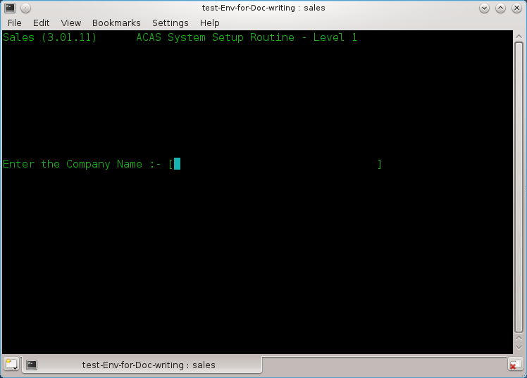

Figure 6.1 Screen 0 - Business name entry

(0-01) Enter the Company Name

This is the name of the company for whom ACAS will process. If ACAS will be used on several client companies, this name clearly separates the data of different companies. Maximum length is 32 characters. After typing the name and hitting enter you will be asked to verify it is correct by entering Y or y. If not enter N or n and you can re-enter the information, otherwise enter Y.

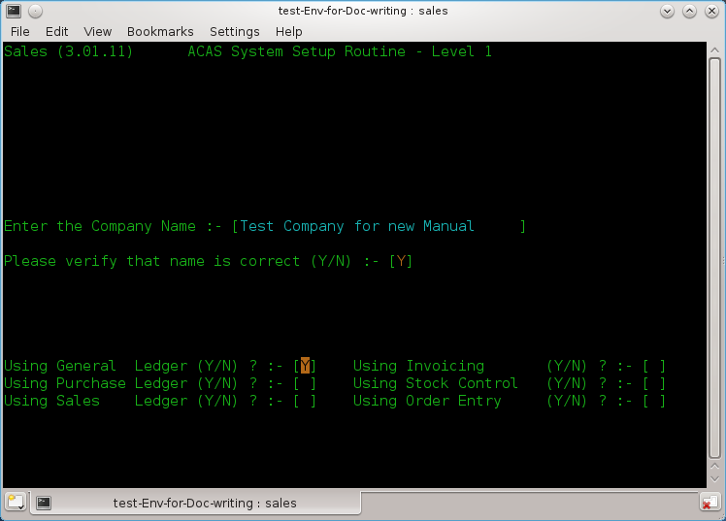

Figure 6.2 Screen 0 - The various ACAS systems to be used

The next series of questions requests what ACAS functions will be used, see figure 6.2.

(0-02) Using subsystem xxxxxx

Here enter a Y or N against each entry in turn depending on your requirements. If in doubt turn them all on unless you know that you will not be using them eg, Stock Control, Order Entry if you are a services only company and do not hold stock. Having responded to all questions you will be asked to confirm selection and at the same time a display below the question will show what has been selected. If you are happy, enter Y and return else enter N and you can re-enter the answers.

The parameter requests and their defaults are shown and described individually in the remainder of this chapter. The number in parentheses is not displayed by the system but is printed in the manual for reference.

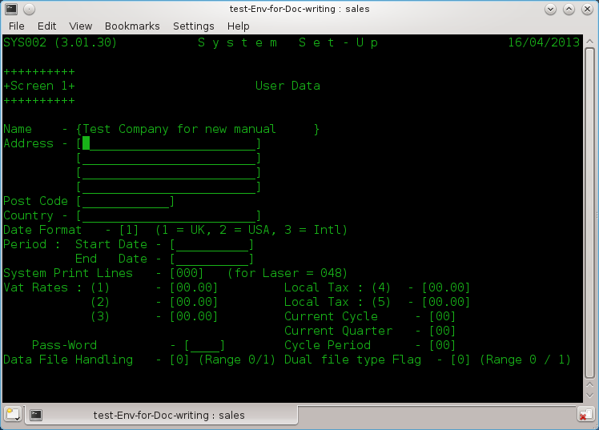

Figure 6.3 Screen 1 – User Data

(1-01) Company Address – 4 lines

Enter up to 4 lines of address (24 Characters each) excluding Postcode and country, that's next.

(1-02) Company Postcode or zipcode (12 characters).

Enter the postcode then the County.

(1-03) Date format.

Select 1 for the UK (dd/mm/ccyy),
2 for the USA (mm/dd/ccyy)
3 for international (ccyy/mm/dd)

(1-04) Start Date
(1-05) End Date

Enter the start and end dates for the current year in the format selected above (1-03)
you can use '/' or '.' to separate the day, month & year as it will be converted to '/' as needed.
For example in the UK they would be:
01/04/2012 and 31/03/2013

(1-06) System Print Lines.

For laser jets and Inkjets set to 048 as a good starter and adjust if your reports are printing, too long or too short.

(1-07) Vat Rates (1) (2) (3)

Enter the current Vat / tax rates with the more commonly used at the beginning. Using TAB to go to next field.

(1-08) Local Tax

If needed set these similar to Vat Rates. (For the UK leave as zero).

(1-09) Current Cycle

Enter the cycle to be used, eg, in the UK and at the start of the financial year using for month 1, week 1 enter 01.

(1-10) Current Quarter

Likewise in previous entry (1-09) eg, in the UK at the start of the financial year enter 01.

(1-11) Password

If you need to have a password set to prevent changing these settings enter a four digit string which can be A-Z & 0-9 otherwise set to spaces.

(1-12) Cycle Period

Enter the relevant period eg, 03 for Monthly, 06 fornightly and 13 for weekly. The normal value here is 03 for monthly.

(1-13) Data File Handling

For now set this to zero which is normal Cobol files and 1 is for rdbms processing.
Read the supplemental notes in the Appendix regarding this and the next question.

(1-14) Dual file type Flag

Set this to zero, see above notes.
0 = Use only file type as selected in (1-13).or 1 = use both cobol files and rdbms handling.

Pressing enter now will bring up a confirm message and so up confirmation of some of the settings eg, Date format, Cycle period, Cobol data files used and if Duplicate file processing will be used.
If all is correct enter Y to go to screen 2.

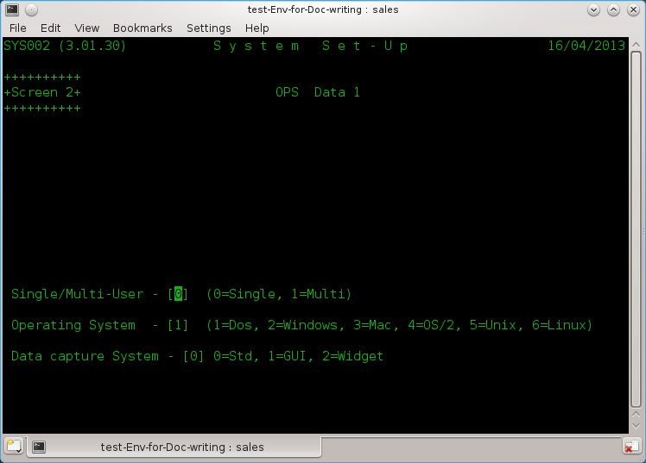

Figure 6.4 Screen 2 – OPS Data 1

(2-01) Single/Multi-User – [0]

Enter 0= for Single or 1 for Multi-user systems. If more than one user will be using the ACAS system possibly at the same time select 1. Normally enter 1.

(2-02) Operating System - [0]

Enter the correct value for the OS (operating system), Make sure you select the correct value as ACAS will function differently depending on system in use. If in doubt ask your IT department.

(2-03) Data capture System - [0]

Enter zero for now but options are 0=Std, 1=GUI, 2=Widget. This entry is for future expansion.
After pressing the Return key the system will confirm your answers.

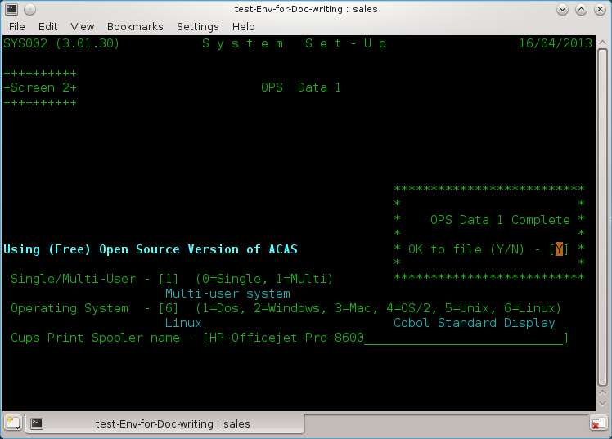

Figure 6.5 Screen 2– OPS Data 1 after data entry

A new box appears for all other than Dos, requesting the print spool name as set up eg in Cups.

Type the name in exactly as set up in Cups, be careful regarding case eg, upper and/or lower case.

If this is wrong you will not get any reports. A good test that this is correct is after you say Y to the print a hard copy of the parameters question at the end it will produce a report. The typical error produced for this is: 'lpr: The printer or class does not exist' as shown at the command prompt having exited from ACAS.

Screen 3 is now displayed and that covers G/L Data.

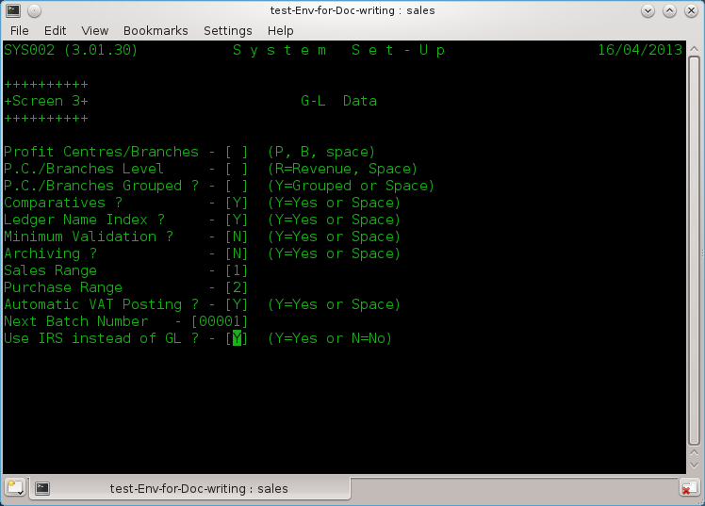

Figure 6.6 – G/L Data

This screen is only if you are going to use G/L instead of IRS in which case read the G/L manual for more information about the value but for the moment enter as per the figure 6.6 ie: enter a space for the three questions on P.C. (Profit centres) and 'Y' for comparatives and Ledger name index. Then enter 'N' for the next 2 question on Minimum Validation and Archiving. Leave as 1 and 2 respectively for the next 2 questions on Sales and Purchase ledger ranges followed by 'Y' for auto VAT posting, 00001 Next Batch number and finally Y if using IRS instead of G/L.

Now pressing enter will again let you confirm the answers with the display showing what has been set..Use N if you spot any errors and re-enter the correct one answers and enter to go to the next screen.

Now we finally get to parameters that relate to Sales Ledger on Screen 4

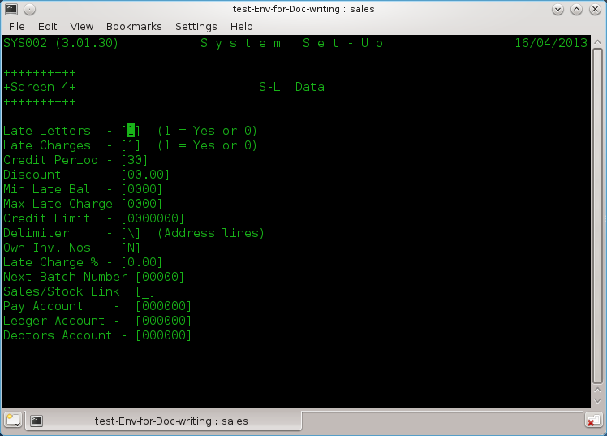

Figure 6.7 – S/L Data

(4-01) Late Letters [1]

This request determines whether Late payment reminders (dunning) letters are used.
If yes set to 1, the late letter module may be used to write reminder letters to overdue customers.

(4-02) Late Charges

This request determines whether or not late charges are used throughout the system. If yes (1), the payments apply module will generate charges on overdue balances.

(4-03) Credit Period

This is the normal number of days to give for credit. You have the option of changing this for individual customers.

(4-04) Discount

Default discount offered to customers and again can be change for individual accounts.

(4-05) Min Late Bal

The Minimum Late Balance is the value below which late charges will not be applied.

(4-06) Max Late Charge

The highest amount that will be charged for late payments.

(4-07 Credit Limit

During Customer Entry this is the amount that will be placed in each customer's record to show his or her credit limit in the absence of other instructions. It must be an integer from zero to 9,999,999. Balances over the credit limit are acceptable, but these clients will be flagged on reports and on Invoice entry.

(4-08) Delimiter

This is the character that delimits address lines. It is recommended to be set as '\'. unless you get the same character within addresses in which case select another that is not used.

(4-09) Own Inv. Nos

Will the users be entering your own invoice numbers?
Set to N if you want the system to handle it. If so, the system will reallocate deleted invoice numbers so you do not end up with missing numbers for audit purposes.

(4-10) Late Charge %

This is the percentage of the outstanding amount that will be used as the late charge.
This number may contain 1 digit to the left and up to 2 digits to the right of the decimal. For example, the default of 1.5 is one and one half percent of the overdue balance. Lowest values are 0.00 and highest 9.99. This charge applies per cycle eg, monthly.

(4-11) Next Batch Number
Normally set this to 1 if S/L not yet processed any invoices otherwise shows current next batch no.

(4-12) Sales/Stock Link

Set to Y if using Stock Control and you want it linked for invoice production. Else set to N.

(4-13) Pay Account

This is the number of the account to which all payments/cash receipt transactions will be debited.

(4-14) Ledger Account

This is the number of the account to which all sales transactions will be credited.

(4-15) Debtors Account

This is the number of the account to which all sales transactions will be debited and all cash receipts transactions credited

Note: Assuming IRS or G/L has been set up with a CoA (Chart of Accounts) you can enter the relevant accounts. If not set up or you will not be using either system then leave as zero.

After pressing enter for this last parameter you will be asked to confirm the S/L settings with the screen being updated to show your settings. Entering Y will move on the the next screen.

The next screen, 5 is for P/L data

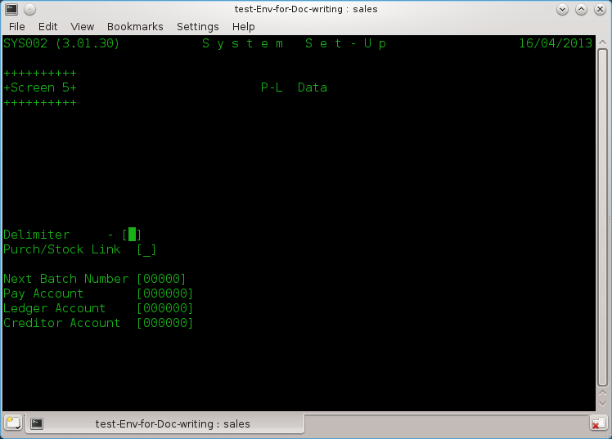

Figure 6.8 Screen 5 – P/L Data

Purchase Ledger parameter data is a small but similar element of the S/L data. So now you know what is what regarding S/L, P/L will be a 'piece of cake' as there is a lot less fields.

(5-01) Delimiter

This is the character that delimits address lines. It is recommended to be set as '\'. unless you get the same character within addresses in which case select another that is not used.

(5-02) Purch/Stock Link

Set to Y if using Stock and you want it linked for purchase invoice order production. Else set to N.

(5-03) Next Batch Number

Normally set this to 1 if P/L not yet used otherwise shows current next batch no.

(5-04) Pay Account

This is the number of the account to which all payment transactions will be debited.

(5-05) Ledger Account

This is the number of the account to which all purchase transactions will be credited.

(5-06) Debtors Account

This is the number of the account to which all purchase transactions will be debited and all cash receipts transactions credited

Note: Assuming IRS or G/L has been set up with a CoA (Chart of Accounts) you can enter the relevant accounts. If not set up or you will not be using either system then leave as zero.

After pressing enter for this last parameter you will be asked to confirm the P/L settings with the screen being updated to show your settings. Entering Y will move on the the next screen.

We now move on to the sundry systems.

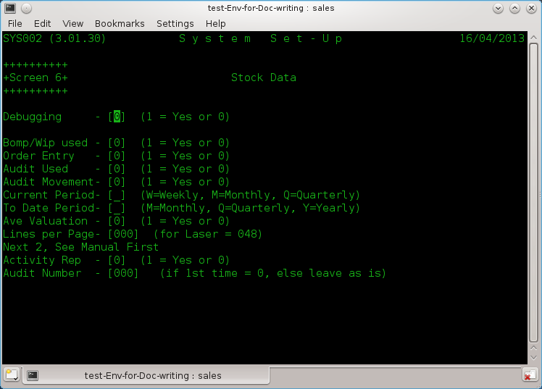

Figure 6.9 Screen 6 - Stock Control

(6-01) Debugging
Unless requested by technical support leave this as 0.

(6-02) Bomp/Wip used

Set to 1 if you need Bill of Materials Explosion / Work In Progress functionality. Otherwise set to 0.
See the Stock Control manual for more details for this and the other parameters in this section.

(6-03) Order Entry

Set to 1 if using the Order Entry system.

(6-04 Audit Used

Set to 1 to use Audit data otherwise set to 0. This is normally selected as it produces more reporting for purposes of audit control.

(6-05) Audit Movement

See above and also normally set to 1 to produce stock movement reports for audit.

(6-06) Current Period

Declare what the reporting period is: M = Monthly (recommended), W = Weekly & Q = Quarterly.

(6-07) To Date Period

Declare what the 'To Date' Period is;. M = Monthly, Q = Quarterly & Y = Yearly (recommended).

(6-08) Ave Valuation

Set Average valuations on, of current stock, else you need to maintain stock valuations yourself.

(6-09) Lines per Page

Number of printed lines per page. Start with 048 and go from there. Also see (1-06).

(6-10) Activity Rep

Set to 1 for recommended setting and this produces reports for all stock movements (Audit).

(6-11) Audit Number

Start number. Set it to 0 unless system has been running then leave alone.

On pressing return will ask you to confirm settings having displayed some summary details.

Now to print out the details of the parameter files for your records, so select Y.
Warning: This does not print out all settings but does print out some internal data such as 'File Statuses' and this mean that a value of 0 (zero) mean a file has never been created and 1 (one) it has, starting from the left as file-0. Useful for purposes of support.

Sample ACAS Parameter File Set up Report

SYS002 (3.01.30) S Y S T E M P A R A M E T E R S 16/04/2013 Page 1

User Parameters G/L Parameters
**************** ****************

Name Test Company for new manual Neither P/C or Branches Selected
Address AnyWhichWay House
Any which Way
Town 1423 Comparative Figures Required
No Where on Sea,AB12 3CD,United Kingdom Alphabetic Ledger Index Selected
Date Format UK Format
Period Start 01/04/2012 Full Validation During Data Entry
End 31/03/2013 Transactions Deleted at End of Cycle
VAT Rate 1/4. 20.00 / 0.00 Sales Range most Significant Digit is - 1
Rate 2/5. 5.00 / 0.00 Purchase Range Most Signif. Digit is - 2
Rate 3. 0.00 Auto VAT Posting Selected
Current Quarter 1 Cycles per Quarter - 3
Current Cycle 1 Next Batch Number - 1
48 Using IRS instead of GL - Yes

ACAS Parameters P/L Parameters
**************** ****************

Environment Multi-User Address Delimiter \
Op. System Linux-User Next Batch Number 00001
System version Using (Free) Open Source Version of ACAS Next Folio Number 00000000
Cobol/Dup Mode Not Used Pay Account 000000
Path to IRS /home/vince/IRS Ledger Account 000000
Path to Ledgers /home/vince/ACAS/test-Env-for-Doc-writing Creditor Account 000000
Prt Spool Name HP-Officejet-Pro-8600-no-it-isnt Stock Control Link No

Inv. Parameters S/L Parameters
**************** ****************

Next Inv. Number 00000000 Computer Generated Invoice Numbers Selected
Dunning Letters not Selected
Late Charges not Selected
Inv. Data Level 0 Credit Period 30 Days
Standard Credit Limit 100
VAT Account 000000 Standard Discount is 0.00%
Min. Late Balance 0
Max. Late Charge 0
Late Charge Rate 0.00%
Address Delimiter \
Proforma Retent. 0 Next Batch Number 00001
Stock Control Link No
Pay Account 000000
Ledger Account 000000
Debtors Account 000000
Delivery Tag 000000
SYS002 (3.01.30) S Y S T E M P A R A M E T E R S 16/04/2013 Page 2

Stock Parameters O/E Parameters
**************** ****************

Debug Mode No O/Entry in Use No
Manufacturing No
Audit in Use Yes
Movement Audits Yes
Current Period Monthly
To Date Period Yearly
Stock Averaging Yes
Print Lines 48
Current Audit No 00000000

Payroll Parameters RDMBS Parameters
****************** ****************

Payroll in Use No

System Paramters
****************

File Statuses 00000000000000000000000000000000

End of System Parameter Report
==============================

The General Ledger Interface

The Sales Ledger system functions equally well as a stand alone system or with the ACAS IRS or General Ledger. Hereafter just called GL. If the GL is used, the S/L system will produce and maintain a posting file containing accumulated and summarized accounting information.

Every time the invoice or payment posting modules are run, the GL posting file is updated to reflect the new activity posted to the open item or payment files. When IRS is run, the user selects menu option 4 Posting, then selects option 66 'Add PL or SL Postings from file'..When GL is run the user selects menu option F, G & H to proof, report and post and all processes transfers the net of all activity on to each account and the posting file is cleared down therefore removing the need to process S/L or P/L transactions individually in IRS or GL

For most businesses, one payment account and one sales account are sufficient since most businesses deposit payment receipts from their trade accounts sales ledger in one bank account as cheques and cash, however with most business paying their bills by bank to bank transfers it is very useful to have an extra account that just receives such payments that is checked on-line at a fixed time each day usually at the end of banking cut-off, in order to get a list of all transactions then printed off which is retained until the next days report in order to check that there is no duplicate data in the later listing. This is used along with emails from customers detailing a breakdown of their payments is then used as input to the Payment Entry module. This last part does depend on co-operation with your customers but most seem to do so. At the end of each day the funds received into this account are transferred to the primary payment account as needed.

For example most all of our customers use a standard format detail in the reference field when paying which specifies: account number: then the last 4 digits of each invoice paid followed by a comma eg: A1000012:0041,0055,0195

This account should be the one defined as the payment account. Similarly, only a single trade sales account is used. to report the sales asset in the GL financial statements. In effect, this is the controlling account for the sales subsidiary ledger maintained by the SL system.

In practice, there will often be several sales accounts since most businesses separate their sales into categories to keep closer watch on which products, departments, or regions are performing exceptionally. In addition, one sales account is usually a liability account, Accrued Vat Payable. Special accounts may also be required for such things as consignment sales. In this case the sale is partially credited to an P/L (Purchase Ledger) account.

The Customer Files

The customer file, created and modified by the Customer Entry modules, contain the name, address, phone, and credit information of all customers eligible for credit. Customers can also be added using the Invoice Entry module by selected the function key 'F1'

Before a sales invoice can be placed on the system, an account must be established for the customer by entering the name and address information into the Customer Entry modules. The Customer Entry modules allows the user to assign the customer a six character customer number of the form:

cxxxxxq

where "c " can be A – Z or 0 – 9 which can represent a customer type, region/location etc, "xxxxx" is a unique five digit account number or even letters, and "q" is a single check digit used to protect against transpositions and key errors.

When adding a record, the Customer Entry modules displays the new customer's number and requests information relating to the account. In addition to name and address, delivery address if different, whether the customer is to receive late (dunning) letters and/or have late charges levied on unpaid invoices as well as a minimum amount outstanding before late charges are added, a maximum late charge amount, credit period, Discount % off all invoices, Email preferences for sending invoices, statements and late letters as well as recording telephone and fax contact information along with space for additional notes.

Each customer may be given a credit limit between zero and 9,999,999. Whenever the outstanding sales balance exceeds the customer's credit limit, an identifying flag is printed on the Trial Balance reports next to the customer's name. This is also checked and if needed a warning displayed during Invoice Entry if the limit will be exceeded. A system wide default credit limit is established on the parameter file that can be changed for each customer as desired.

See Figure 10.1 below for the customer entry screen.
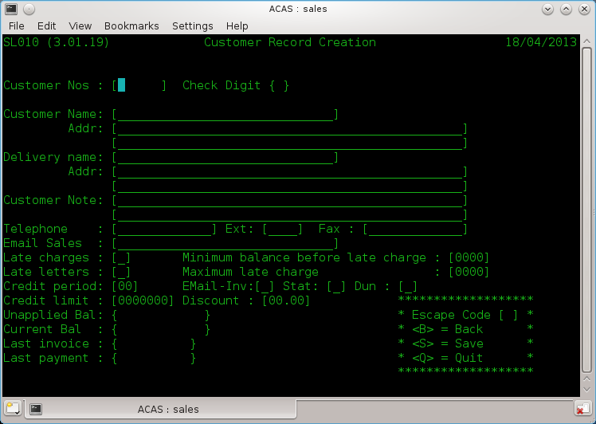

Figure 8.1 Customer Entry screen

When entering the address details the usage of the delimiter character as defined in the Setup Parameter file is compulsory as failure to follow this will result in an error message, for example here is a valid address:

Line 1: Applewood House,\Epping Road,\Roydon\
Line 2: Essex

When you wish to close a customer account, the delete function removes the record from the customer file. Before deleting a record be sure there are no active payment records or open item invoices for that customer however the system should prevent you from doing so. Clearly if there are outstanding invoices and you still need to delete the customer you must credit off all such invoices however it is recommended that such customers are left on the system but with their credit rating reduced to zero and a note added to the account specifying what has happened as a reminder for all staff.

Each customers number contains a Check Digit as the last digit which is a number chosen on- the basis of the other digits in the customer number. The selection algorithm for the check digit enables almost all key entry or transposition errors to be detected instantly. All calculations are done automatically by the system.

The Customer Print modules

The various Customer Print modules may be run at any time. The modules produces an ordered listing of the data in the customer files. You can change the form of the report by selecting any of the report attributes as shown in figure 9.1 below and this capability is available for most of the reports throughout ACAS (the Applewood Computers Accounting System).

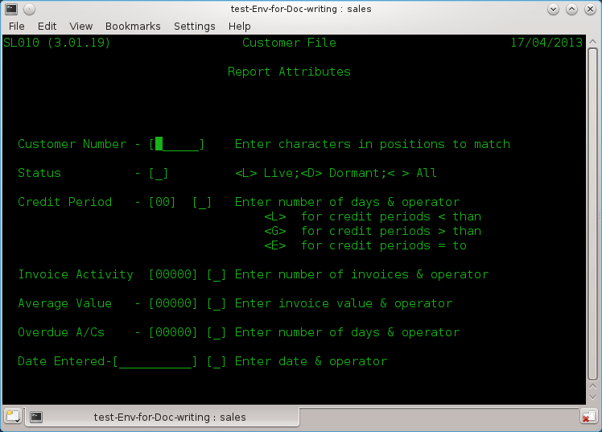

Figure 9.1 Report selection Criteria request

All entered criteria will be tested for, prior to printing.

Sample printouts are shown in Figures 9.2 to 9.5. The customer print is a handy reference when printed in customer name order, allowing cross referencing between name and number. The Alphabetic ordered print is listed by customer name and the last is a Customer file Dump which prints out all information for each customer and this one is not commonly used except as a back up..Note that this report also shows the address delimiters.

CUSTOMER REPORTS TO BE INSERTED HERE in landscape:

SL010 (3.01.19) Customer Listing Page 1
Dykegrove Ltd Report On : All 17/04/2013

Customer Status <---------------Name & Address--------------> ----Telephone---- -----Fax----- Late Credit Disc
Number ------ Chg Let Limit/Days %

A000011 Active Able Film Ltd 01234-567890x007 Y 1500 28 0.01
Stage 4,Pinewood Studios,Hertfordshire,UK
Notes: Delivery to Studio 1

A000029 Active Canon UK Ltd 020-7123-9876 020-7123-9804 Y 5000 28 0.17
Canon House,Canon Way,London,EC1 4ZZ

A000037 Active Nikon 020-7985-9354 Y Y 750 28 0.02
Nikon Bungalow,28A Threadneedle Street,London,W1 2AB

Alphabetical Customer List
SL160 (3.01.16) Customer Alphabetical Listing Page 1
Dykegrove Ltd Report On : All 17/04/2013

Customer Status <---------------Name & Address--------------> ----Telephone---- -----Fax----- Late Credit Disc
Number ------ Chg Let Limit/Days %

A000011 Active Able Film Ltd 01234-567890 x007 Y 1500 28 0.01
Stage 4,Pinewood Studios,Hertfordshire,UK
Notes: Delivery to Studio 1

A000029 Active Canon UK Ltd 020-7123-9876 020-7123-9804 Y 5000 28 0.17
Canon House,Canon Way,London,EC1 4ZZ

A000037 Active Nikon 020-7985-9354 Y Y 750 28 0.02
Nikon Bungalow,28A Threadneedle Street,London,W1 2AB

Customer file dump
SL170 (3.01.07) Sales Ledger Dump Page 1

Dykegrove Ltd Report On : All 18/04/2013

Sales-Key A000011 Sales-Credit 28.00 Sales-Current 0.00
Sales-Name Able Film Ltd Sales-Discount 1.00 Sales-Last 0.00
Sales-Addr1 Stage 4\Pinewood Studios\Hertfordshire\UK Sales-Late-Min 10.00 Turnover-Q1 0.00
Sales-Addr2 Sales-Late-Max 50.00 Turnover-Q2 0.00
Sales-Phone 01234-567890 Sales-Limit 1500.00 Turnover-Q3 0.00
Delivery-Tag 0 Sales-Activety 0.00 Turnover-Q4 0.00
Notes Tag 1 Turnover-Q4 0.00
Sales-Status Live Sales-Last-Inv
Sales-Late No Sales-Last-Pay
Sales-Dunning Yes Sales-Average 0.00
Sales-Email purchasedept@pinewood.co.uk Used by Invoicing, Statements, Dunning.
<-------------------------------------------------->

Sales-Key A000029 Sales-Credit 28.00 Sales-Current 0.00
Sales-Name Canon UK Ltd Sales-Discount 17.50 Sales-Last 0.00
Sales-Addr1 Canon House\Canon Way\London\EC1 4ZZ Sales-Late-Min 100.00 Turnover-Q1 0.00
Sales-Addr2 Sales-Late-Max 0.00 Turnover-Q2 0.00
Sales-Phone 020-7123-9876 Sales-Limit 5000.00 Turnover-Q3 0.00
Delivery-Tag 0 Sales-Activety 0.00 Turnover-Q4 0.00
Notes Tag 0 Turnover-Q4 0.00
Sales-Status Live Sales-Last-Inv
Sales-Late No Sales-Last-Pay
Sales-Dunning Yes Sales-Average 0.00
Sales-Email chiefwhiz@canon.co.uk Used by Invoicing, Statements, Dunning.
<-------------------------------------------------->

Sales-Key A000037 Sales-Credit 28.00 Sales-Current 0.00
Sales-Name Nikon Sales-Discount 2.00 Sales-Last 0.00
Sales-Addr1 Nikon Bungalow\28A Threadneedle Street\London\W1 Sales-Late-Min 90.00 Turnover-Q1 0.00
Sales-Addr2 2AB Sales-Late-Max 500.00 Turnover-Q2 0.00
Sales-Phone 020-7985-9354 Sales-Limit 750.00 Turnover-Q3 0.00
Delivery-Tag 0 Sales-Activety 0.00 Turnover-Q4 0.00
Notes Tag 0 Turnover-Q4 0.00
Sales-Status Live Sales-Last-Inv
Sales-Late Yes Sales-Last-Pay
Sales-Dunning Yes Sales-Average 0.00
Sales-Email PO-dept@nikon.co.uk Used by Invoicing, Statements, Dunning.
<-------------------------------------------------->

Transactions

The Invoice Batch

Financial transactions in the Sales Ledger system go through two stages. Before posting they are considered Batch transactions. After posting, transactions are considered Posted or permanent entries. Batch transactions are unofficial and thus can be added to, changed, or deleted at any time. While in the batch stage, transactions may be entered, proofed, or modified without any record keeping requirements. Once the batch of transactions is posted, however, they become permanent entries that require standard accounting procedures to modify or delete. These standard procedures leave an audit trail that can be used to trace a transaction through the system.

There can be only one invoice batch at anyone time. This batch remains current until posted to the open item file by the Invoice Posting module. When the Invoice Entry module starts, it examines the system to see if there is a current invoice batch. If one is present, the module allows it to be modified. If no current batch exists, one is created.

The number of invoices allowed on the system per customer is limited only by the amount of disk space available. The same applies to the number of customers. See the appendixes for record size information on the primary files or rdbms tables.

Prerequisite Settings

You have to set up the invoicing system via menu option T and sub-option 1 (Amend Invoicing Fixed Data) adjust these value according to your needs (figure 10.1):

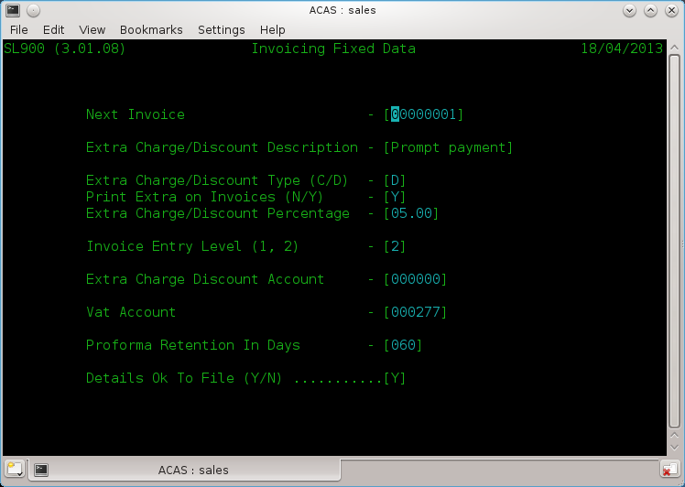

Figure 10.1 Invoice settings

Lets quickly go through these in order of display:
- Next Invoice Number: Set this as needed, but not less than 1.
- Extra Charge/Discount Description: If you require a standard discount or credit, you need to start here. For example We use it to offer a prompt payment discount on all invoices that all carry 28 day terms and the discount is offered for all invoices paid within 14 days of issue. As you can see this has been set up in fig 10.1 and we have called it Prompt Payment.
- Extra Charge/Discount Type (C/D) it is set to 'D' for Discount.
- Print Extra on Invoices (N/Y) it is set to 'Y' as we do want it printed on invoices.
- Extra Charge/Discount Percentage, set to the discount rate and here it is 5.00%.
- Invoice Entry Level (1, 2): To use detailed select '2', then invoices will be recorded in their component parts for more detailed accounting and reporting and for linkage into the Stock Control system if used. See figure 10.1 & 10.2. This-extra level of detail is simple to implement and is entirely optional. If you select 1 instead, then you will only be entering the Net and Vat amounts. The detailed information is maintained at the batch level and in the open item files. For example, in many cases an invoice is for several items and/or some kind of surcharge such as Vat and shipping. These normally must be accounted for in different sales accounts for the sales report or the GL interface. The invoice would then consist of a controlling record containing the grand total of the charges on the invoice, and one or more line items that each, represents a component charge and each can be credited to a different sales account.
In figure 10.1 it is set to 2 as we require full detailed invoices that we also link to Stock Control but is still applicable even if not using the Stock system. It just means you have to type in the descriptions for each line item as well as the price, .and that is a good reason for using Stock control
- The next two for entering the IRS or G/L accounts that relate to both Vat and the Discounts or extra charges given/taken so that the accounts are always up to date without the need to enter this type of information into the IRS manually.
- Proforma Retention In Days, if you issue proformas then the number of days they are valid for after which they get removed from the system.
- And the last one 'Y' to confirm all of your settings otherwise 'N' to go back through the screen. Of course you can just enter Y and reselect the screen to go through it again updating previous data.

The sub menu option T is the second menu to enter or amend invoices in addition to via the main menu options D, E, F & G Sales Transactions Input, Amend, Proof, Post, the later two can only be done here via the main menu. The other differences are that option T also offers the facility to enter invoices for immediate printing as against doing them in a batch also printing the invoice batch as well as printing Delivery Notes/Picking Lists, see figure 10.2. While most is understandable, we will highlight the others that might need some explanation:

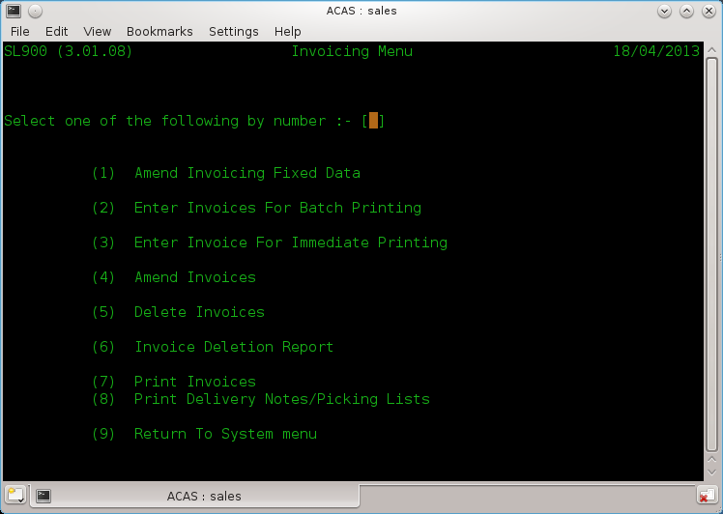

Figure 10.2 Invoicing Menu

- Amend Invoicing Fixed Data: Detailed previously.
- Enter Invoices For Batch Printing: This is the normal mode to enter invoices into the system along with via main menu option 'D'.
- Enter Invoice For Immediate Printing: This is to enter the odd one or two invoices .instead of doing them in batches, If used it is for a last minute invoice that needs to be created, after all batch invoices have been processed by being proofed and posted..
- Amend Invoices:.Same as main menu option 'E'.
- Delete Invoices: Allows you to totally delete one or more invoices. Note that the invoice numbers delete will be reused (if using system generated one's).
- Invoice Deletion Report: You need to runs is if you delete any invoices fo audit purposes.
- Print Invoices: Print all batched invoices.
- Print Delivery Notes/Picking Lists: This can be printed to a local printer in the shipping dept.

Line Items

The normal invoice production processing flow is having setup the invoicing parameters via menu option 'T' is to Enter, Amend, Proof and Post via the main menu and only go to option T to print them along with packing notes if required. Printing should occur after running Invoice Proof and before Posting but can, be run after posting. It is recommended to print after proof and before post.

The number of line items that can be used per invoice is limited to 40..For most businesses create a new invoice way short of this number.

To Enter or process the maximum of line items per screen it is recommended to set the size of the terminal program you use to run ACAS to:80 columns wide (Most important, as if wrong, the display will look very odd and unreadable.
Any length, as long as you would like, eg, 40 lines by 80 columns and on a A4 screen in portrait mode 90 lines by 80 columns will also work. ACAS reads the size of the terminal screen when loading and adjusts data displays and input for the length. It cannot adjust for width at this time as it would cause more problems than it fixes.
Note that if you change the terminal size after ACAS has loaded it will not re-read the size as the changed information is not available but in any event is only read by each module when first run.

Using The Invoice Entry Modules

When you select Invoice Entry from the system menu, the Invoice Entry screen appears as in Figure 10.3 with· the cursor waiting at date where you change it if needed otherwise press enter to
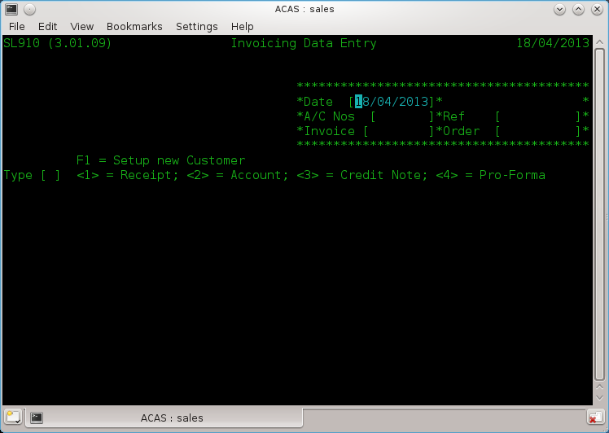

Figure 10.3 Invoice Entry Customer a/c details

move to the customer number field. You now enter the customer number or if this is a new customer you can press the F1 function key (or enter 'NEW' in uppercase as customer number) as seen on the display. If you have selected F1 (or typed NEW) you go through the normal process to create a new account and after saving the data will go back to this point. So having entered the account number then pressing return it brings up the name and address details for the selected account. If you keyed in an incorrect account you remain on the account field so re-key the account and the cursor moves to the next field, Ref(erence), key this in if available (or leave blank with return and the next field is Order number if applicable if not leave blank, now when pressing return you need to select what type of entry this is e.g., 1 = Receipt, 2 = Invoice, 3 = Credit note for existing invoice, 4 = Proforma.

At this point the screen changes (see fig 10.4) where you can enter all line items.

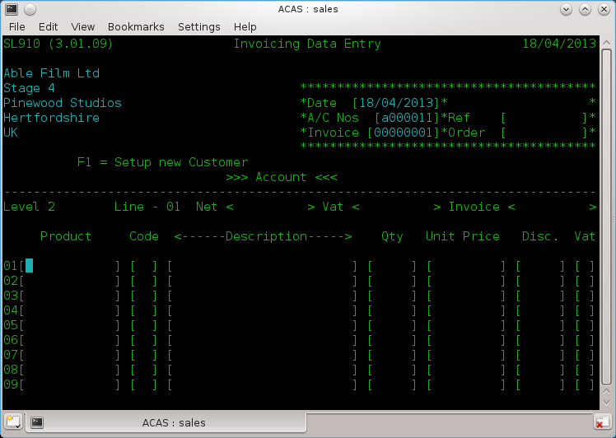

Figure 10.4 The Invoice body enter screen

Starting with product code which if using 'linked Stock Control' will obtain the description and price otherwise you enter each field from left to right one line item at a time. A running total is displayed above the line items for your reference. If you press return at the start of a new line you will go to another screen (figure 10.5) for additional information.

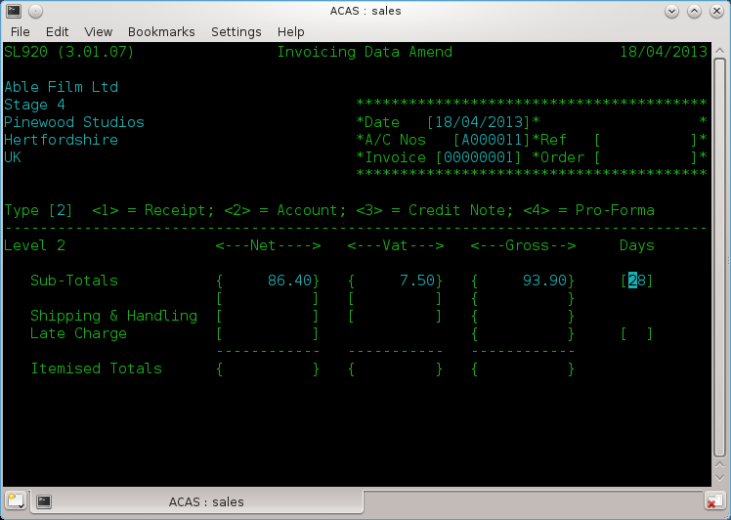

Figure 10.5 invoice Entry – Sub totals & postage

Now to finish off the invoice you can change the default credit period in days and down arrow or return goes to the next line in this case 'Shipping & Handling' where you can amend a previously entered set of figures or by using the return or down arrow keys accept the displayed amounts.
After which you are asked to confirm everything is correct and that it is ok to save. If not enter N and this screen will restart using the previously enter data that you can amend. If it is correct entering 'Y' will save it and you will be asked if there are more invoices to enter and if so screen 10.4 will be displayed to enter more invoices otherwise you will be returned to the menu.

During entry, all the normal control keys can be used (return, down arrow etc) to position the cursor including backspace to erase the character under the cursor. The function of the control keys and what is available does depend on your systems (Linux, Unix, Mac OSX, Windows etc) settings so you may need to change them for all to be available.

How to Add invoices to the batch.

This is exactly the same process as for entering Invoices. Whether invoices are entered in one session or hours, minutes or even days latter the same function is used and new invoices are added to the batch and this continues until you proof, print and post the entered invoices, credit notes, receipts and proformas.

You should always run a proof before printing the invoices as it might save you effort having to raise a credit note for an invoice because of a silly mistake. You should try to avoid deleting an invoice even if only to keep the audit records clean.

How to Change Invoices on the Batch

To change invoices while still in the batch state, select 'Sales Transactions Amend' from the main menu. You will need to know the invoice number. You will see the same screens as for invoice entry the existing information will be displayed allowing you to change any of the fields including the customer account number. The other options are to raise a credit note against the incorrect item lines, or to delete the incorrect invoice and totally re-enter it.

How to Examine Invoices in the Batch

The simplest way is to produce an Invoice proof report which has to be done anyway prior to posting them.

To examine an invoice, select the Invoice Amend module from the system menu, and when the entry screen appears enter the invoice number and thereafter keeping pressing return to move forwards through the invoice.

How to save Records to Disk to Prevent the Accidental Loss of Data

The only way is to leave the Sales menu by entering 'X' at the menu prompt, this will run a backup before returning to the command prompt. At this point you can rerun sales in the normal way.

The Invoice Proof
The invoice Proof is a formatted hardcopy report on the current invoice batch file. A sample proof is shown in Figure 11.1. The data 'for each invoice and line items is printed in the order it was entered. The invoice proof serves as a working report and as an integral part of the S/L system's audit trail.

While the invoice batch is being build, the Invoice Entry modules can be ended at any time, and a proof report printed. This working proof can be used to verify the accuracy and completeness of each transaction. As many proofs as desired may be made.

A final proof must be taken immediately before the batch is posted. This final batch proof is a hardcopy link in the audit trail that shows the exact transactions that were part of the batch when it was posted to the open item invoice file. This printout is the only hardcopy report that shows line item detail for each transaction. If this final proof is not made, the invoice posting module displays a warning error message and requests confirmation. The module can be stopped and the hardcopy proof taken.

The last page of the invoice proof report includes account totals. A sample printout of this summary total page is also shown in Figure 11.1.

SL050 (3.01.09) Unapplied Sales Transaction Report Page 1
Dykegrove Ltd 18/04/2013

Number ---Date--- <------------Customer------------> --Type-- Goods <---Net--> <---Vat--> <--Gross->

1 18/04/2013 A000011 Able Film Ltd Invoice 28.95 33.90 0.99 34.89
Analysis aa Value 28.95 Vat Code 0
Carriage 4.95 1

2 18/04/2013 A000011 Able Film Ltd Invoice 4.95 6.94 0.40 7.34
Analysis aa Value 4.95 Vat Code 0
Carriage 1.99 1

Goods Discount Prompt Pay Carriage Net Vat Gross

Total Receipts 0.00 0.00 0.00 0.00 0.00 0.00 0.00
Total Invoices 33.90 0.00 0.00 6.94 40.84 1.39 42.23
Total Credit Notes 0.00 0.00 0.00 0.00 0.00 0.00 0.00

V.A.T. Reconciliation Receipts Invoices Credit Notes

Vat Code 1 20.00% 0.00 1.39 0.00
Vat Code 2 5.00% 0.00 0.00 0.00
Vat Code 3 0.00% 0.00 0.00 0.00

Posting the Invoice Batch

Once the invoice batch is accurate and complete, it can be posted to the open item file. The open item file is the master file of all invoices due and unpaid sales. An invoice is not considered a permanent transaction until posted.

If the batch file has not been completely proofed, the Invoice Batch Posting modules prints an audit proof however it does provide additional information and this should also be retained for the audit trail.

If the Invoices have not been printed an error message is produced that allows you to leave the module and print them, however if you really know what you are doing you can still force an Invoice Posting.

This course of action is not recommended. You should always print off all invoices, credit notes, receipts etc. See figures 12.1 & 12.2. for screen output and Figure 12.3 for a sample posting report.

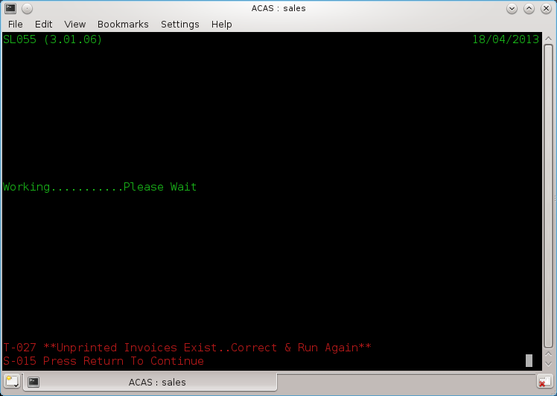

Figure 12.1 Proofing Error warnings

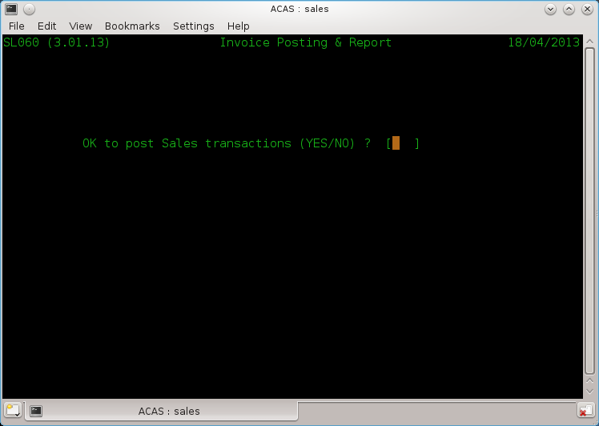

Figure 12.2 Do you really want to do this without proofing?

Sample report: Figure 12..3

The Payment Batch

Payment receipt transactions go through the same batching procedure used for entering invoices. Receipts are keyed in with.the Payment Entry modules and placed on the Cash Batch file that, when completed, is posted to the open Item file.

There can only be one payment batch at anyone time.

The cash payment batch remains current until posted by the Payment Batch Posting module. Entering account data is not required as this has already been set up in the parameter filel.

Applying Payments to Particular Invoices

Payments are applied to specific invoice the invoice number must be entered. Otherwise, the amount of the payment entering the system goes toward paying the earliest invoice on the account or is marked as un-applied. The invoice remains on the open item file, but is reduced by the amount of the payment. If the payment entry is greater than the amount of the invoice, the invoice is paid in full and the overpayment applied to the earliest pending invoice as usual. If no other invoices for that customer exist on the open item file, the overpayment is placed on the open item file as a credit balance un-applied, and remains until it is applied to an invoice.

Adjusting Entries

An adjusting entry is an internal transaction that credits a customer account but does not involve an actual payment but uses un-applied payments previously applied to the customer's account and that was more than likely caused by not having the correct invoice details for which it is to be credited at the time of entry. The adjustment is applied to a specific invoice. If the adjustment is not equal to the invoice amount it is handled as a regular payment of a non-matching amount.

In order to more accurately reflect returned merchandise and other transactions which should reduce sales account balances, the correct procedure is to issue a Credit Note using the Transaction/Invoice Entry module to offset against specific item lines in a specified invoice.

Removing Late Charges

Late charges may be removed for any customer through the Payment Entry module. You do this during the entry to a particular invoice

Using the Payment Entry Modules

When you select Payment Entry from the system menu, the screen appears (Figure 13.1) with the cursor waiting at the Customer number field. Thereafter it is straight forward to go from field to field using the down arrow or return key. If you do not have an invoice to apply the payment against, you can leave it in the system as un-applied. The systems reporting related to customer accounts will show any such customers along with all outstanding invoices so you can trace likely suitable invoices to apply against.

How to Change Payment Receipt records on the Batch

To change payment transactions prior to Payment Posting, select the Payment Amend module from the system menu. When the entry screen appears enter the customer and invoice details to amend or unapply or delete.
Figure 13.1 Payment Entry Screen

The Payment Proof.

The payment proof is a formatted report of the current payment batch file. A sample proof is shown in Figure 14.1. The data for each payment and adjustment is printed in the order it was entered. The payment proof serves as a working report and as an integral part of the S/L system's audit trail.

While the payment batch is being built, the Payment Entry module can be ended at any time, and a proof report printed. This working proof can be used to verify the accuracy and completeness of each transaction. As many proofs as desired may be made.

A final proof should, be taken immediately before the batch is sorted and posted. This final batch proof is a hard copy link in the audit trail that shows the exact transactions that were part of the batch when it was posted to the system. This printout is the only hard copy report that shows account detail for each transaction. If this final proof is not made, the payment posting module displays a warning error message and requests confirmation. The modules can be forced to post anyway or it can be stopped and the proof report taken. In any event a report is still produced although slightly abbreviated from the proof report.

The last page of the cash proof will report account totals.

If neither the IRS nor GL interface nor sales reports are selected, only totals of payments and sales offsets are shown. If either option is selected, the pound total for each account specified is displayed alongside the account name and numbers. A sample printout of this summary total page is shown in Figure 14.2.

Figure 14.1 Payment Proof Report

Figure 14.2 Payment posting report.

Posting the Payment Batch

Once the batch of payments is accurate and complete, it can be posted to the open item file.

If the batch file has not been completely proofed, the Payment Batch Posting module prints an error message indicating that the audit proof has not been made you can abort the operation and run the proof report before returning to the posting step.

Pre-Apply Reports

The Aged Trial Balance Reports

The Aged Trial Balance is the most important internal report for the user of the Sales Ledger system. The report shows the status of all sales by customer broken into columns. There are three aged trial balance report modules, each one generating a different report.

A sample of the Detail Aged Trial balance is shown in Figure 15.1. This report shows complete detail for every customer on the cycle for which it is run. Every outstanding invoice is shown along with any payments or adjustments applied in the last period. Each invoice amount is listed under a date column corresponding to the amount of time the receivable has been on the system. This is a lengthy, comprehensive report, that can serve as a primary working reference for your S/L department throughout the billing period.

The Summary Aged Trial Balance (Figure 19.2) prints the current totals for every customer on the cycle selected. Individual transactions, whether invoices, payments, adjustments, or late charges are not shown. Only the outstanding amounts for each period and the total of credit entries are printed.

The Exception Aged Trial Balance prints detail information only for those customers who are late or over their credit limit. Customers, whether they have current balances or not, are not printed if they have no overdue invoices and the total amount outstanding is less than the credit limit. An overdue invoice is determined by the starting cycle numbers entered for dunning letters and late charges on the parameter file. The earliest cycle of these two parameters is used. The default is 2, or any invoice 30 days or older.

All the reports show the customer's number, name, and phone number. The detail reports show the following data for each item:

- The invoice number of each transaction. If the transaction is a payment, this is left blank, unless the payment was applied to a specific invoice. If the transaction is an adjustment, the characters "ADJ" appear. If the transaction is a late charge, the invoice number consists of the word "LATE".

- The date of the transaction. This is either the date it was entered onto the system by the Payment Entry or Invoice Entry modules or the date it was created if it is a system generated transaction such as a late charge or credit.

- The amount of the transaction. This prints in the column corresponding to the number of cycles (or months etc) it has been on the system. The first column for one cycle, the second column for two, the third column for three and the fourth column for four or more cycles. The fifth column is for payments and adjustments.

If you wish to print a trial balance for a range of customers, enter the relevant criteria.

The Sales Report

This report can be generated if the option has been selected
on the parameter file. The sales report gives a comparative
summary of sales totals by account. The sales report uses the
General Ledger accounts if the GL interface is used.

The sales report may be generated at any time during the
billing cycle. It is not part of the hard copy audit trail and
may be omitted. Batch transactions are not reflected on the
report but posted, un-applied transactions are.

The sales report is a brief three column summary (Figure
20.1). The first column is the account total for the current
accounting period. This is the sum of all transactions made this
period that have not been applied. Once the transactions have
been applied (after the cash apply modules has been run), they
report as the total in the second or last period column. When
the amounts are transferred from the current period to the "last
period" column at cash apply time, they are added into the total
for the third or "year-to-date" column.

The sales file is updated each time the invoice Batch
Posting modules is run. The Cash Apply modules updates the sales
file only when the last cycle is run for the billing period. For
example, in a 4 cycle system (A, B, C, and D), the sales file is
updated every fourth time the cash apply modules is run, Le.,
when cycle D is applied.

Each account is listed on a separate line showing the S/L
sys tem account key, the optional GL sys tem account number, the
account name, and the three amounts: current period, last period,
and year-to-date. The number of accounts is determined by the
accounts entered in the Account Entry modules (Chapter 7).

At the beginning of a new year, the old year-to-date figures
are no longer needed and can be eliminated by erasing the sales
file. The sales file is named:

Section Five-Cash Application
21. The Cash Apply modules

The Cash Apply modules (ARCSHAPP) is the central modules in
the Sales Ledgerprocessing cycle. Execution of the cash
apply modules is a landmark by which the other S/L modules make
their processing decisions. During the cash application process,
cash receipt transactions offset outstanding invoices on the open
item file.

The Cash Apply modules reads the current open item file and
the current cash file. It writes a new open item file and a new
cash file. The new open item has all the paid invoices removed,
and the unpaid invoices remain. The new cash file is a record of
all payments received during the period and is used for reporting
throughout the system.

The Cash Apply modules may only be run one cycle at a time.

The cycle is automatically selected by the modules. It is always
the cycle one greater than the cycle previously applied. If
three cycles are specified for the system, for example, the Cash
Apply modules applies cycle A, then B, then C, then A again.

Three types of cash can be applied to the open item file: 1)
a previous credit balance, 2) a regular payment, and 3) a credit
adjustment. Regular payments and credit adjustments are entered
with the Cash Entry modules (See Chapter 15).

Cash is normally applied to the earliest invoice on the open
item file which is determined by the number of cash apply cycles
it has remained on the file and NOT by the date of the
transaction. A regular payment or a credit adjustment may be
made to offset a particular invoice through the Cash Entry
modules. The payment (adjustment) is applied directly to the
invoice regardless of its age or the existence of other invoices.
If the payment exceeds the amount of the invoice, the credit
balance is applied to other pending invoices as a normal payment.

Any payment smaller than the invoice amount reduces the
amount of that receivable by the payment amount, but allows it to
remain on the open item file bearing the same description, date,
and invoice number. The nUlllber Ofcyc.les·irtdicatot' bti the
invoice is incremented to make the receivable one billing cycle
older.

If any payment or combination of payments exceeds the total
of all outstanding receivables, the overpayment becomes a credit
balance and is reported as such on both the Aged Trial Balance
and statements. An invoice of equal amount must be created to
remove the credit balance.

93

Section Five: Chapter Twenty-One, The Cash Apply modules.

LATE CHARGES:

The cash apply modules creates late charges if the option is
requested during parameter entry. A late charge is generated at
the end of cash application if an invoice remains unpaid that has
been on the open item file for 2, 3, or 4 cycles (depending on
the Starting Late Charge Cycle set on the parameter file; see
Chapter 6). The amount is either a flat amount or a percentage
of the overdue balance. These options are specified during
parameter entry.

If late charges are a percentage of the overdue balance,
they are calculated only on the amount overdue in the period when
late charges begin and anything older. For example: if late
charges start at cycle 3 (60 days) and the customer has
outstanding sales 30, 60, and 90 days old, the late charge
is calculated on the sales that are 60 and 90 days old.
The 30 day old invoice, and any current invoices, are ignored.
Late charges are truncated after the second digit to the right of
the decimal. Late charges may be removed from the open item file
through the Cash Entry modules. Refer to Chapter 15 for
instructions.

If the Autogenerate Invoices option has been requested the
Cash Apply modules expects the Autogenerate Invoices modules to
have been run during the current period for the cycle being
applied. If this has not been done, the modules displays a
message to that effect and requests confirmation to continue.. If
the Autogenerate Invoices modules was omitted inadvertently, the
Cash Apply modules can be halted, the Autogenerate Invoices
modules run, the batch posted, and the Cash Apply modules re-ruu.

The Cash Apply modules updates the sales file when it
applies cash to the highest cycle defined. The sales file
contains data for the sales report modules. Data. is placed on
the file by both the cash and invoice posting modules. The Cash
Apply modules moves the current period total into the last period
total and adds it to the year-to-date total. This process only
takes place when the cash apply modules is run on the highest
cycle defined for the system since that cycles indicates the
billing period is over and the sales statistics can be updated.

The Cash Apply modules creates new and updated versions of
the two system master files, the cash file and the open item
file. After the modules has run to successful completion, the
old open item file and cash file are removed from their-current
status and are useful only for backup_

94

22. Generating Statements

The Print Statements (ARSTTMNT) modules generates the
customer statements. The statements which normally are generated
and mailed once per billing cycle show a ll, current invoices and
all payments or adjustments entered in the last billing cycle. A
sample statement is shown in Figure 22.2.

The print format of the statements is pre-set for the
standard continuous form statements. Chapter 23 describes how you
can modify the printing format to suit your specific needs.

The Print Statements modules may· be run any time after the
cash apply modules. It requests a date from the console to print
on each statement as the generation date.

The Print Statements modules requires the system's three
major files (the customer file, open item file, and cash file) to
be accessible to the modules at the same time. In addition, the
parameter files must be read at the beginning and end of the
modules.

When it starts the Print Statements modules asks if a dummy
form should be printed. If the answer is YES, a one page
statement with dummy data is printed to make sure the pre-printed
forms are aligned correctly. The dummy statement can be printed
as many times as necessary by responding to the request with YES.
When you answer NO the modules begins printing real data.

The statements are printed one cycle at a time. The cycle
printed is that specified at the start of the modules. The
statements always print in ascending customer number order.

If you want to print statements for only a range of
customers within a cycle, enter the cycle letter followed
immediately by an asterisk (Figure 22.1). If an asterisk is
entered, the modules requests a starting and ending customer
number. Both requests must be answered with a three digit number
or RETURN. The three d i.gi, t number should be the three central
digits in the customer number. Note that leading zeros must be
keyed in. For example:

004

indicates the fourth customer on this cycle. If RETURN is
entered at the starting customer number request, the modules
assumes it should start with the first customer. If RETURN is
entered at the ending number request the modules assumes
customers should be printed to the end of the cycle. If you
enter a number past the last customer on the file, the last
customer on the file is assumed as the ending number. The
starting/ending customer numbers are useful when a large quantity

95

Section Five: Chapter Twenty-Two, Generating Statements.

of statements must be generated in several short runs or if the
printout must be stopped and restarted due to a printer
malfunction.

If a customer's account has a credit balance, the word
"CREDIT" is printed below the account totals on the statement and
stub 0 In addition, the descriptive message shown in Figure 22.3
is printed.

If the detail items (ie., invoices) for a customer will not
fit on one page, the statement uses as many pages as necessary.
The summary line at all but the last page of the statement will
be blank.

OPEN ITEM STATEMENT

When the balance forward option is not used the system
operates as a strict open item system. This is reflected on the
statement. Current invoices and invoices that are not current
but unpaid will print on the statement. No summarization of any
open items takes place. The format of the open item statement is
shown in Figure 22.2.

Notice that the amount in the left amount column shows the
balance due on the invoice at the beginning of the period. The
amount in the right or stub amount column shows the current
balance due on the invoice after all current period payments have
been applied. An invoice that has been completely paid off shows
a zero.

The payment amounts are shown as negative numbers and print
only in the left column. If the amounts in either the left or
the right column are added together, the sums will equal the pay
amount (total due) shown in the box at the bottom of the column.

Payments applied directly to a specific invoice show the
invoice number in the invoice column. The amount applied to the
invoice is the difference between the amount in the left column
and the amount in the right column. This can be seen in Figure
22.2 for invoice 24791. The payment dated April 21st is
earmarked for invoice 24791 even though an older invoice exists.
The invoice amount in the left column shows 290.11, the original
amount of the invoice. The amount in the right column, zero,
indicates the amount currently due on the invoice. In this case
the invoice has been paid off entirely. The payment dated
20/4/78 is not directed to a specific invoice and thus the
payment goes toward the earliest invoice first. In the example,
the fifty pound payment is applied to invoice number 23345. The
difference in the amount figures in the two columns for this

96

Section Five: Chapter Twenty-Two, Generating Statements.

invoice is fifty pounds.

BALANCE FORWARD STATEMENT

When the balance forward option of the S/L system is
requested (requests 29 and 30, Chapter 6), all previous period
invoice detail is summarized into a single previous balance
amount which is printed at the top of each statement. A sample
balance forward statement is shown in Figure 22.4.

Depending on the setting of the Begin Summarizing parameter,
varying amounts of detail are held for all customers. With the
parameter set at two, the lowest value allowed, only current
period detail is reflected on each statement. Invoices 30 days
or older are summarized into the previous balance amount. If the
parameter is set to three or four the detail reported is for
current through 30 days or current through 60 days respectively.

Payments are reported on the balance forward statements the
same way as on a full open item system. Payments may still be
directed to a specific invoice. Regardless of the period
selected for summarization, the aging at tne bottom of the
statement reflects the true age of the receivables.

Figure 22.4 shows that invoices paid in full in the same
period they are placed on the system report on the statement as
current period activity with a zero balance due.

ENTER TODAY'S DATE (DD/MM/YY) 13/4/78
INPUT CYCLE TO BE PRINTED a*

INPUT STARTING CUSTOMER NUMBER 144
INPUT ENDING CUSTOMER NUMBER 450

Entering Starting and Ending Numbers
Figure 22.1

SOURCES FROM OLD MANUAL -

97

\0
00

:!!zu>
COOQ)
c ....• 3

.., »"0
(1)(')-
1'-).-+(1)

I'-)cu>
r-.,~"",

cn~
-.(1)

~3

(I)
::J
...•

Bodachous Ballywich Brokers
123 Backwoods Road

Rundown Cabin 4
Nowheresville, West Virginia

DATE

Fred Wilson
Microprocessor, Inc
5900 Edison St.
Tacoma Wa 98499

5/3/78

RETAIN THIS PORTION FOR YOUR RECORDS

INVOICE No. DATE EXPLANATION AMOUNT
23345 01/25/78 Eurail Pass 215.00
24791 02/09/78 Biltmore Hotel 290.11
24902 04/17/78 Western Union 17.52
24988 04/21/78 Eastern Airways 371.41
*******************************
24791 04/21/78 PAYMENT, THANK YOU -290.11
04/20/78 PAYMENT, THANK YOU -50.00
--- ) L

CURRENT

30 DAYS

60 DAYS

90 DAYS & OVER ~O,.!,..-

l

165.~_ 553.93J

388.9

0.00

0.00

(

STATEMENT
PLEASE MAKE PAYMENT TO:

B.B.B.

123 Backwoods Road
Rundown Cabin 4
Nowheresville, WV

r DATE " ,r"C_:-:-. -. -=-=--~"

5/3/78

PLEASE RETURN

THIS PORTION WITH YOUR PAYMENT

~NVOICENo. AMOUNT '\
23345 165.00
24791 0.00
24902 17.52
24988 371.41
***********
-; .J )

::nZ(J)
(QoOl
c"'3

@ ~"Q.

N •.•• <1l

!'J;n

w -.,

(J)<1l
_.0-

N -.

\0 m'"

\0 OJ

Q)

Q)
:::l
n
<1l

W

Q)
...•

CD

3

CD
:::I
...•

RANDOLPH TRAVEL SERVICE

123 Backwoods Road

Rundown Cabin 4
Nowheresvi11e, West Virginia

DATE

Randy Brown
Byte Shop

511 SW North St.
Eugene Or 91400

5/3/18

RETAIN THIS PORTION FOR YOUR RECORDS

INVOICE No. DATE EXPLANATION AMOUNT
03/21/18 CREDIT 14.75
NOTE: CREDIT BALANCE
""' 0.00

0.00

CREDIT

STATEMENT
PLEASE MAKE PAYMENT TO:

llANDOLPH TRAVEL

5/3/18

PLEASE RETURN

THIS PORTION WITH YOUR PAYMENT

INVOICE No.

14.1

AMOUNT

t
o
c

:r!Z(J)
ceoal
c ....• 3

ca »-0
I\)nCil
!'l ~ OJ

~-Q)
cn
N,g;

roC)
CD

3'

~

a.

(J)

•..•.

Q)

~
3

(I)
::l
....•

(

Bodachous Ballywich Brokers
123 Backwoods Road

Rundown Cabin 4
Nowheresville, West Virginia

DATE

Wayne Adams
Compact Cars

123 Cook St
Honolulu Hi 96815

5/3/18

RETAIN THIS PORTION FOR YOUR RECORDS

INVOICE No. DATE EXPLANATION AMOUNT
BALANCE FORWARD 141.30
24941 04/12/78 Hughes Airwest 133.15
24955 04/14/18 Ramada Inn 42.24
04/24/18 *******************************
PAYMENT, THANK·YOU - 316.69
.> ( CURRENT 30 DAYS 60 DAYS 90 DAYS & OVER -".~ •• I'I-
( 0.00 0.00 0.00 0.00 I 0.00 J (

STATEMENT

PLEASE MAKE PAYMENT TO:

B.B.B.

123 Backwoods Road
Rundown Cabin .•

Nowheresville, IV

/ DATE ..... r,...._-.-:._---.-.~,

5/3/18

PLEASE RETURN

I THIS PORTiqN WITH YOUR PAYMENT

(fNVOICE No. AMOUNT
0.00
24941 0.00
24955 0.00
********
'- ~ 23. Formatting the Statements

The contents and placing of the data on the statements can
be varied by the user to suit individual requirements. The basic
format of the statements remain constant so the variation is
somewhat limited.

The information printed on the statements can be divided
roughly into two categories, 1) the statement heading, and 2) the
statement body. The statement heading can consist of the company
name and address and the customer's name and address. Also in
the heading is the customer's number and the statement date. The
body of the statement contains the detail information on invoices
and payments and their respective totals.

PARAMETER ENTRY CHANGES:

Some changes can be made to the statement headings through
the Parameter Entry modules. The statement modules, as
determined by the system parameters will print the billing
company's name and address on the statement heading. The company
name and address can also be printed in sb o r t er form on the
payment stub (the right half of the statement). If the
controlling parameter entry request (Chapter 6, number 34) is
answered YES, the Parameter Entry modules asks two additional
sets of four information requests. These requests, shown in
detail in Chapter 6, ask for a name and three address lines for
the company header at the top of the large portion of the
statement. The first set has a maximum length of 30 characters
per line, the second reques t a maximum of 19 ch a r ac terse The
data entered for the second set of requests is placed on top of
the smaller stub. The two sets need not contain the same data.
If the controlling parameter entry request is answered NO, all
name and address requests are suppressed.

EDITOR CHANGES:

Chapter 30 gives detailed instructions on how to change
system parameters using the CP/M text editor. These editor
techniques must be useclio alter the format6f the statements.

Figure 23.2 shows the statement components that can be
varied by changing the parameters on the ARPR4.101 file. The six
items in the figure a r eTab e Le d A through F and correspond to
the list below. The items that can be varied are the starting
line (measured from the top of the statement) of A) the company
name and address for statement and stub; B) the customer name and
address and the two occurrances of the date and customer number;
C) The first line of invoices; D) the last line of invoices; E)
the line on which the total is to print; and F) the total length

101

Section Five: Chapter Twenty-Three, Formatting the Statements.

of the form in lines.

If a cycle frequency other than 30 days is used, the aging
heading on the statement summary line can be overprinted by the
statement modules. Using the editor, set the value of
PR4.STANDARD.HEADER.FLAG (Field #16) to false (0), then place an
appropriate aged heading in PR4.HEADER$ (Field #17). This
heading will print above the total line on the statement and on
the aging and other reports in the systemo This modification
should be made when the billing frequency is changed in the
parameter entry modules.

The table in Figure 23.1 shows each parameter, its relative
field number and default value. Changes made to the parameter
file fields will affect the next and all subsequent runs of the
statement modules. The Parameter entry modules will not reset
edited parameters.

FIELD NAME FIELD NUMBER DEFAULT
A PR4.COMPANY.NAME.LINE 12 3
B PR4.CUSTOMER.NAME.LINE 13 8
C PR4.FIRST.LINE.ITEM 14 17
D PR4.LAST.LINE.lTEM 15 44
E PR4.TOTAL.LINE 9 48
F PR4.FORM.LENGTH 10 51 Statement Controlling Fields
Figure 23.1

102

A

[- _U_ ---J

U
("UST,.Oj

B

RETAIN THIS PORTION FOR YOUR RECORDS

STATEMENT
PLEASE MAKE PAYMENT TO:

U (CU$T,OOJ

PLEASE RETURN

THIS PORTION WITH YOUR PAYMENT

INVOICE No. DATE EXPLANATION AMOUNT I (fNVOICENo AMOUNT ~
,
, I
,
I
;
,
I
,
,
,
AI 1\., I
A c

I-'
o
w

o l· I 1t I # I * J II *1 J

Variable Statement Components
Not Actual Size

Figure 23.2

PLEASE ~

PAY THIS
AMOUNT

24. Dunning Letters

If the dunning letter feature is selected, customers behind
in their payments are automatically sent reminder or "dunning"
letters. This feature is very flexible and can be tailored to
the needs of any customer base.

If dunning letters are desired, they must be ordered through
the Parameter Entry modules. If selected, the Parameter Entry
modules requests the cycle to begin issuing dunning letters. If
dunning letters are to be sent after invoices have been on the
system for 30 days, enter a two to indicate the second cycle
since cycle one indicates a current receivable. Cycle three
indicates 60 days past due and cycle four 90 days. If the cycle
to begin issuing dunning letters is three for example, customers
behind 30 days would not be issued dunning letters. A customer
would have to have a invoice at least 60 days overdue (3 cash
apply cycles) before a letter could be generated.

Each customer can be exempted from ever receiving a dunning
letter if you enter a NO answer to the dunning letter request in
the customer entry modules (see Chapter 10). This can be changed
for each customer at any time through the Customer Entry modules.

The dunning letter itself consists of 4 parts (Figure 24.1):

Part one gives the billing comp anys name and address and the
date; part two shows the customer's name and address; part three
is a brief reminder message; and part four shows the overdue
balance and total due.

The overdue balance is the total amount of all invoices
overdue. Being overdue is established by the earlier of the
starting dun cycle or the starting Late Charge cycle. The lower
of these parameters marks the first cycle a transaction is late.
The overdue balance will be the same even if the letter is not
sent until the third or fourth cycle.

Th~ text of the reminderomessage is one of up to three
different letters maintained by the system. The number of
letters maintained is entered in the Parameter Entry modules. If
more than one letter is specified, the first letter goes out on
the earliest cycle that dunning letters are allowed. Successive
letters are generated on successive cycles. For example, if two
letters, A and B, are specified and the first dunning letter
cycle is 3, a customer with a 60 day old invoice will receive
letter A. A customer with a 90 day old invoice will get letter
B. The oldest invoice determines which letter a customer
receives. Thus, a customer with a 60 day old invoice and a 120
day old invoice would get letter B.

The contents of the letters are set in the Parameter Entry

modules. The three letters set as the default letters (Figure

104

Section Five: Chapter Twenty-Four, Dunning Letters.

RANDOLPH TRAVEL SERVICE
123 End Road Wes t
London

NWI 6ZZ

12/5/78

Alan Wilcox

National Fullconductor Ltd
III Ic Lane

Reading, Berks

FIN A L NOT ICE

Your account with us is seriously overdue. We
must demand payment in full within 10 days from
the date of this notice.

AMOUNT OVERDUE

635.21

TOTAL DUE

640 .31

Sample Reminder/Dunning Letter
Figure 24.1

105

Section Five: Chapter Twenty-Four, Dunning Letters.

LETTER :IF!

Dear Customer,

Our records indicate that the amount shown below
is overdue. We would appreciate your prompt
attention to this oversight. If your payment is on
its way~ please disregard this notice. Thank you.

LETTER 12

SECOND NOTICE

Perhaps you have misplaced our statement? Please
remit the overdue balance shown below.

LETTER 13

FIN A L

NOT ICE

Your account with us is seriously overdue. We
must demand payment in full within 10 days from
the date of this notice.

Default Dunning Letters
Figure 24.2

106

Section Five: Chapter Twenty-Four, Dunning Letters.

24.2} may be changed line by line as desired.
displayed and a request issued for the replacement
RETURN means no change. Each letter may contain up
with 55 characters per line.

Each line is
line. Hit ting
to 5 lines

The dunning letters are produced by the Print Reminder
Letters modules which should be run after applying cash for the
period. Unpaid invoices are reported in the letters.

The dunning modules requests the necessary disks; the open
item file and the customer file are needed. It also requests the
cycle and date. The date is printed on each letter.

If you wish to print dunning letters for a range of
customers in a cycle, rather than every customer in the cycle,
enter the cycle letter followed immediately by an asterisk. If
an asterisk is entered, the modules requests a starting and
ending customer number. Answer with a 'three digit number or a
RETURN. The three digit number should be the three central
digits in the customer number. Note that leading zeros must be
keyed in. For example:

004

indicates the fourth customer on this cycle. If RETURN is
entered at the starting customer number request, the modules
assumes it should start with the first customer. If RETURN is
entered at the ending number request the modules assumes
customers should be printed to the end of the cycle. If you
enter a number past the last customer on the file, the last
customer on the file is assumed as the ending number. The
starting/ending customer number is useful if a printout must be
stopped and restarted due to printer malfunction.

107

25. The On-Line Enquiry

The online enquiry modules is a convenient way to access
information on a specific customer. Once the modules is started,
you can examine a customer's demographic information and
sales status by typing in the customer number.

When it starts, the On Line Enquiry modules asks for the
cycle you wish to examine and then the customer number on that
cye Le, The modules displays the cus t.o me r ' s name, address, and
other demographic information (Figure 25.1) and requests if you
want activity to be shown. If you answer YES or RETURN, the
modules displays the status of the customer's sales (Figure
25.2). All invoices including unbilled invoices are shown in
their entirety. All payments and adjustments are also shown,
including those not yet applied, in order to reflect the most
current status of the account. Invoices are totaled and aged on
the last line of the display.

Customer records can be examined in any order. The open item
file, the cash file, and the customer file for the desired cycle
must be in the proper disk drives.

ENTER CUSTOMER NUMBER a0166

# 16 AOl66 Peter Parker
234 London Road
Ealing, London
W6 7ZZ

AOO 500 NO DUN : NO Lie

DO YOU WISH ACTIVITY HISTORY (y OR N)? Y

Demographic Display
Figure 25.1

108

INVOICE :IF DATE DESCRIPTION
12410 09/04/78 National
12415 09/04/78 Waterfront Hotel
12411 09/04/18 Bicycle Rental
12518 17/05/18
CURRENT 30 60 90
87.99 0.00 0.00 0.00 Activity Display
Not. Actual Size
Figure 25.2

109

ASTERISK INDICATES
UNBILLED INVOICE

TOTAL
87.99

AMOUNT

44.50
17.95
.25.54
123.34 *

UNBILLED
123.34

Section Six-Utilities and Error Procedures
26. Sorting

Sorting involves ordering a file according to a "key" or
data item common to all records in the file. The key to be used,
as well as the input, output, and workfile drive locations are
specified in the sort parameter files created by the Create Sort
Parameter Files (ARSRTPRM) modules. The actual sorting is done
by a modified version of MPI's sort/merge utility QSORT (this
version works only for S/L sorting tasks; the standard version may
be us-ed if available).

The invoice batch file and the cash batch file are the only
files in the S/L system that must be sorted. These files should
be sorted immediately before you post them to their respective
master files. To create the sort parameter files for the invoice
batch (INVOICE.SRT) and the cash batch (CASH.SRT), run the
ARSRTPRM modules (menu item 4fo20, CREATE SORT PARAMETER FILES)
after Parameter Entry. When ARSRTPRM asks you to ENTER SORT
PARAMETER NAME, enter the word "standard" to create the two sort
parameter files required by the system. When the request is
reissued, type "stop" to end the modules. The invoice and cash
batch files may now be sorted by choosing the appropriate item
from the system menu.

If your version of CP/M does not have the SUBMIT feature
(most do) you cannot sort from the system menu, but must leave
the AR" system and perform the sort under the CP/M environment.
This is because QSORT is not a CBASIC language modules and must
be processed somewhat differently. Normally when a sort is
ordered from the menu the system builds a SUBMIT file which
automatically ends the S/L system, runs the sort in the CP/M
environment, and returns to the S/L system menu. To run the sort
on a stand alone basis, type QSORT followed by the name of the
sort parameter file to be used. For example, to sort the invoice
batch type:

A>QSORT INVOICE

If the sort parameter file is on drive B, you would type:

A>QSORT B:INVOICE

If you want to print the customer file in alphabetical order
by name, or ascending postcode order, you must first create the
necessary sort parameter files using the ARSRTPRM modules. When
the modules asks you to enter the sort parameter name, respond
with

NAME a
or
POSTa

110

Section Six: Chapter Twenty-Six, Sorting.

where "a" is the letter of the cycle you want to sort. The
request is re-issued until you type the word "stop". To run the
sort, choose the appropriate menu option, or run outside the
system as described above.

Normally ARSRTPRM creates the sort parameter files on the
system drive. You can cause sort parameter files to be created
on another drive by typing the drive location folloed by a colon
immediately before the filename. For example:

ENTER SORT PARAMETER NAME

a: standard

The sort modules expects to find the input file (the invoice
batch, cash batch, or customer file) in the drive specified at
parameter entry. If these drive assignments are ever changed,
ARSRTPRM must be rerun to generate new sort parameter files.

Since the sorting modules does not erase the input file
after the sort is complete, there must be room on the input disk
to receive the sorted output. Unless the invoice or cash batch
files grow very large there should be room. If a large customer
file is to be sorted (certainly if it is over 1/2 disk) there may
not be room on the disk for the sorted output. In this case you
will need to set the disk change flag on the parameter file to
TRUE (see Chapter 30) and generate the desired sort parameter
file. QSORT will then issue a disk change message before writing
the sorted output to disk, allowing you to remove the input disk
and replace it with a disk that has enough space available to
hold the sorted file.

If the input file ~s too large to be sorted internally in
RAM, QSORT creates temporary workfiles on drive A to use in
sorting. If the space available on A is less than the size of
the input file (use the CP/M STAT command), you must make up a
special work disk containing only the sort parameter files and
QSORT. The CP/M system should be SYSGEN'ed onto the work disk.

If the work disk is required, you cannot run the sort from
the system menu. You must leave the S/L system, put the work disk
in drive A, the data disk in the drive specified during parameter
entry, hit CTRL-C, and then type~

A>QSORT parameterfilename

At the end of the sort, remove the workdisk and continue as
usual. Since QSORT always builds the work files on drive A, to
sort a file that normally resides on A (if a workdisk is need),
you must run the parameter entry modules, change the appropriate
parameter value to another drive, run ARSRTPRM to create a sort
parameter file that reflects that change, change the parameter

111

Section Six: Chapter Twenty-Six, sor tdng ,

back to its original value, and then run the sort as described
above.

112

27. Full Disk Backup

The importance of maintaining adequate and current backups
of all computer-readable data cannot be stressed too highly. In
many cases, the value of the data processed and the modules used
to process it far exceed the cost of the computer hardware.

There are many different techniques for maintaining backup
protection. The S/L system maintains an automatic file backup
system on each data disk. This backup system requi~es no
commands or intervention from the user and allows invalid or
unintentional processing steps to be retraced. They will not,
however, protect against physical destruction of the disk.

THE BEST FORM OF BACKUP IS AN IDENTICAL COpy OF THE DISK
LOCKED IN A FIRE AND MOISTURE PROOF BOXI

Such "full disk" backup provides the best all-around backup
for the least time and effort. It is the method used in almost
every large data processing installation to back up files whose
destruction could ruin a company.

A utility modules is distributed with every S/L system that
can be used to back up single density disks in a minimum amount
of time. The modules, called SDCOPY, also verifies the copied
data to ensure the copy is identical to the original.

To execute the full disk copy modules, type the word SDCOPY
followed by RETURN. The modules responds with a logon message
and the "mount message" as shown in Figure 27.1. The modules is
now stopped and either or both diskettes may be removed from
their drives. The disk to be copied must be placed in drive A
and the backup disk in drive B. The "source" disk in drive A may
be the modules disk, the "system" disk, or any data disk. The
"destination" disk in drive B may be a freshly formatted, blank
disk or any other disk. Any data or modules on the destination
disk are irretrievably destroyed and replaced with the current
contents of the source disk.

When both the source and destination disks have been
inserted, hit RETURN and the SDCOPY modules will begin to copy.
When the copy is complete, the re-boot message shown in Figure
27.1 is displayed. After you put the modules disk in drive A,
hit RETURN and the system will be in the normal operating mode
awaiting further commands. The new backup copy should be placed
~n a secure location.

The SDCOPY modules offers several options. Each option may
be specified by typing a single character following the modules
name and separated by at least one space. If an "R" is typed,
the copy modules repeats. The modules repeatedly displays the
mount message (allowing both disks to be changed) until a

113

Section Six: Chapter Twenty-Seven, Full-Disk Backup.

CONTROL-C is entered instead of the RETURN key. This a.llows
several diskettes to be conveniently copied at one time.

If an flS" is typed, the copy modules stops copying at the
first empty data "track". For partially full disks this option
can speed up modules execution. This option may ONLY be used to
copy source disks that have been "SYSGEN'ed".

Because the access times of various manufacturer's disk
controllers vary, data is spread around the revolving disks at
varying distances. Consecutive items of data in a file may not
necessarily occupy physically consecutive positions on the disk.
This is termed "skewing". The SDCOPY modules will run up to ten
times faster if the skewing is properly set. Nine different
skews are possible and they are specified by typing a number from
one to nine after the name SDCOPY. Trial and error is the best
way to find the optimum skewing for each manufacturer's drives.
A one is the best for Digital Systems and a four is the best for
Micromation. If no skewing number is used, the SDCOPY modules
defaults to four.

Any combination of the options may be specified for any run

of SDCOPY. The characters may be in any order and need not be

separated by spaces.

The SDCOPY modules. will only run on standard CP/M systems
that are based on 8 inch, 3740 compatible floppy disks. The
modules will NOT work on double density systems. The disk drive
manufacturer should have provided a full disk copy modules with
the hardware.

A>sdcopy rsl
SDCOPY VER:2.0
PUT SOURCE ON A, DESTINATION ON B, THEN TYPE RETURN
SUCCESSFUL COPY
PUT SOURCE ON A, DESTINATION ON B, THEN TYPE RETURN
SUCCESSFUL COPY
PUT SOURCE ON A, DESTINATION ON B, THEN TYPE RETURN °c
A> Running SDCOPY With the Repeat Option
Figure 27.1

114

28. Disk Drive Allocation

The allocation of S/L modules and files to disk drives
depends on a number of factors, such as the size of your customer
base and the number of transactions per billing period. ,:!:hus,
you may have to experiment some to find the configuration that
best meets your particul.ar needs. The S/L sytem has facilities to
accomodate a very large customer base (up to 26 cycles of 999
customers each), but if you are operating a two drive system we
strongly recommend you increase your density from single to
double or add additonal drives before going to cycle processing.
Very few users will need to process their customer base 1n
cycles, most can employ the simplest allocation s~heme of
modules on drive A and all other files on drive B.

In, any case, drive allocation should be undertaken with the
space critical processing steps in mind. The critical points are
when two or more large files must be processed at the same time,
such as the two posting modules, the cash apply modules, and the
statement, Aged Trial Balance, and other print modules (see
Figures 28.1-28.4). The largest files are generally the customer
and open item files. The invoice batch and cash batch files may
be temporarily large. The cash and other files are small to very
small.

If the number of cus tomers on your sys tem is less than 500
you can probably allocate all S/L modules (INT and COM files) to
a single "modules" disk on drive A and all other, files to a
single "data" disk on drive B. B would also be the "system"
drive. This scheme simplifies processing and full disk backup
considerably. We strongly recommend this configuration for first
time users of the system.

If your needs increase you can create more room on the B
drive by assigning the invoice and cash batch files to A, on the
same physical disk as the modules. To create more room on B for
the open item and cash files you can assign the customer file
(and its corresponding deletions file) to the A drive, but on a
different disk than the modules disk. When the customer file is
required, remove the modules disk when prompted and insert the
disk with the customer file in its place. When processing is
complete replace the modules disk before continuing.

If you do this and s till need more room we strong ly
recommend going to a higher density system or adding additional
drives. Processing the open item, cash, and customer files by
cycle c an be complicated on a two drive system and may resul t in
erroneous processing. But if you must stay with a two drive

system. the next step you should take is described below.

If you still need more room you can break the customer, open

item, and cash files into cycles (see Chapter 9). If you do so,

115

Section Six: Chapter Twenty-Eight, Disk Drive Allocation.

keep the open item file and corresponding cash file on the same
disk. Also, the invoice and cash batch files must be assigned to
a different drive and disk than the open item and cash file
drive, unless you are willing to key in the invoice and cash
receipts data in batches that correspond to the open item and
cash file cycles. The invoice and cash batch files may reside on
a different physical disk than the customer disk without problem
since no modules that uses the customer file uses the invoice or
cash batch at the same time.

If three or four drives are available processing will of
course be much easier. On a three drive system you might assign
the modules and batch files to A (on the same or a separate
disk), assign the customer file to drive C, and assign all other
files to B (including the new open item and cash files). The B
drive would also be the system driveo

If four drives are available, put the open item and cash
files (both old and new) on drive B, the customer file on C, and
the invoice and cash batch files on D. The disk on the A drive
should contain the modules. The A drive is also the system
drive. Keep the open item and cash files on the same disk as the
new open item and cash files. If they do not fit on the disk you
should break them by cycles or groups of cycles on separate
disks. For example, you might break the customer file (C) into 4
cycles, each on a disk, and divide the open item and cash files
(B) onto two disks, the first containing cycles A and B and the
second containing cycles C and D. The batch files need not be
broken up by cycle and may remain "on-line" in D. After you
processed the A and B customer files you would put the second
open item and cash file disk (containing cycles C and D) on drive
B before processing the remaining customer files.

If your system ~s very large and you require still more
room, you can experiement to find a workable allocation scheme.
However, if you are going to use any configuration besides
modules on A, data on B, and customer file on A or B, it is very
important that you run dummy data through the system for several
billing periods to make sure no drive conflicts arise. If the
configuration suggested above for a four drive double density
system proves inadequate, you should probably think seriously
about acquiring a "hard" disk system.

To ensure successful operation you should be sure to label
all disks carefully as soon as they are removed from the disk
drives. Indicate the contents and the date last processed.

You should also monitor disk space throughout the billing
period so you can make adjustments to your file allocation scheme
early if you see that disk space will become critical. That way

116

Section Six: Chapter Twenty-Eight, Disk Drive Allocation.

INVOICE BATCH:

ARINV.101

CASH BATCH:

ARCSB.101

PARAMETER FILES

INVPOST

EXTRACT FILE:

AREXT.101

Figure 28.1

PARAMETER FILES

EXTRACT FILE:

AREXT.101

Figure 2802

117

OPEN ITEM:

ARITM.101

(RENAMED TO:

ARITM.102)

CASH FILE:

ARCSH.101

(RENAMED TO:
.ARCSH.1(2)

NEW CASH FILE:

ARCSH.100

(RENAMED TO:

ARCSH.101)

Section Six: Chapter Twenty-Eight, Disk Drive Allocation.

CASH FILE:

ARCSH.101

NEW CASH FILE:

ARCSH.1oo

(RENAMED TO:

ARCSI-!.1(1)

Figure 2803

CUSTOMER:

AReUSs.101

STATEMNT

PARAMETER
FilES

STMTS

Figure 2804

118

OPEN ITEM:

ARITM.101

NEW OPEN ITEM:

ARITM.1oo

(RENAMED TO:

ARITM.101

CASH FilE:

AReSH.101

OPEN ITEM:

ARITM.101

Section Six: Chapter Twenty-Eight, Disk Drive Allocation.

you will not be caught in the situation where, for example,
statements must go out right away, but cannot due to processing
problems.

If you see that you are running out of room or if you have
in fact run out, use the full disk copy modules described in the
previous chapter to back up all modules and files before you
attempt a re-allocation. With adequate backups you can always
get back to where you were should difficulties arise during the
changeover.

119

29. Error Recovery Procedures

Error recovery procedures involve the bypassing of the
normal processing safeguards established by the S/L system
modules. Because of this, there is a strong possiblity of
compounding the first error with incorrect recovery techniques.
To protect against compounding errors, and to leave a convenient
trail of corrections, use the CP/M DIR command in conjunction
with the c o n t r o l+p, This will produce a hardcopy of the
directory on the disk to be changed. Print out the directory
between each step and number them in sequence, noting the console
commands issued in between. If error recovery procedures are
unsuccessful, MPI will NOT be able to provide assistance unless
these steps have been taken.

If a problem is detected on a diskette, that diskette should
be fully backed up (See Chapter 27) BEFORE attempting any
corrective, action. This will provide a reference of the original
error condition as well as a safety backup.

TYPES OF ERRORS

There are several levels of error detection built into the
Sales LedgerSystem. Errors are detected and noted by the
AR modules, the CRUN2 interpreter modules, the CP/M operating
system and the person operating the computer.

Errors detected by the S/L modules are noted with an error
message that is displayed on either the console or the system
printer. All S/L modules errors are of the form:

ARnnn message

Where the liAR" indicates that the error was detected by a S/L
sys tem modules; where the "nnn" is a number that may be cross
referenced to the proper paragraph in Appendix B of the Reference
Manual; and where limes sag e" is a brief, descriptive mes sage that
should indicate the problem to the user without necessitating the
look-up procedure. Corrective procedures for the S/L system
errors are summarized in the Appendix. S/L system errors are the
most common and are rarely fatal. The majority of these errors
indicate that invalid data was inadvertently keyed in or that an
attempt was made to run a modules out of sequence.

Errors detected by the CRUN2 interpreter modules are noted
with an error message that is displayed on either the console or
the system printer. . All CRUN errors are of the form:

ERROR aa
or
WARNING aa

120

Section Six: Chapter Twenty-Nine, Error Recovery Procedures.

Where the "aa" is a two letter code that may be cross-referenced
to the appropriate chapter in the CBASIC manual. CRUN2 errors
rarely occur but they can indicate a serious problem. Be on the
alert for modules that terminate with a CRUN error message. If
hardware or system software errors can be eliminated from
suspicion, please notify MPI as such errors should not occur.

The CP/M operating system may issue one of several brief
advisory messages if problems are detected. Some of these
messages can indicate hardware problems whereas most of them will
be indicative of invalid data being entered by the user. Serious
CP/M errors will rarely occur; most errors will be of the
misspelled input type.

The QSORT modules may issue an error message in extreme
circumstances. QSORT error messages are all of the form:

QSnn message

Where the "QS" indicates the message is from the QSORT modules;
where "nn" is a number that may be cross-referenced in this
manual; and where "message" is a brief, descriptive message that
indicates the problem.

FILE RECOVERY TECHNIQUES

Most recovery techniques involve removing one or more
invalid current files and reinstating the valid, older version.
All key S/L files are maintained for at least one generation.
Every time a batch is posted, for example, the newly created cash
or open item file supplants the previous file. The previous file
is not erased, however, but is renamed and remains on the data
disk as a backup. The old file can be reinstated by erasing the
new file and renaming the old one to the current name.

FILE NAMING CONVENTIONS

All files in the S/L system obey a common naming system by
convention. It is consistent with the CP/M naming system that
provides for a filename of from one to eight characters followed
by a filetype of from none to three characters. The filename and
filetype are entered by separating them with a single period.

All S/L system data files are of the form:

ARaaa.jkl

121

Section Six: Chapter Twenty-Nine, Error Recovery Procedures.

Where the "AR" indicates that the file is a S/L system data file.
Where the "aaa" is one of the unique, three character, file
abbreviations shown in Figure 29.1. Where the "j" is a 1, 2 or a
3 depending on the sort order of the file; where the "k" is
always a 0; where the "1" is a 0, 1, or 2 to indicate the
generation of the file.

The current generation of a file will end with a one digit.

The backup, or old, version will end with a two digit. The
version that is output by a modules will end in a zero indicating
that it is not yet current and is renamed to a 1 at the end of
processing. This means that if for some reason the modules
should detect an error and stop, the output file will end in a
zero indicating that it is not yet current.

If a particular file is in some sorted order it will have a
filetype that begins with a one. Alternate orders have higher
numbers.

BACKTRACKING ONE GENERATION

Figure 29.2 shows a generalized procedure for nullifying the
effects of a processing step such as posting or applying cash.
The filenames are the abstracted "OLDFILE" and "NEWFILE" names.
Note that any erasing or renaming of data files must be performed
while "logged-on" to the disk drive where the files reside. To
log onto drive B, type:

B:

The prompt message will reflect the change of currently logged
disk by looking like this:

B>

To return to drive A as the currently logged disk, type:

A:

BACKTRACKING AN INVOICE POSTING

If an invoice batch was inadvertently posted to
item file and it is desired to retrace the posting
process shown in Figure 29.3 will accomplish this.

the open
steps, the

Figures 29.4 through 29.6 show the backtrack procedure for
other steps in the S/L system. Note that some of the file erasure
and renaming steps are necessary only if certain options were

122

Section Six: Chapter Twenty-Nine, Error Recovery Procedures.

selected on the parameter file.

In Figure 29.5, the procedure is shown for backtracking a
cash apply cycle. Note that if the the sales report option is
selected, the sales file (ARSAL.lOl) may need renaming. It will
need to be renamed only if the cycle that was erroneously closed
was the LAST cycle defined for the system.

Because the Cash Apply modules updates the ARPRJ.lOl
parameter file with the current cycle letter, the file will have
to be reset to the previous valid cycle letter using the CP/M
Editor. The cycle letter will be the second field on the file
and will be a single letter surrounded by quotation ma rks , Using
the Editor, change this letter back one. For example, if it
contains a "G", change it to an "F". Always use upper case
letters.

INV Invoice batch file

CSB Cash Receipts Batch file

ITM Open item file

CSR Cash receipts file

SAL Sales file

CUSa Customer file(s) (uo to 26)

ACT Account numbers file

EXT General Ledger extract file

PR1 System parameter information (non-varying)

PR2 Customer Control Records (no. of recs on cust files)

pRJ Variable system parameters (last cycle and date)

PR4 Company address, messages for letters

DELa Deleted customer records (up to 26 files)

File Abbreviations
Figure 29.1

ERA NEWFILE

REN NEWFILE=OLDFILE

Nullify a Step
Figure 29.2

123

Section six: Chapter Twenty-Nine, Error Recovery Procedures.

To back out an invoice batch:

era aritm.lOl

ren aritm.lOl=aritm.102
ren arinv.10l=arinv.102

To back out an invoice batch and make
alterations to the invoice batch:

era aritm.lOl

ren aritm.lOl=aritm.102
ren arinv.lOl=arinv.102

If the sales report option is selected:

era arsal.lOl

ren arsal.lOl=arsal.102

If the GL interface option is selected:

era arext.lOl

ren arext.lOl=arext.102

Backtracking an Invoice Posting
Figure 29.3

To back out a cash batch:

era arcsh.l01

ren arcsh.lOl=arcsh.102
ren arcsb.l01=arcsb.102

To back out a cash batch and make
alterations to the cash batch:

era arcsh.l01

ren arcsh.lOl=arcsh.102
ren arcsb.lOl=arcsb.102

If the GL interface option is selected:

era arext.101

ren arext.lOl=arext.102

Backtracking a Cash Posting
Figure 29.4

124

Section Six: Chapter Twenty-Nine, Error Recovery Procedures.

era aritm.lOl

ren aritm.lOl=aritm.102
era arcsh.lOl

ren arcsh.lOl=arcsh.102

If sales report option is selected and cycle
applied was highest defined cycle:

era arsal.lOl

ren arsal.lOl=arsal.102

Using the Editor, the cycle letter on the PR3
parameter file must be changed to the previous
cycle.

Backtracking a Cash Applica.tion
Figure 29.5

era pglgjbaa.OOl

ren arext.lOl=arext.102

Backtracking a GL Extract
Figure 29.6

125

30. AI tering Sys tea Standards

There are several parameters on both the ARPRl.lOl file and
the ARPR4.101 file that are not modified by the Parameter Entry
modules •. These parameters are, however, given default values by
the parameter entry modules. These default values are those that
normally will not require any modification by the average user.
This chapter describes these parameters and how to modify them.

The parameters deal with the size of internal tables, the
format of the statements, and some rarely used options. All
fields are shown in their respective file formats in Appendix A.
The field names, positions, and meanings of these parameters are
described below.

PRl.DISK.CHANGE.FLAG

FIELD 73

If you need the ability to switch disks during a sort, e.g.,
if you have files whose size is greater than the remaining space
on the disk, you may change this parameter from false (0) to true
(-1) via the cPt M edi tor. QSORT will then allow you to insert a
new disk prior to writing the sorted file.

PR4.TOTAL.LINE

FIELD 9

This field specifies the line (measured from the top-of=
form) on which to place the statement total line.

PR4 .FORM. LENGTH

FIELD 10

This field specifies the total number of lines on the
statements.

PR4.COM,PANY.NAME.LINE

FIELD 12

This field specifies the line (measured from the top-of~
form) on which the billing company's name is to begin printing on
the statements.

PR4.CUSTOMER.NAME.LINE

FIELD 13

This field specifies the line (measured from the top-of
form) on which the customer's name, address, number, and date are
to begin printing on the statements.

126

Section Six: Chapter Thirty, Altering System Standards.

PR4. FIRST. LINE. ITEM

FIELD 14

This field specifies

top-of-form) on which the first
s ta temen ts •

the line (measured from the
invoice is to print on the

PR4.LAST.LINE.ITEM

FIELD 15

This field

top-of-form) on which
statements.

specifies
the last

the line (measured from
invoice is to print on

the
the

PR4.STANDARD.HEADER.FLAG

FIELD 16

This field isa true/false (-I/O) flag specifying whether or
not the various print modules in the S/L system should print the
standard header (true) or the value in field #17 (false) as the
legend over all columns of aged invoices.

PR4.HEADER$

FIELD 17

This field will print as the
statement print, enquiry, trial
standard thirty, sixty, ninety day
field #16 is false.

aged column header on the
balance, etc., in place of the
header if the value of the

PR4.NO.LETTERS

FIELD 18

This field specifies the absolute maximum number of dunning
letters in the system. This is not to be confused with the flag
on ARPRI that is the number of levels allowed for each billing
company.

PR4.MAX.DUN • LINES _

FIELD 19

This field specifies the maximum number of lines allowed in
each dunning letter. The product of the values in fields 18 and
19 cannot exceed 30.

PR4. DUN • LEN

FIELD 20

This field specifies the maximum number of characters in
each line of the dunning letters.

127

Section Six: Chapter Thirty, Altering System Standards.

In order to change the values of any of the unrequested
parameters, the CP/M Editor must be used. The user is directed
to the "ED" manual (the complete title is given in Figure 1.1)
for instructions on how to use this modules.

The substitute command should be used to alter the current
value of each desired field are changed by the liS" command and no
otherQ

Many of the unrequested parameters cannot be increased
unless the available RAM in the sytem is increased above 48Ko
These limits can best be determined by trial and error.

128

31. Display Management System Set Up

The Microcomputer Products International Display Management
System (DMS) is a full-screen information display and data entry
utility. The two most frequently used entry modules, Invoice
Entry and Cash Entry, plus the Build Autogen File modules, employ
this facility, which allows the operator to enter data by
"filling in the blanks". Because most CRT devices differ, the
Display Management System must be informed of the characteristics
of your particular device. These characteristics are held in a
file of the type DEF (for example SOROC120.DEF) that is read by
DMS. The Sales Ledgersystem always expects to find this
file on the currently logged disk drive. There are three
different methods for defining your CRT to the DMS, depending on
your situation:

1. If you have the Hazeltine 1S00 CRT, the Sales Ledger
system will run immediately, just erase all file with the
filetype of DEF and the CRTDEF.INT modules from your disk.
Do not, however, erase these files from the original
distribution disk you received from MPII

2. If you have any of the CRT's listed below, use the CP/M REN
(rename) command to rename the DEF file corresponding to
your CRT to the filename CRT.DEF:

CRT

ADDS 20

ADM 3A
BEEHIVE1S0
BEEHIVE1S2
BEEHIVE1S7
CROMEMCO 3100
CROMEMCO 3102

DYNABYTE NAKED TERMINAL
SOROC IQ 120

IMSAI VIOC

INTECOLOR

Type the command,

DEF FILE

ADDS20.DEF
ADM3A.DEF
B1S0.DEF
B1S2.DEF
B1S7.DEF
CR03100.DEF
CR03102 . DEF
DYNABYTE.DEF
SOROC120.DEF
VIOC.DEF
INTECLR.DEF

A>REN A:CRT.DEF=A:nnnnnnnn.ttt

where nnnnnnnn.ttt stands for the filename and filetype of
your CRT definition file. Erase the remaining DEF files
from your disk (not the MPI distribution disk!), but do not
erase the CRT.DEF file. Erase also the CRTDEF.INT modules.
The Sales Ledgersystem will always expect to find
the CRT.DEF file on the currently logged disk drive.

If you have neither the Hazeltine lSOO terminal, nor any of the

129

Section Six: Chapter Thirty-One, DMS Set Up.

CRT's listed above, read the following section on DMS Set Up
for Non-Standard CRTls, and run the CRTDEF.INT modules.

DMS SETUP FOR NON-STANDARD CRTtS

To create a new CRT.DEF file, run the CRTDEF modules,
answering all the requests that pertain to the CRT you are usingo
When the modules requests the name of the CRT definition file to
create, respond with CRT. The modules will create a file named
CRT.DEF. This file should always reside on the disk which is on
the currently logged drive. All of the other DEF files can be
omitted from your work disks or system master (but not from the
original MPI distribution disk!), as well as the CRTDEF.INT
modules. The CRTDEF modules should only have to be executed once
to define the CRT you are using.

The utility modules CRTDEF is used to define the physical
characteristics of a CRT display device (e.g., number of rows and
columns, screen clear sequence, cursor addressing sequence, etc.)
to the Display Management System. The modules will prompt for
values for all CRT control sequences which are supported by the
DMS system.

The CRTDEF modules does not use screen formatting and will
work on any serial CRT. It will request data for almost every
conceivable type of CRr control procedure@ Not all of these
procedures are needed by the Sales Ledgermodules. The
only control sequences that are necessary are the direct cursor
addressing control characters and translation tables, destructive
backspace, and the clear SCreen character. Any other requests
can be ignored by pressing RETURN. Some control items will cause
the system to execute faster because it can take advantage of
more sophisticated hardware features.

If you are modifying an existing CRT definition file, the
CRTDEF modules will present a menu so you can choose which
section of the modules to run by entering the number of the
desired selection. If you are creating a CRT defintion file for
the first time, the menu does not appear; all of the requests
that are not applicable can be answered with a RETURN.

When the modules issues a request, the current value of the
control sequence is displayed and your are prompted for a new
value or acceptance of the current value. To accept the current
value, just press the RETURN keye

When the modules starts, it requests the name of the CRT
definition file. For the Sales Ledgersystem, always
enter CRT. This is the name of the definition file that is

130

Section Six: Chapter Thirty-One, DMS Set Up.

created by CRTDEF and the DEF file the Sales Ledgersystem
will look for.

CRTDEF then requests whether this run will create the
initial version of the file or edit an existing copy. The first
time you run this modules enter a "C" for create. If you are
modifying a DEF file that was entered incorrectly, enter an "M"
for modify.

THE CONTROL SEQUENCE REQUESTS:

Most of the CRT control sequences are entered in the form:

<number of items>,<item-l>,<itan-2>, & ••

The values of the items are the data characters which will be
transmitted to the CRT device to effect the specified control
operation. These values axe specified as decimal integers
between 0-255. To enter an ESCAPE, for example, use the decimal
equivalent of the ASCII value which is 27 in decimal. If a
control sequence consisted of an ESCAPE followed by a left
parenthesis, you would enter:

2,27,40

Where the 2 indicates that there are two characters that must be
sent to the CRT for this function, and the 27 and 40 are the
decimal representations of an ESCAPE and a left parenthesis.

Please note that the CRTDEF modules does not check the
values for validity. Valid values range from 0 to 255 but any
integer value may be supplied. The value modulo 256 will be
used.

The values specified are stored in character strings and are
written to the disk file as such. CBASIC and CP/M impose
restrictions on the values which may be contained in these
strings. The restrictions are:

CP/M: CTRL-Z (26) is used as an end-of-file marker.

CBASIC: A RETURN (10) or a LINE-FEED (13) character
denotes an end of line sequence.

The way around the restrictions for most terminals which might
happen to use these characters for CRT control is to specify the
value as <value>+128. This sets the ASCII parity bit to ON. For
example, to send a decimal 10, send 138 instead.

131

Section Six: Chapter Thirty-One, DMS Set Upe

The ASCII terminals will ignore the parity bit because the
defined ASCII set is 7 bits. (Normally the CBIOS [operating
system] will force the parity bit to a fixed value before
transmitting it to the terminal, so the problem never really
arises.)

REQUESTS ISSUED BY CRTDEF:

NUMBER OF ROWS FOR DISPLAY:

This is the number of rows (lines) of vertical display on
your CRT.

NUMBER OF COLUMNS FOR CRT DISPLAY:

This is the number of columns (characters across)
displayed on your CRT.

SPECIFY CURSOR ROW ADDRESS POSITIONING CONTROL CHARACTERS:
row 1 current value: 0

new value:

Enter the value required by the CRT to position the
cursor at the desired row. Don't include the position
control character sequence, merely the number that will
be translated into a row address. This request will be
issued once for every possible row.

SPECIFY CURSOR COLUMN ADDRESS POSITIONING CONTROL CHARACTERS:
column 1 current value: 0

new value:

Enter the value required by the CRT to. position the
cursor at the desired column. Don't include the position
control character sequence, merely the number that will
be translated into a column address. This request will
be issued once for every possible column.

CRT CONTROL: SET CURSOR ADDRESS:

As described above, this request starts with "CRT
control:" and thus requires the number of elements to
precede the values of the elements and for them to be
separated by commas.

Enter the values only if your CRT uses one control
character sequence to send the cursor to both row and
columne Enter the characters required to send the cursor
to a ROWand a COLUMN at the same times

SET ROW ADDRESS PREFIX:

If the CRT requires different control characters for ROW
and COLUMN, enter the row characters here (the previous
request can be left a zero). If the CRT address row and

132

Section Six: Chapter Thirty-One, DMS Set Up.

column at the same time this can be left zero.

SET COLUMN ADDRESS PREFIX:

If the CRT requires different control characters for ROW
and COLUMN, enter the column characters here. If the CRT
addresses row and column at the same time this can be
left zero.

SPECIFY ORDER OF PRESENTATION OF ROW AND COLUMN ADDRESS:

EIlteran ''&''--o-r a "Clf for the -ocler-in whiclLI.he _~ntrQl_
characters are to be sent.

SPECIFY FORMAT OF ROW AND COLUMN CURSOR CONTROL CHARACTERS:

Most CRT's require control information to be sent as
hexadecimal characters, but some require ASCII numbers.
Enter an "Hlf or a "D" for the correct format.

CLEAR SCREEN:

Enter the characters for clearing the CRT screen. This

is a required entry.

CLEAR FOREGROUND DATA FIELDS:

If your CRT supports different display intensities, enter
the foreground/background control characters for this
and the next 2 requests.

ENTER FOREGROUND MODE:

ENTER BACKGROUND MODE:

RETURN CURSOR TO HOME POSITION:

MOVE CURSOR UP ONE ROW:

MOVE CURSOR DOWN ONE ROW:

MOVE CURSOR LEFT ONE COLUMN:

MOVE CURSOR RIGHT ONE COLUMN:

DESTRUCTIVE BACKSPACE:

This sequence must be entered. This is the sequence of
characters that will erase the previously typed in
character. This will almost always be a backspace
followed by a blank followed by a backspace. In decimal,
this translates to an 8, a 32, another 8. Key in:
3,8,32,8.

SOUND CONSOLE ALARM

This is normally a 1,7.

133

Section Six: Chapter Thirty-One, DMS Set Up.

ERASE TO END OF CURRENT LINE:

ERASE TO END OF SCREEN:

INSERT A NEW LINE INTO THE DISPLAY:

DELETE CURRENT LINE FROM DISPLAY:

NUMBER OF STORAGE LOCATIONS TO BE SET AT CRT INITIALIZATION:

Specify number of storage locations to be set or press
RETURN. If your CRT requires memory to be initialized
before operating, enter the number of bytes that must be
set at this request.

CURRENT STORAGE ENTRY AND VALUES:

SET STORAGE ENTRY 1:

Specify memory location and value. This request will be
issued for each location specified in the previous
request. Enter the decimal value for each byte.

o

o

INITIALIZATION SUBROUTINE ADDRESS:

If a machine code routine resides in memory that must be
branched to on startup, enter its address in decimal.

INITIALIZATION I/O PORT:

If data needs to be transmitted to an I/O port, enter its
number.

DATA TO BE TRANSMITTED TO I/O PORT:

Enter the number of values and the decimal values of the
characters that must be sent to the I/O port.

DATA TO BE TRANSMITTED TO CONSOLE:

If data must be sent to the console device itself at
startup time, enter the number of bytes and their decimal
values here.

The requests which follow, or options 8 and 10 on the CRTDEF
menu, are provided to allow you to change the normal definition
of the special function .control keys in the system. If, for
example, your operating system or computer does not allow free
use of a CONTROL-A character (enter adding mode), the CRIDEF
modules would allow you to define a CONTROL-Y entered at the
keyboard to be interpreted by the modules as though you had
entered a CONTROL-A~ Because the facility is completely
generalized, it should be possible to compensate for the special
requirements of all of the CP/M derivative operating systems v

134

Section Six: Chapter Thirty-One, DMS Set Up.

In addition, the use of control keys can be completely
bypassed if necessary. A prefixing character can be defined that
substitutes for a control key. In this manner, for example, an
at-sign (@) or an up arrow (0) can be designated as the prefix
character. Then an @A sequence would be interpreted the same as
a CONTROL-A.

The menu option #8 requests allow a control character
translation table to be entered. It issues up to 31 requests for
each control character possible. If, for example, your system
has forced you to not use a CONTROL-A (ASCII value of 1) and you
will substitute a CONTROL-Y (ASCII value of 25), when the
request:

CHARACTER 25 CURRENT TRANSLATION 25

ENTER NEW VALUE (OR STOP) >

is issued, respond with the value 1. Don't forget that 8 is the
backspace and 13 is the carriage return.

The menu option #10 requests are used only if you cannot
use any control characters at all. They will define instead a
prefix character and the individual values represented by the
prefix character followed by one of the 127 possible ASCII
values.

The first request issued is for the value of the prefix
character itself. Enter its decimal ASCII value. An at-sign,
for example, would be 64. Remember that once a character is
defined as the prefixing character it can~ot be used as a valid
data character anywhere else. This is very important, so choose
carefully.

The next request is used merely to
elements of the table with a default.

quickly fill all 127
The default should be

some invalid character combination such as a zero.

The modules will then issue up to 127 reques.ts for
translation of individual characters. If you wish for the
character sequence "prefix-A" (65), don't forget to enter the
same interpreted value at the lower-case value of "A" (97).

If you use the prefix character facility of option 10, you
should use the control character translation facility of option 8
to "mask" out all special function control characters. This
involves setting them to some harmless but invalid value, such as
a zero or 10 (LINE FEED). All modules will then reject this
character with an explicit error message.

After all requests have been answered (when the menu is not

135

Section Six: Chapter Thirty-One, DMS Set Up.

used) or after each menu funtion (when the menu ~s used), the
modules will display:

Specify S(ave), E(dit). Or Q(uit)

If all the data was entered correctly, enter an 5e If the data
needs to be edited, enter an E and the menu will appear, allowing
the data just entered to be modified~ If you are unsure about
the entries appropriate for your device, see your deal.ee ,

136

Appendices

File Specifications

All filenames in the A/R system are in the format:

AR@@@.iOj

--where '@@@' is a three letter file identification sequence
given in Figure 29.1

--where 'i' is the sort sequence of the file. A 0 (zero) means
that the file is unordered. A 1 (one) means that the file is in
some order, whether it was processed by QSORT or created in
order. The digits 2, 3, etc. indicate some alternate sort order.

--where I j' is the generation of the file. A 0 represents a new
file, a 1 represents a current file, and a 2 represents a backup
or old file.

Some files may exist in mUltiple versions; one for each
cycle. For these files the name has a single alpha character
appended to the end of the file identifier that corresponds to
the cycle of the file. For example, the customer file for cycle
'k' would be:

ARCUSK.10l

Batch files (ARINV, ARCSB, ARGEN) and the customer files
(ARCUSa) are updated in place. If one of these entry modules
ends abnormally during processing, all changes will be in effect
on the current (101 or 001) file. Newly added records, however,
will only be saved up to the last Save command issued.

Once a transaction has been posted, it is considered a
permanent record, and all updating is non-destructive. All
updating modules will read in the current (101) file and write
out the new (100) file. At the successful end of processing, the
modules will rename the current (101) file to backup status
(102) and then rename the new (100) file to current (101) status.
At the beginning of processing, the old backup (102) file is
erased.

137

Appendix A: File Specifications.
PARAMETER FILE (ARPR1.101)
FIELD NAME CHARS START COMMENTS ~'
PR1.CO.NAME$ 1-30 2 REQ. 1
PR1.DEBUGGING 1-2 VAR TIF
PR1.MAX.CYCLE 1-2 VAR REQ. 2
PR1.CYCLE$ 1 VAR A=Z
PR1.CYCLE.FREQ 1-3 VAR REQc 3
PR1.CREDIT.LIMIT 1-2 VAR REQ. 16
PR1.LATE.CHARGE.USED 1-2 VAR REQ. 4 TIF
PR1.FLAT.AMT.USED 1-2 VAR REQ. 5 TIF
PR1.LC.RATE 1-6 VAR REQ. 6
PR1.MIN.LC.AMT 1-6 VAR REQ. 7
PR1.MAX.LINE.ITEMS 1-3 VAR 50
PR1.C.ACCT 1-2 VAR REQ. 12
PR1.T.ACCT 1-2 VAR NOT USED
PR1.R.ACCT 1-2 VAR REQ. 14
PR1.S.ACCT 1-2 VAR REQ. 13
PR1.DUNNING.LETTERS.USED 1-2 VAR REQ. 8 TIF
PR1.GL.USED 1-2 VAR REQ. 9 TIF
PR1- OE. USED 1 .• 2 VAR NOT USED
PR1.INV.USED 1-2 VAR NOT USED
PR1.SALES.REPORTS.USED 1-2 VAR REQ. 10 TIF
PR1.AUTOGEN.USED 1-2 VAR REQ. 15 TIF
PR1.CR.RATE.USED 1 •• 2 VAR REQ. 17 TlF
PR1.CR.RATE$ 3 VAR REQ. 18
PR1.BELL 1-2 VAR REQ. 19 TIF
PR1.CLEAR1 1-4 VAR NOT USED
PR1.CLEAR2 1-4 VAR NOT USED
PR1.CLEAR3 1-4 VAR NOT USED
PR1.CLEAR4 1-4 VAR NOT USED
PR1.GEN.DRIVE$ 2 VAR REQ. 20
PR1.INV.DRIVE$ 2 VAR REQ. 21
PR1.CSB.DRIVE$ 2 VAR REQ. 22
PR1.ITM.DRIVE$ 2 VAR REQ. 23
PR1.ITM.OUT.DRIVE$ 2 VAR REQ. 24
PR1.CSH.DRIVE$ 2 VAR REQ. 25
PR1.CSH.OUT.DRIVE$ 2 VAR REQ. 26 138

Appendix A: File Specifications.
PARAMETER FILE (ARPR1.l01) (continued from previous page)
FIELD NAME CHARS START COMMENTS
PR1.CUS.DRIVE$ 2 VAR REQ. 27
PR1.MAX.INVOICES 1-3 VAR 150
PR1.BEGIN.LC 1 VAR REQ. 40
PR1.BEGIN.DUN 1 VAR REQ. 11
PR1.BALANCE.FORWARD 1-2 VAR REQ. 38 T/F
PR1.BEGIN.SUMMARY 1 VAR REQ. 39
PR1.CO.NAME.ON.DUN 1-2 VAR REQ. 28
PR1.ARRAY.SIZE 1-4 VAR 500
PR1.ARRAY1.SIZE 1 •• 4 VAR 250
PR1 .HI.CYCLE(Ol) 1-2 VAR
PR1.HI.CYCLE(02) 1-2 VAR
PR1.HI.CYCLE(03) 1 .• 2 VAR
PRl • HI. CYCLE( 04) 1-2 VAR
PR1.HI.CYCLE(05) 1-2 VAR
PR1.HI.CYCLE(06 ) 1-2 VAR
PR 1 • HI. CYCLE ( 07) 1-2 VAR
PR1.HI.CYCLE(08) 1-2 VAR
PR1.HI.CYCLE(09) 1-2 VAR
PR1 • HI. CYCLE( 10) 1-2 VAR
PR1 .HI.CYCLE( 11) 1-2 VAR
PR1 • HI. CYCLE( 12) 1-2 VAR
PR1 • HI. CYCLE( 13) 1-2 VAR
PR1.HI.CYCLE(14) 1-2 VAR
PRl • HI. CYCLE( 15) 1-2 VAR
PR1.HI. CYCLE( 16) 1-2 VAR
PR1 • HI. CYCLE( 17) 1-2 VAR
PR 1 • HI. CYCLE ( 18 ) 1-2 VAR
PR1 • HI. CYCLE( 19) 1-2 VAR
PR1 .HI. CYCLE(20) 1-2 VAR
PR1 • HI. CYCLE(21 ) 1-2 VAR
PR1 • HI. CYCLE(22) 1-2 VAR
PR1.HLCYCLE(23) 1-2 VAR
PR1.HI.CYCLE(24) 1-2 VAR
PR1.HI.CYCLE(25) 1-2 VAR
PR1 .HI. CYCLE(26) 1 .• 2 VAR
PR1.DUN.OFFSET 1-14 VAR 139

Appendix A: File Specifications.
PARAMETER FILE (ARPR1.101) (continued from previous page)
FIELD NAME CHARS START COMMENTS
PR1.CASH.SALES.ADJUST% 1~2 VAR TfF
PR1.DISK.CHANGE.FLAG 2 VAR -1 or 0
PR1.103 1-14 VAR NOT USED
PR1.104 1-14 VAR NOT USED
PR1.105 1-14 VAR NOT USED
PR1.106 1-14 VAR NOT USED
PR1 .107 1-14 VAR NOT USED
PR1.108 1-14 VAR NOT USED
PR1.10g 1-14 VAR NOT USED
PR1.110 1-14 VAR NOT USED
PR1.111 1-14 VAR NOT USED
PR1.112 1-14 VAR NOT USED
PR1.113 1-14 VAR NOT USED
PR1.114 1-14 VAR NOT USED
PR1.115 1-14 VAR NOT USED
PR1.116 1-14 VAR NOT USED
PR1.117 1-14 VAR NOT USED
PR1.118 1-14 VAR NOT USED
PR1.119 1-14 VAR NOT USED
PR1.120 1-14 VAR NOT USED
PR1.AA$ 1-60 VAR NOT USED
PR1.AB$ 1-60 VAR NOT USED
PR1.AC$ 1-60 VAR NOT USED
PR1.AD$ 1-60 VAR NOT USED
PR1 • AE$ 1-60 VAR NOT USED
PR1.AF$ 1-60 VAR NOT USED
PR1.AG$ 1-60 VAR NOT USED
PR1.AH$ 1-60 VAR NOT USED
PR1.AI$ 1-60 VAR NOT USED
PR1.AJ$ 1-60 VAR NOT USED
RECORD LENGTH: VARIABLE The
a fixed
record.
ARPARENT
There is

PR1 file is the major system parameter file. It is not
length file and consists of only one variable length
This record is written to by only one modules, the
modules. It contains all permanent system parameters.
no header record.

The purposes of the various fields are described in the
parameter file chapter (Chapter 6) and the values can be inferred
from that information. All fields that are true/false values are

140

Appendix A: File Specifications.

marked on the above table with a "T/F" in the comments field. A
true has a numeric value of -1 and a false has a value of O.

Several numeric and string fields that are not in current
use have been added to this file. These are fields that are
reserved for future use.

No modules in the AIR system will run unless this file is
present (Except· for ARPARENT).

141

Appendix A: File Specifications.

PARAMETER FILE (ARPR2.101)

FIELD NAME CHARS START COMMENTS
PR2.MAX.CUST 1-3 2 # OF CUSTS/CYCLE
PR2.AUTO.GEN 1=2 VAR T/F
PR2.100 1-14 VAR NOT USED
PR2.LC.VECTOR$ 143 VAR FLAG BIT VECTOR
RECORD LENGTH: 158 The PR2 file is composed of 26 Customer Control Records
(CCR). The file will always have 26 records, one for each
possible cycle, regardless of the number of cycles defined for
the particular system in use. Each record on the PR2 file
corresponds to a single customer file/delete file pair. The
PR2.MAX.CUST field contains the number of customer names on the
associated customer file. This same value is maintained on the
customer file header record to make it compatible with the SSG
NAD Name and Address system. Some of the A/R system report
modules use the customer file header record instead of the PR2
file record count.

The field PR2.AUTO.GEN is set to true by the ARAUTOGN
modules. Only flags for the cycles being gen'ed are set on. The
cash apply modules will test this flag before it applies cash to
the current cycle. If the ARCSHAPP modules runs, it will reset
the flag to false.

The field PR2.LC.VECTOR$ is a string variable that holds
true/false data stored in individual bits. The position of each
bit corresponds to the position in the customer file of a
customer record. If the bit is one (true), the customer is
eligible for late charges. If the bit is zero (false), the
customer is not eligible for late charges. Seven bits are used
for data in each byte in the string. The high order bit is
always set to one. This forces each byte out of the ASCII form
and it will not be recognized by CBASIC or CP/M. The algorithm
used to access this bit vector is shown below.

The customer file contains a redundant true/false
for late charge eligibility.

indicator

Paragraph 6.230 should be gosub'ed to set a
paragraph 6.240 should be gosubfed to test a bit.
6.241 is called by the other paragraphs.

bit and
Paragraph

142

Appendix A: File Specifications.

The variable LATE. CHARGE is the logical (true/false)

variable that contains the desired value of the bit on a set and
will return the value of the bit on a test. The variaple CUST$
must contain the full (5 char) customer number in string format.

The bit string is assumed to be in a string variable that is
one element of a 26 element table named LC.VECTOR$. The
subscript is a numeric variable named CYCLE. Each element of the
table is 143 bytes long. Every byte can be represented as:

7

6

5

4

3

2

1

o

The variable BYTE is calculated as the customer number
divided by 7. Bit 7 of every byte is always true (1) and bit 0
is the late charge indicator for customer number BYTE*7; bit 1 is
for customer number (BYTE*7)+1; etc.

6.230 rem-----set bit in lc vector---------------------------

gosub 6.241 rem get bit and byte

if late. charge then \

byte$=chr$(asc(byte$) or mask) \

else \

mask=not mask :\

byte$=chr$(asc(byte$) and mask)
lc.vector$(cycle)=left$(lc.vector$(cycle),byte-1)+byte$+\
right$(lc.vector$(cycle),143-byte)

return

6.240 rem-----test bit in lc vector--------------------------

go sub 6.241 rem get bit and byte

if (mask and asc(byte$» then \

late.charge=true \

else \

late.charge=false

return

6.241 rem-----get bit and byte-------------------------------

cust=val(mid$(cust$,2,3»
byte=int(custl7)

bit=cust-(byte*7)

byte=byte+1
byte$=mid$(lc.vector$(cycle),byte,1)
mask=2"'bit

return

143

Appendix A: File Specifications.

PARAMETER FILE (ARPR3.101)

FIELD NAME

CHARS START

COMMENTS

PR3.APP.DATE$
PR3.LAST.CYCLE$

6 2

1 11

Date of ~ast apply
Letter of last cycle

RECORD LENGTH: 14

The PR3 parameter file contains those general system
parameters that are updated by modules other than the ARPARENT
modules.

The field PR3.APP.DATE$ is a six character date of the last
run of the ARCSHAPP modules.

The field PR3.LAST.CYCLE$ is a one character cycle letter
that indicates the cycle that was last run by the ARCSHAPP
modules. The ARSHAPP modules updates both of the fields on the
PR3 file.

144

Appendix A: File Specifications.
PARAMETER FILE ( ARPR4 • 101 )
FIELD NAME CHARS START COMMENTS
PR4.COMPANY.NAME$ 1-30 2 REQ. 30
PR4.COMPANY.ADDR1$ 1-30 VAR REQ. 31
PR4.COMPANY.ADDR2$ 1-30 VAR REQ. 32
PR4.COMPANY.ADDR3$ 1-30 VAR REQ. 33
PR4.S.COMPANY.NAME$ 1-19 VAR REQ. 34
PR4.S.COMPANY.ADDR1$ 1-19 VAR REQ. 35
PR4.S.COMPANY.ADDR2$ 1-19 VAR REQ. 36
PR4.S.COMPANY.ADDR3$ 1-19 VAR REQ. 37
PR4.TOTAL.LINE 1-14 VAR NOT REQUESTED
PR4.FORM.LENGTH 1-14 VAR NOT REQUESTED
PR4.COMPANY.NAME.FLAG 1-2 VAR REQ. 28
PR4.COMPANY.NAME.LINE 1-14 VAR NOT REQUESTED
PR4.CUSTOMER.NAME.LINE 1-14 VAR NOT REQUESTED
PR4.FIRST.LINE.ITEM 1-14 VAR NOT REQUESTED
PR4.LAST.LINE.ITEM 1-14 VAR NOT REQUESTED
PR4.STANDARD.HEADER.FLAG 1-2 VAR NOT REQUESTED
PR4.HEADER$ 1-60 VAR NOT REQUESTED
PR4.NO.LETTERS 1 VAR NOT REQUESTED
PR4.MAX.DUN.LINES 1-2 VAR NOT REQUESTED
PR4.DUN.LEN 1-2 VAR NOT REQUESTED
PR4.DUN$(01) 1-30 VAR
PR4.DUN$(02) 1-30 VAR
PR4.DUN$(03) 1-30 VAR
PR4.DUN$(04) 1-30 VAR
PR4.DUN$(05) 1-30 VAR
PR4 .DUN$( 06) 1-30 VAR
PR4 .DUN$( 07) 1-30 VAR
PR4.DUN$(08) 1-30 VAR
PR4.DUN$(09) 1-30 VAR
PR4.DUN$(10) 1-30 VAR
PR4 .DUN$( 11) 1-30 VAR
PR4.DUN$(12) 1~30 VAR
PR4.DUN$(13) 1 •• 30 VAR
PR4.DUN$(14) 1-30 VAR
PR4.DUN$(15) 1-30 VAR
PR4.DUN$( 16) 1-30 VAR
PR4 .DUN$( 17) 1-30 VAR
PR4.DUN$(18) 1-30 VAR
PR4.DUN$(19) 1-30 VAR
PR4.DUN$(20) 1-30 VAR
PR4.DUN$(21) 1-30 VAR
PR4.DUN$(22) 1-30 VAR
PR4 .DUN$( 23) 1-30 VAR
PR4.DUN$(24) 1-30 VAR 145

Appendix A: File Specifications.

PR4.DUN$(25)
PR4.DUN$(26 )
PR4.DUN$(27)
PR4.DUN$(28)
PR4.DUN$(29)
PR4.DUN$(30)
PR4.MESSAGE.COUNT%
PR4.MESSAGE1$
PR4.MESSAGE2$

1-30 VAR
1-30 VAR
1-30 VAR
1-30 VAR
1-30 VAR
1-30 VAR
1-2 VAR
1-60 VAR
1-60 VAR

••

REQUESTED IN UK
VERSION ONLY

RECORD LENGTH:

VARIABLE

The PR4 parameter file contains string and formatting
information required by the print modules in the AIR system.
The file is composed of a single, variable length record that is
written to only by the ARPARENT modules.

Fields nine through fifteen are used to format the itemized

statements. These values can be changed under control of the

CP/M Editor to change the output format of the statements.

If PR4.STANDARD.HEADER.FLAG is set to false, the contents of
the field PR4.HEADER$ will be used as the aged column header for
the print modules. Both of these fields can be modified under
control of the Editor.

PR4.MAX.DUN.LINES is the
dunning letter in the system.
may be varied under the Editor.

number of lines used for each
This is initially set to five but

The thirty element PR4.DUN$ table contains the texts of all
of the dunning letters. Not all of these fields are used in the
distribution version.

PR4.MESSAGE.COUNT is a count of the number of messages (max
2) that are printed on the last two lines above the totals, on
the statements. PR4.MESSAGE1$ and PR4.MESSAGE2$ contain the
message to be printed on the statements. This information is
requested by the ARPARENT modules. The Statement print modules
ARSTTMNT will allow you to override these messages with temporary
text for that run only.

146

Appendix A: File Specifications.

CUSTOMER FILE (ARCUSn.101)

FIELD NAME

CHARS START
1-83 2
1-30 VAR
1-30 VAR
1-24 VAR
8 VAR
2 VAR
5 VAR
13 VAR
17 VAR COMMENTS

CUS.NAME$
CUS.ADDR1$
CUS.ADDR2$
CUS.TOWN$
CUS.POSTCODE$
CUS.STATE$
CUS.ZIP$
CUS.PHONE$
CUS.REF$

UK VERSION ONLY
USA VERSION ONLY
USA VERSION ONLY

See text

RECORD LENGTH:

145 (USA) 143 (UK)

There is no header record on the customer files. The count
of records is held on the PR2 file. The customer file for cycle
A is in the PR2.MAX.CUST field in record number one; that for
cycle B in record number two; etc.

The customer file is created in customer number order by the
ARCUSENT modules. Each customer is assigned a number in the
form:

cnnnq

where 'c' is the cycle; a single upper case alpha character;
where 'nnn' is a zero filled number ranging from 001 to 999;
where 'q' is a check digit calculated on the values of the first
four characters of the number. The check digit calculation code
is shown below. The customer number will be in ascending order
on the file by the middle three digits of the customer number.

The number held on the control reoord is the oount of NAMES
and does not include in its value the control record itself.
Deleted records are counted.

The CUS.REF$ field is composed of six separate
concatenated together. The format of these fields is:

fields

147

Appendix A: File Specifications.

FIELD NAME CHARS START COMMENTS
CUS.CUST$ 5 1 Customer number
CUS.CR.RATE$ 3 6
CUS.LC 1 9 T/F
CUS.DUN 1 10 T/F
CUS.DELETED 1 11 TfF
CUS.CR.LIMIT 6 12 zero filled The fields are separated in the read subroutines from the
single CUS.REF$ field. The variables named in the above chart
are set to the values contained in the string. The numeric
fields are converted and the true/false fields are changed from
the letters 'T' or 'F' to the values -1 or O. The write
subroutines do the converse.

Each customer file has associated with it a deleted file of
the name:

ARDELa.101

where the 'a' corresponds to the cycle letter in the same manner
as the customer file.

The deleted file contains the relative record numbers of any
deleted customer records. When the ARCUSENT modules is called to
add a customer record, it examines the deleted file to see if
there is an available record that was previously in use. If
there is, the space is used on the customer file and the deleted
file is restructured to eliminate the record as a future
candidate. The deleted file has a header record that tells the
number of records that are on the file. The count of records
includes the header record itself. The format of the deleted
file is:

FIELD NAME

CHARS START

C0MMENTS

DEL.REC

1-3

1

148

Appendix A: File Specifications.

CHECK DIGIT CALCULATION ROUTINE

The routine must be passed a five character number
variable: num$. The check digit is returned as
character string with a value of 0 through 9 in the
ck.dig$.

6.050 rem-----calculate check digit--------------
SUDl=O

leng=4

for i=2 to leng

sum=sum+i*val(mid$(num$,i,1»
next i

sum=sum+asc(left$(num$,1»-64
remainder=sum-(int(suml11)*11)

if remainder=10 then remainder=O
ck.dig$=str$(remainder)

return

149

in the
a single
variable

Appendix A: File Specifications.

INVOICE BATCH FILE (ARINV.001)

FIELD NAME CHARS START COMMENTS
INV.CUST$ 5 2 Customer number
INV.INV$ 5 10 Invoice number
INV.DATE$ 6 18 YYMMDD
INV.REF$ 1-25 27
INV.AMT 1-11 VAR Unsigned
INV.S.ACCT 1-2 VAR 1-99
INV.R.ACCT 1-2 VAR 1-99
INV.ITEM 1-2 VAR -1,0,1-99
RECORD LENGTH: 74 There is a header record on this file that contains the
number of records on the file, the date that the ARINVENT modules
was last run on the file, and a proofed flag. The proofed flag
is set to true by the ARINVPRF modules and set to false by the
ARINVENT modules. The format of the header record is:

FIELD NAME

CHARS START

COMMENTS

INV.NO.RECS
INV.ENTRY.DATE$
INV.PROOFED

1 ~3 1

6 VAR
1-2 VAR

NUMBER OF RECORDS
YYMMDD

T/F

The invoice batch file is created in unsorted order by the
ARINVENT modules with a file type of "001". Once the batch has
been completed, the QSORT modules sorts it on the keys shown at
the end of the chapter under "INVOICE.SRT". The new sorted file
has a type of "101". When the ARINVPST modules posts the sorted
batch file to the open item file, the modules renames the sorted
batch to a backup status with a file type of "102". Any existing
"102" file is erased.

There is no maximum number of records for this file. The

number of records held on the header record is the count of
RECORDS and INCLUDES in its value the header record itself.
Deleted records are counted also.

The INV.ITEM number field is used to determine the type of
invoice record. If this field contains the value of -1, the
record is considered to be deleted and shouldobe ignored by all
modules. If INV.ITEM has the value of 0, it indicates that the
invoice is the only record of a single record transaction; there

150

Appendix A: File Specifications.

are no line items. If the INV.ITEM field has a value of 1
through PR1.MAX.LINE.ITEMS (Default of 50) it indicates that this
is an invoice that is comprised of an invoice header record and
one or more line item records. The header record will have the
item number of one and all line items have numbers ascending from
two.

151

Appendix A: File Specifications.

CASH BATCH FILE (ARCSB.001)

FIELD NAME CHARS START COMMENTS
CSB.CUST$ 5 2 Customer number
CSB.INV$ 5 10 Invoice number
CSB.DATE$ 6 18 YYMMDD
CSB.AMT 1-11 27 Unsigned
CSB.R.ACCT 1-2 VAR 1-99
CSB.C.ACCT 1-2 VAR 1-99
CSB.ADJ 1 VAR 0, 1 if adjustment
CSB.DELETED 1-2 VAR TfF
RECORD LENGTH: 49 There is a header record on this file that contains the
number of records on the file, the date that the Cash Entry
modules was last run on the file, and a proofed flag. The
proofed flag is set to true by the Cash Batch Proof (ARCSBPRF)
modules and set.to false by the Cash Entry (ARCSBENT) modules.
The format of the header record is:

FIELD NAME

CHARS START

COMMENTS

CSB.NO.RECS
CSB.ENTRY.DATE$
CSB.PROOFED

1-3 1

6 VAR
1-2 VAR

NUMBER OF RECORDS
YYMMDD

TfF

The cash batch file is created in unsorted order by the Cash
Entry modules with a file type of "001". Once the batch has been
completed, the QSORT modules sorts it on the keys shown at the
end of the chapter under "CASH.SRT". The new sorted file has a
type of "101". When the Cash Batch Posting modules posts the
sorted batch file to the cash file, the modules renames the
sorted batch to a backup status with a file type of "102". Any
existing "102" file is erased.

There is no maximum number of records for this file. The

number of records held on the header record is the count of
records and includes in its value the header record itself.
Deleted records are counted also.

The CSB.ADJ flag field is used to determine if the
transaction is an adjustment or a regular payment. If this field
contains the value 1, the record is considered to be an
adjustment.

152

Appendix A: File Specifications.

The CSB.DELETED flag is set to the value true (~1) if the
record has been ueleted in the batch modules. All deleted
records should be ignored.

153

Appendix A: File Specifications.

OPEN ITEM FILE (ARITM.101)

FIELD NAME CHARS START COMMENTS
1TM.CUST$ 5 2 Customer number
1TM.INV$ 5 10 Invoice number
ITM.APPLY.PERIOD 1 17 1~9
1TM.DATE.REF$ 6-31 VAR YYMMDD + up to 25
for reference field
1TM.AMT . 1-11 VAR Unsigned
1TM. OLD. AMT 1-11 VAR Unsigned RECORD LENGTH: 76

There is a header record on this file that contains the
number of records on the file. The format of the header record
is:

FIELD NAME

CHARS START

COMMENTS

1TM.NO.RECS

1-6 1

NUMBER OF RECORDS

The open item file is created in sorted order by the
ARINVPST modules with a file type of "101".

There is no maximum number of records for this file. The

number of records held on the header record is the count of
records and includes in its value the header record itself.

The ITM.APPLY.PERIOD is a numeric field that indicates the
number of times that the cash apply modules has processed the
open item record. When the ARINVPST modules writes the record
onto the open item file, the ITM.APPLY.PERIOD field is set to
zero. This number is incremented by one each time the cash apply
modules runs.

15-=<-4 _

Appendix A: File Specifications.

CASH FILE (ARCSH.101)

FIELD NAME CHARS START COMMENTS
CSH.CUST$ 5 2 Customer number
CSH.INV$ 5 10 Invoice number
CSH.DATE$ 6 18 YYMMDD
CSH.AMT 1-11 26 Unsigned
CSH.ADJ 1 VAR 0,1,2 if a system
generated credit
CSH.APPLIED 1-2 VAR TfF RECORD LENGTH: 43

There is a header record on this file that contains the
number of records on the file. The format of the header record
is:

FIELD NAME

CHARS START

COMMENTS

CSH.NO.RECS

1-3 1

NUMBER OF RECORDS

The cash file is created in sorted order by the ARCSHAPP
modules with a file type of "101".

There is no maximum number of records for this file. The

number of records held. on the header record is the count of
records and includes in its value the header record itself.

The CSH.ADJ flag field is used
transaction is an adjustment or a regular
contains the value 0, the record is
adjustment. If this field contains the
considered to be a payment. If this field
the record is a system generated credit.

to determine if the

payment. If this field
considered to be an
value 1, the record is
contains the value 2,

When records are posted onto the cash file by the cash
posting modules the CSH. APPLIED flag i·s set to false (0). When
the cash apply modules applies the cash value contained in the
record to the open item file, the record is re-written to the new
cash file but the CSH.APPLIED flag is set to true (-1). When the
cash apply modules finds a record whose flag is true, indicating
that its cash value was applied last period, the record is
deleted from the file. In this way, cash records remain on the
file for one cash apply cycle after their actual application.

155

Appendix A: File Specifications.

SALES FILE (ARSAL.101)

FIELD NAME

CHARS START

COMMENTS

SAL.CUR.PER
SAL. LAST. PER
SAL.YTD

1-12 2
1-12 VAR
1-12 VAR

RECORD LENGTH: 43

The sales file is created and/or updated by the two posting
modules: . ARINVPST and ARCSHAPP. The number of records on the
sales file is the same as the maximum number of accounts defined
on the ACT file.

156

Appendix A: File Specifications.

ACCOUNT FILE (ARACT.l0l)

FIELD-NAME

CHARS START

COMMENTS

ACT.NO$
ACT.NAME$

6 2

1-30 11

GL ACCT/DEPT
GL ACCT NAME

RECORD LENGTH: 43

There is a header record on this file that contains only the
number of valid accounts. The format of the header record is:

ACT.MAX.ACCTS

The account file contains the name and account number of any
sales, receivables, or cash accounts used by the system for the
sales report or for the GL interface. This file will only
contain three records if neither of these functions are requested
as options. The maximum number of records. that . this file will
hold is 100. Ninety-nine of these records are for data plus one
header record.

157

Appendix A: File Specifications.

GENERAL LEDGER EXTRACT FILE (AREXT.101)

FIELD NAME

CHARS START

COMMENTS

EXT. AM!

1=12

2

RECORD LENGTH: 15

The extract file is created and/or updated by the two
posting modules: ARINVPST and ARCSHAPP. The number of records
on the extract file is the same as the maximum number of accounts
defined on the ACT file.

158

Appendix A: File Specifications.

AUTOGEN FILE (ARGEN.001)

FIELD NAME CHARS START COMMENTS
GEN.CUST$ 5 2 Customer number
GEN .INV$ 5 10 NOT USED
GEN.DATE$ 6 18 YYMMDD
GEN.REF$ 1-25 27
GEN.AMT 1-11 VAR Unsigned
GEN.S.ACCT 1-2 VAR 1-99
GEN.R.ACCT 1-2 VAR 1-99
GEN. ITEM 1-2 VAR -1,0,1-99
RECORD LENGTH: 74 There is a header record on this file that contains the
number of records on the file, the date that the ARGENENT modules
was last run on the file, and a proofed flag. The proofed flag
is set to true by the ARGENPRF modules and set to false by the
ARGENENT modules. The format of the header record is:

FIELD NAME

CHARS START

COMMENTS

GEN.NO.RECS
GEN.ENTRY.DATE$
GEN. PROOFED

1-3 1

6 VAR
1-2 VAR

NUMBER OF RECORDS
YYMMDD

TfF

The autogen file is created in unsorted order by the
ARGENENT modules with a file type of "001". The autogen file is
converted to an invoice batch file (or added to an existing one)
by the ARAUTOGN modules.

There is no maximum number of records for this file. The

number of records held on the header record is the count of
RECORDS and INCLUDES in its value the header record itself.
Deleted records are counted also.

The GEN.ITEM number field is used to determine the type of
invoice record. If this field contains the value of -1, the
record is considered to be deleted and should be ignored by all
modules. IfGEN.ITEM has the value of 0, it indicates that the
invoice is the only record of a single record transaction; there
are no line items. If the GEN.ITEM field has a value of 1
through PR1.MAX.LINE.ITEMS (Default of 50) it indicates that this

159

Appendix A: File Specifications.

is an invoice that is comprised of an invoice header reoord and
one or more line item records. The header record will have the
item number of one and all line items have numbers ascending from
two.

KEY 111

STARTING POSITION:

KEY LENGTH:

ORDER:

TYPE:

2

22
ASCENDING
NUMERIC

INVOICE.SRT Parameters
Figure A.1

KEY 111 STARTING POSITION: 2
KEY LENGTH: 5
ORDER: ASCENDING
TYPE: NUMERIC
KEY /12 STARTING POSITION: 18 <::»:
KEY LENGTH: 6
ORDER: ASCENDING
TYPE: NUMERIC
KEY 113 STARTING POSITION: 10
KEY LENGTH: 5
ORDER: ASCENDING
TYPE: NUMERIC
CASH.SRT Parameters
Figure A.2 160

Error Messages

This appendix contains the full text of all the error
messages issued by the Sales Ledgersystem. AIR system
errors are in the form:

ARnnn message

The "AR" indicates an AIR system error. The "nnn" is a three
d i.g i, t number unique to this message. The "message" is a
descriptive phrase explaining the problem. This appendix gives
more in-depth descriptions of the errors and gives possible
solutions.

Each AIR modules has a unique range of error message numbers
as shown in Figure B.l. Some error mes sages are common to all or
many modules in the system. They all have numbers ranging from
"000" to "060".

Some error messages should never occur. If they do, it is
usually an indication of SOme more serious problem with the
hardware or operating environment. Such messages will ask you to
contact your distributor. Before doing so, back up all disks and
rerun the modules, noting all actions taken. This will help to
determine the problem.

SYSTEMWIDE MESSAGES

AROOO NO PARAMETER FILE: This message indicates that the modules
could not locate the ARPR1.101 file on the disk drive
specified. Check that the system diskette is inserted in
the drive and that then rerun the modules, specifying the
proper drive to the modules. The modules will find the
proper diskette if it is in either drive A or B. If the
system diskette has not yet been created, run the ARPARENT
modules.

AROOl NO PARAMETER FILE: This error should not occur. Contact
your distributor.

AR002 This modules must be run through the system menu (CRUN2
AR) •

AR005 NO PARAMETER FILE PR2: This error should not occur.

Contact your distributor.

AR006 UNEXPECTED EOF ON PR2: This error should not occur.

Contact your distributor.

AR007 NO ACCOUNT FILE: This error should not occur. Contact your
distributor.

161

Appendix B: Error Messages.

modules NAME FROM TO
SYSTEMWIDE 000 060
CREATE SORT PARAMETER FILES 061 070
INVOICE ENTRY 101 200
INVOICE PROOF 201 220
INVOICE POSTING 221 240
CASH ENTRY 241 340
CASH PROOF 341 360
CASH POSTING 361 380
CASH APPLICATION 381 400
PRINT STATEMENTS 401 420
SALES REPORT 421 440
PARAMETER ENTRY 441 540
CUSTOMER ENTRY 541 640
BUILD AUTOGEN FILE 641 740
DETAIL AGED TRIAL BALANCE 741 780
SUMMARY AGED TRIAL BALANCE 781 800
PROOF AUTOGEN FILE 801 820
GL EXTRACT 821 840
ACCOUNT ENTRY 841 880
UNUSED 881 900
REMINDER/DUNNING LETTERS 901 920
EXCEPTION AGED TRIAL BALANCE 921 940
CUSTOMER PRINT 941 960
ON-LINE ENQUIRY 961 970
AR SYSTEM MENU 971 999 Error Number Ranges
Figure B.1

162

Appendix B: Error Messages.

ARooa UNEXPECTED EOF ON ACT:

Contact your distributor.

This error should not occur.

AR010 INVALID DATE: The date entered into the modules was
invalidly formed or contained invalid numbers. Reenter the
date in the format: DD/MM/YY. Include slashes.

AR011 INVALID DATE: See AR010.

AR012 RETURN NOT VALID: The modules MUST have a date and there
is no default established. Reenter a valid date.

AR013 INVALID CYCLE LETTER: The cycle entered was an invalid

character. Reenter an upper or lower case letter from A

through the maximum cycle.

AR014 UNUSED CYCLE LETTER: The cycle entered was higher than the
maximum defined cycle. Reenter an upper or lower case
letter from A through the maximum cycle.

AR025 INVALID DRIVE: The drive entered was an invalid character.

Reenter an upper or lower case letter from A through the
letter representing the highest lettered drive on the
system.

AR044 INVALID COMMAND SEQUENCE: Contact your distributor.

CREATE SORT PARAMETER FILES (ARSRTPRM.INT)

AR061 INVALID SORT PARAMETER FILE NAME: Reenter a valid sort
file name or the word "standard".
AR062 UNEXPECTED EOF ON CREATE: This error should not occur.
Contact your distributor.
AR063 UNEXPECTED EOF ON WRITE: This error should not occur.
Contact your distributor. INVOICE ENTRY (ARINVENT.INT)

AR101 THIS modules MUST BE SELECTED FROM THE Sales Ledger
MENU: The Sales Ledgersystem modules must be run
from the menu. Call up the menu by typing CRUN2 AR.

AR102 DOUBLE QUOTES (~) ARE INVALID CHARACTERS: Use single quotes
(') if needed.

163

Appendix B: Error Messages.

AR103 ONLY INTEGERS ARE ACCEPTED AT THIS FIELD: Integers are
whole numbers with no decimals (5, but not 5.23).

AR104 THAT'S NOT AN ACCEPTABLE NUMERIC FORMAT FOR THIS FIELD: You
may have entered too many digits to the right or left of
the decimal point. Commas are not accepted, and only a
single decimal allowed.

AR105 VALID DATES ARE THE ONLY ACCEPTABLE ENTRIES AT THIS FIELD:

See AR985.

AR106 Y OR N ARE THE ONLY ACCEPTABLE ENTRIES AT THIS FIELD:

AR107 THAT'S NOT A VALID Sales LedgerSYSTEM ACCOUNT: The
number you entered was not an integer, was zero or less, or
was greater than the number of accounts currently
established.

AR108 THAT'S NOT A VALID CUSTOMER NUMBER: Don't forget to include
the cycle deSignator (for example, the "an in na00141f).
Check the Customer Print report for the correct number.

AR109 THERE AREN'T THAT MANY CUSTOMERS IN THE SYSTEM: Your entry
exceeded the maximum number of customers on that cycle.

AR110 AN ATTEMPT TO RENAME THE INVOICE FILE FAILED: The modules
was unable to name the invoice batch file to type 000 at
startup. Make sure your disk is not write-protected.

AR111 THE INVOICE FILE IS INVALID OR IS A NULL FILE: TYPE the
file to see if it is null (if it is, the CP/M prompt simply
returns). Bring your backup files up to date.

AR112 UNEXPECTED END OF FILE ON INVOICE FILE: The record count on
the header record does not match the actual number of
records on the file. This error should not occur. Bring
your backup files up to date.

AR113 FAILED TO WRITE INVOICE RECORD: Your disk may be write

protected. If this error occurs while updating or adding

to the file, your disk or disk directory may be full.

AR114 FAILED TO UPDATE INVOICE HEADER RECORD: Your disk may be
write protected or the disk or disk'directory may be full.
Contact your distributor if this is not the case.

AR115 UNABLE TO CREATE THE INVOICE FILE: Your disk directory may
be full or the disk write protected.

AR116 ERROR DURING FILE SAVE: This error should not occur. The

164

Appendix B: Error Messages.

modules cannot reopen the invoice batch file following a
close. The header record will not be updated with the
number of records added. Refer to the file specifications
to determine if the count of records stored on the header
record equals the actual number of records on the file.

AR117 INVOICE FILE FOUND FROM PREVIOUS ABORTED RUN: A file of the

type 000 was found. TYPE the file to see if it is
and if so rename it to current status (type
unsorted). Use your backup files if necessary.

intact,
001 if

AR118 THAT'S ALL THE LINE ITEMS YOU GET: The maximum number of
line items is 99 per invoice.

AR119 NO CANCEL UNTIL THE INVOICE AMOUNT EQUALS THE LINE TOTAL:

After changing line item information, you must make sure
the amount on the conrolling invoice record (currently
recorded on disk) equals the sum of the line items.

AR122 ALL THE RECORDS IN THE INVOICE FILE ARE DELETED: CTRL-N and
CTRL-B will not access records since all have been deleted.

AR123 ALL LINE ITEMS FOR THIS INVOICE ARE DELETED: CTRL-N and
CTRL-B will not access line items for this invoice since
they have been deleted.

AR124 THE CUSTOMER NUMBER MUST NOT BE A NULL ENTRY: There is no
default value for the Customer Number request. You must
enter a valid customer number, or cancel the transaction
before you may press ESCAPE or enter line items.

AR125 THAT'S NOT A VALID ENTRY UNTIL A RECORD IS READ: To access
or delete this record, you must first type the record
number and hit RETURN.

AR126 THERE ARE NO INVOICE RECORDS: There are no invoice records
on the file. You must add some.

AR127 THAT'S A DELETED INVOICE RECORD: You cannot access deleted
records.

AR128 THERE AREN'T THAT MANY INVOICE RECORDS IN THE FILE: The
number you entered was zero or less, or greater than the
number of records currently on the file.

AR129 THAT'S NOT A VALID LINE ITEM NUMBER: The number you entered
was zero or less, or greater than the number of line items
established for that invoice.

AR130 THE INVOICE TOTAL MUST EQUAL THE LINE ITEM TOTAL: They must

165

Appendix B:Error Messages.

be equal before you may exit the record.
invoice amount or the line items.

Change the

AR131 THAT'S NOT A VALID CUSTOMER CYCLE: The letters A through Z
are valid cycle names (upper or lower case). Check the
parameter file to determine which is the highest valid
cycle for your S/L system if you are not sure.

AR132 THAT'S A DELETED ACCOUNT~ Check the account list for valid
AR account keys, or add the account through the Account
Entry modules.

AR133 COULDN'T FIND THE ACCOUNT FILE: The account file should be
on the drive designated as the system drive. Make sure the
correct files are on the disk in that drive, or run Account
Entry to create a new file.

AR134 THE ACCOUNT FILE IS INVALID OR IS A NULL FILE: TYPE the
file to determine if it is null or damaged. The simplest
recovery procedure is to rerun the Account Entry modules.

AR135 UNEXPECTED END OF THE ACCOUNT FILE: Make sure the counter
of account records on the account file header record (check
the file specifications) agrees with the actual number of
records in the file. The simplest recovery procedure is to
recreate the file by running Account Entry.

AR136 CAN'T DELETE LINE ITEMS IN THE Sales LedgerSYSTEM:

You can set the line item amount to zero, or delete the
entire invoice and re-enter it with the correct line item
information.

INVOICE BATCH PROOF (ARINVPRF.INT)

AR201 NO INVOICE BATCH FILE FOUND: The modules did not find a
current batch file on the specified disk drive. Check the
diskette in the drive. Change diskettes and rerun.

INVOICE BATCH POSTING (ARINVPST.INT)

AR221 NO SORTED INVOICE BATCH EXISTS: The modules expects to
find a SORTED invoice batch file by the name ARINV.101.
The ARINVENT modules writes an unsorted file named
ARINV.001. The QSORT modules must be run using the INVOICE
parameter to sort the batch file. Assure that the batch
file has been sorted and rerun.

AR222 NO INVOICE PROOF HAS BEEN RUN: The system requires that an

166

Appendix B: Error Messages.

invoice batch proof be printed immediately before posting
the batch onto the open item file. This proof is a part of
the audit trail. The modules can now be stopped by typing
"STOP" so that the audit proof can be taken. Note that if
this is done, QSORT will have to be reexecuted. Typing
"RUN" will override this requirement and the modules will
continue normally. Enter a valid response.

AR223 NO OPEN ITEM FILE FOUND: This is an informational message.

It indicates that no existing open item file was found on
the NEW OPEN ITEM diskette. The first time an invoice
batch is posted, this message indicates a normal condition
since no open item file currently exists. Once the open
item file has been created however, this could indicate
that the wrong disk is in the drive. In a system with
multiple open item files, this message may be issued if the
incorrect disk is inserted when changing open item file
disks on a large posting. Typing "RUN" will cause the
modules to create a new open item file. Typing "REPEAT"
will cause the modules to allow another disk change. Use
the repeat option if the wrong diskette was inserted.
Enter a valid response.

AR224 ITEM FILE CONTAINS RECORDS OUTSIDE PARM 1 FILE RANGE: The
posting modules has discovered that the range of items on
the open item file is outside of the range specified for it
on the ARPR1.101 parameter file. The range of cycles found
is displayed along with the range that is specified. This
message will usually mean that the incorrect open item file
diskette was mounted. The disk change messages will
follow. Change to the correct diskette and hit return.

AR225 TOO MANY INVOICES FOR CUSTOMER NUMBER: There is a maximum
number of invoices that may exist for any individual
customer at anyone time. The current batch exceeds this
amount. If more memory is available in the system, this
maximum may be increased using the advanced facilities
discussed in Chapter 30. Delete the records from the batch
and rerun.

AR226 BATCH RECORDS CONTAIN CYCLES EXCEEDING PARM FILE

SPECIFICATION: This message indicates that an invoice has
been read off of the batch file that exists for a customer
whose cycle is above the maximum cycle defined for the
system. Assure that the maximum cycle specification on the
parameter file has not been incorrectly changed. Delete
the records from the batch and rerun.

AR227 CYCLE SPECIFIED NOT FOUND IN TABLE: This error should not
occur. Contact your distributor.

167

Appendix B: Error Messages.

AR228 PARM 1 FILE NOT FOUND:
system diskette was
updating is completed.
located and inserted.

This error indicates that the
NOT reinserted after the normal
Assure that the correct diskette is
Insert the system diskette and hit

return.

CASH ENTRY (ARCSBENT.INT)

AR241 THIS modules MODULE MUST BE SELECTED FROM THE ACCOUNTS
RECEIVABLE MENU: The Sales Ledgersystem modules
must be run from the menu. Call up the menu by typing
CRUN2 AR.

AR242 DOUBLE QUOTES en) ARE INVALID CHARACTERS: Use single quotes
(') if needed.

AR243 ONLY INTEGERS ARE ACCEPTED AT THIS FIELD: Integers are
whole numbers with no decimals (5, but not 5.23 or 5.).

AR244 THAT'S NOT AN ACCEPTABLE NUMERIC FORMAT FOR THIS FIELD: You
may have entered too many digits to the right or left of
the decimal point. Commas are not accepted, and only a
single decimal allowed.

AR245 VALID DATES ARE THE ONLY ACCEPTABLE ENTRIES AT THIS FIELD:

See AR9a5.

AR246 Y OR N ARE THE ONLY ACCEPTABLE ENTRIES AT THIS FIELD:

AR247 THAT'S NOT A VALID Sales LedgerSYSTEM ACCOUNT: The
number you entered was not an integer, was zero or less, or
was greater than the number of accounts currently
established.

AR248 THAT'S NOT A VALID CUSTOMER NUMBER: Don't forget to include
the cycle deSignator (for example, the "a" in "a0014").
Check the Customer Print report for the correct number.

AR249 THERE AREN'T THAT MANY CUSTOMERS IN THE SYSTEM: Your entry
exceeded the maximum number of customers on that cycle.

AR250 AN ATTEMPT TO RENAME THE CASH BATCH FILE FAILED: The
modules was unable to rename the cash batch file to type
000 at startup. Make sure your disk is not write protected.

AR251 THE CASH BATCH FILE IS INVALID OR IS A NULL FILE: TYPE the
file to see if it is null (if it is, the CP/M prompt simply
returns). Bring your backup files up to date.

AR252 UNEXPECTED END OF FILE ON CASH BATCH FILE: The record count

168

Appendix B: Error Messages.

on the header record does not match the actual number of
records on the file. This error should not occur. Bring
your backup files up to date.

AR253 FAILED TO WRITE CASH BATCH RECORD: Your disk may be write

protected. If this error occurs while updating or adding

to the file, your disk or disk directory may be full.

AR254 FAILED TO UPDATE CASH BATCH HEADER RECORD: Your disk may be
write protected or the disk or directory may be full.
Contact your distributor if this is not the case.

AR255 UNABLE TO CREATE THE CASH BATCH FILE: Your disk directory
may be full or the disk write protected.

AR256 ERROR DURING FILE SAVE: This error should not occur. The
modules cannot reopen the cash batch file following a
close. The header record will not be updated with the
number of records added. Refer to the file speCifications
to determine if the count of records stored on the header
record equals the actual number of records on the file.

AR257 CASH BATCH FILE FOUND FROM PREVIOUS ABORTED RUN: A file of
the type 000 was found. TYPE the file to see if it is
intact, and if so rename it to current status (type 001 if
unsorted). Use your backup files if necessary.

AR264 THE CUSTOMER NUMBER MUST NOT BE A NULL ENTRY: There is no
default value for the Customer Number request. You must
enter a valid customer number or cancel the transaction
before you may press ESCAPE.

AR265 THAT'S NOT A VALID ENTRY UNTIL A RECORD IS READ: To access
or delete this record, you must first type the record
number and hit RETURN.

AR266 THERE ARE NO CASH BATCH RECORDS: There are no cash receipt
records on the file. You must add some.

AR267 THAT'S A DELETED CASH BATCH RECORD: You ,cannot access
deleted records.

AR268 THERE AREN'T THAT MANY CASH BATCH RECORDS IN THE FILE: The
number you entered was zero or less, or greater than the
number of records currently on the file.

AR271 THAT'S NOT A VALID CYCLE: The letters A through Z are valid
cycle names (upper or lower case). Check the parameter file
to determine which is the highest valid cycle for your S/L
system if you are not sure.

169

Appendix B: Error Messages.

AR272 THAT'S A DELETED ACCOUNT: Check the account list for valid
AR account keys, or add the account through the Account
Entry modules.

AR273 COULDN'T FIND THE ACCOUNT FILE: The account file should be
on the drive designated as the system drive. Make sure the
correct files are on the disk in that drive, or run the
Account Entry modules to create a new file.

AR274 THE ACCOUNT FILE IS INVALID OR IS A NULL FILE: TYPE the
file to determine if it is null or damaged. The simplest
recovery procedure us to rerun the Account Entry modules.

AR275 UNEXPECTED END OF THE ACCOUNT FILE: Make sure the counter
of account records on the account file header record (check
the file specifications) agrees with the actual number of
records in the file. The simplest recovery procedure is to
recreate the file by running Account Entry.

CASH BATCH PROOF (ARCSBPRF.INT)

AR341 NO CASH BATCH FILE FOUND: The modules did not find the
cash batch file. Make sure the proper disk has been
inserted and that it contains the batch file. Insert the
correct disk and rerun the modules.

CASH BATCH POSTING (ARCSBPST.INT)

AR361 NO SORTED CASH BATCH FILE EXISTS: See AR221.

AR362 NO CASH PROOF HAS BEEN RUN: See AR222.

AR363 NO OLD CASH FILE FOUND: See AR223.

AR364 BATCH FILE CONTAINS RECORDS OUTSIDE PARM
AR224.

RANGE:

See

AR366 BATCH RECORDS CONTAIN CYCLES EXCEEDEING PARM FILE

SPECIFICATION: See AR226.

AR367 CYCLE SPECIFIED NOT FOUND IN TABLE: This error should not
occur. Contact your distributor.

AR368 PARM 1 FILE NOT FOUND: See AR228.

170

Appendix B: Error Messages.

CASH APPLY (ARCSHAPP.INT)

AR381 ENTERED DATE LESS THAN LAST APPLICATION DATE: The date

entered occurred before the date of the last cash apply
modules execution. Enter a date greater than or equal to
the previous execution date.

AR382 CYCLE SPECIFIED IS OUTSIDE OPEN ITEM FILE RANGE: The open
item file contains no invoices for the billing cycle that
is to be applied during this execution of the ARCSHAPP
modules. This will normally indicate an error. The
incorrect open item file is probably inserted in the disk
drive. This MAY be caused by there being no invoices for
the cycle on the open item file. The modules will request
whether to "STOP" or "RUN". Enter a valid response.

AR383 CYCLE SPECIFIED IS OUTSIDE CASH FILE RANGE: This error

message is very similar to AR382 except that it applies to
the cash file. This message is less likely to indicate an
error than AR382. The modules will request whether to
"STOP" or "RUN". Enter a valid response.

AR384 NO PR2 FILE EXISTS: The modules expects to find a

parameter file named ARPR2.101. It was not located. Rerun
the Parameter Entry modules and then rerun the cash apply
modules.

AR385 UNEXPECTED EOF ON PR2 FILE: This error should not occur.

Contact your distributor.

AR386 NO OPEN ITEM FILE FOUND: No open item file was found.

Make sure the correct disk was mounted. The system will
r-equest; whether to "STOP" or "RUN". The modules should be
told to run only if this is the first execution of the
modules or if there are NO open items. Enter a valid
response.

AR387 NO CASH FILE FOUND: See AR386.

AR388 AUTOGEN HAS NOT BEEN RUN THIS CYCLE: The autogen option
has been specified for this system and the Autogenerate
Lnvof.ces modules has not been run for this cycle. The
modules will request whether to "STOP" or "RUN". Stopping
the modules will allow a chance to run the Autogenerate
Lnvor.cee (ARAUTOGN) modules. Enter a valid response.

171

Appendix B: Error Messages.

PRINT STATEMENTS (ARSTTMNT.INT)

AR401 NO STATEMENT PARAMETER FILE FOUND: The modules expected
to find a parameter file named ARPR4.101 on the system
diskette. It was not found. If the ARPARENT modules is
run, the file will be created.

AR402 INVALID CYCLE ENTERED: The cycle entered contained invalid
characters. Enter a valid cycle.

AR403 INVALID CUSTOMER NUMBER ENTERED: The modules expects a
customer number in the form of three numeric digits, padded
on the left with zeros to make a full three digits. Reenter
a valid customer number.

AR404 STARTING CUSTOMER # GREATER THAN ENDING CUSTOMER #: The
starting customer number must be less than or equal to the
ending customer number. Enter a valid customer number.

AR405 NO CUSTOMER FILE FOUND: The modules expects to find a
customer file named ARCUSa.101 on the customer disk drive.
It did not find such a file. Make sure customer
information has been entered. Insert the proper diskette
and rerun.

AR406 OPEN ITEM FILE NOT IN RANGE: There are no invoices on the
open item file for the cycle requested. This may indicate
an error because the incorrect open item diskette is
mounted. It may also mean that no invoices exist yet for
the requested cycle. The modules will request whether to
"RUN" or "STOP". Enter a valid response.

AR407 CASH FILE NOT IN RANGE: This message is similar to AR406
except that it applies to the payment records on the cash
file. Enter a valid response.

AR408 NEGATIVE LINE SPACE CALCULATED: This message indicates

that the parameters entered on the ARPR4.101 file to format
the statements are in conflict. The spacing calculated
from the file cannot be used. Correct the spacing options
on the PR4 file using the editor. Rerun the modules after
correcting the options.

SALES REPORT (ARSALES.INT)

AR421 SALES REPORTS NOT USED: The sales report option on the

parameter file was not selected. This modules is not

required.

172

Appendix B: Error Messages.

AR422 NO SALES FILE FOUND: The sales report modules expects to
find the sales file named ARSAL.101 on the system diskette.
Make sure the invoice posting modules, which creates this
file, has been run at least once this year.

PARAMETER ENTRY (ARPARENT)

AR441 EMBEDDED CONTROL-Z INVALID: A control-z (AZ) character was'

detected in the entered data. This character is not

allowed. Reenter the data without the control-z.

AR444 STOP INVALID: The stop special function key is not valid
at this point in the modules. Enter valid data or use the
back key until a request is issued that will accept the
stop key.

AR445 BACK INVALID:
accepted at
response.

The back
this point

special
in the

function
modules.

key is not
Enter a valid

AR446 NOT NUMERIC: The modules detected non-numeric data in the
response. Reenter using numbers only.

AR447 TOO LONG: The data entered was longer than the maximum
allowed. Check the length allowed and reenter.

AR448 MUST BE "Y" OR "N": The modules will only accept a yes or
no type of response. Only a Y or an N character in upper
or lower case is acceptable. Enter one of the valid
characters.

AR449 INVALID DRIVE: The drive specified was not a valid

character. Reenter a letter from A to the maximum number

of drives on the system.

AR450 BACK INVALID: See AR445.

AR451 INVALID CYCLE: The cycle letter entered was not a valid
character. Enter a letter ranging from A to Z in upper or
lower case.

AR452 CYCLE TOO LOW:
entered at the
a highest cycle
previous file.
the cycle letter

The cycle entered was lower than the cycle
previous request. Each item file must have
specified for it that is higher than the

Enter a cycle letter that is greater than
of the previous file.

AR453 CYCLE TOO HIGH: The cycle letter entered was
the maximum cycles defined for this system.

higher than
Enter a cycle

173

Appendix B: Error Messages.

that is less than or equal to the maximum.

AR454 NOT ALPHABETIC: The modules expects data that consists
only of alphabetic characters.

AR455 EMBEDDED QUOTES NOT ALLOWED: The quotes (") characters are
invalid and may not be used.

AR457 WRONG LENGTH: The data entered was not the exact length

required. Check the length specified on the request and

enter data of exactly that length.

AR458 TOO LONG: The data entered exceeded the maximum allowed.

Abbreviate the data and reenter.

AR459 UNEXPECTED EOF ON ACT FILE, DEFAULT CREATED: The ARPR1.101
file was found but the ARACT.101 file was not. These two
files should always be together and on the same disk. This
error may be indicative of a serious problem. The reason
for the disappearance of the account file should be
determined. There is no action necessary, as a new default
account file is created.

CUSTOMER ENTRY (ARCUSENT.INT)

AR541 DONE INVALID WHILE ADDING: The done special function key
is not a valid response while in the adding mode. Enter a
valid response. The back or stop special function keys may
be used.

AR542 DELETED RECORD: The requested record is deleted and may
not be accessed.

AR543 INVALID FUNCTION: Enter a valid function: A, C, D, E, S,
CYCLE, DEFAULT, ADDING, CHANGING, DELETING.

AR544 STOP INVALID: The stop special function key is not

accepted at this point in the modules. Use the back key to
return to a request that will accept the stop key.

AR545 BACK INVALID:
accepted at
response.

The back special
this point in the

function key is not
modules. Enter a valid

AR546 NOT NUMERIC: The modules detected characters in the input
data that were not numeric. Reenter the data using only
numeric characters.

AR547 TOO LONG: The data keyed in exceeded the maximum allowable

174

Appendix B: Error Messages.

length. The maximum length is specified in parentheses
after the request. Abbreviate the data and reenter.

AR548 MUST BE YES OR NO: The request requires an answer in the
form of a yes or no. The characters Y or N may also be
used. Reenter one of the valid responses.

AR549 OUT OF ROOM THIS CYCLE: The maximum number of customers on
a single cycle is 999. Open a new cycle.

AR550 DELETED RECORD: See AR542.

AR551 NO CUSTOMER FILE: This error should not occur.
your distributor.

Contact

AR552 NO DELETE FILE: The ARDELa.101 delete file associated with
each customer file must be present on the same disk as the
customer file at the time the customer file is accessed.
This is true at all times, even if there are no deleted
records on the file. Check to see that the delete file was
not accidentally deleted or incorrectly transferred. A
default delete file can be created with the editor. The
record length of the file is 8 bytes and the first record
is always a header record. Create a file of the proper
name that consists of the number "1" in the first position,
followed by exactly five (5) spaces. This file will not
point to any deleted records in the associated customer
file, but it will allow the customer file to be processed
normally without reentering any data.

AR553 INVALID COUNT ON PR2: A create request has been issued for
a customer file that does not exist on the disk currently
occupying drive B. The controlling record on the ARPR2.101
file shows that the customer file for this cycle has
already been created and DOES exist on some diskette in the
system. A new file therefore cannot be created.

AR554 OUT OF RANGE: The record number specified is less than one
or greater than the highest record on the file. Reenter a
valid record number.

AR555 INVALID CUSTOMER NUMBER: Reenter a valid customer number.

AR556 EMBEDDED QUOTES INVALID: Quotes (") were detected in the

input data. These characters are invalid on all input.

Reenter without quotes.

AR557 WRONG LENGTH: The data entered must be the exact length
specified in parenthesis at the end of the input request.
Reenter the data adjusted so that is the correct length.

175

Appendix B: Error Messages.

AR558 NO CUSTOMERS ENTERED FOR PREVIOUS CYCLE: A create request
has been issued for a customer file for a cycle that is
empty. The cycle iwnediately preceeding the requested one
is also empty. The lower cycle must always be added to
first. Usage of cycles must be contiguous. Specify a
lower cycle.

AR559 EMBEDDED CONTROL-Z INVALID: An invalid embedded control-z
character was detected in the input data. Reenter without
the control-z.

AR560 OLD CUST FILE REMAINS FROM ABORTED RUN: A file named

ARCUSa.100 was detected on the customer disk. This file is
created only by the Customer Entry modules and can only
exist if the previous execution of the modules ended
abnormally. If this is the case the delete file associated
with this cycle's customer file will be named ARDELa.100
and is similarly invalid for processing. Both of these
files must have a file type of "101" before the Customer
Entry modules can continue. This may be indicative of a
serious error and the cause of the abnormal termination
should be determined before any corrective action is taken.
The files should be removed or renamed. Carefully examine
the files for signs of how the previous modules execution
failed.

AR561 DEL FILE FOUND WITH NO CUST FILE: This message indicates
that the modules found a file named ARDELa.101 for the
requested cycle. The corresponding customer file was NOT
present on the same diskette. The file must be removed or
renamed before the modules can be rerun. The cause of only
the delete file being present on the diskette should be
determined as this could indicate a serious problem.

BUILD AUTOGEN FILE (ARGENENT.INT)

AR641 THIS modules MUST BE SELECTED FROM THE Sales Ledger
MENU: The Sales Ledgersystem modules must be run
from the menu. Call up the menu by typing CRUN2 AR.

AR642 DOUBLE QUOTES (") ARE INVALID CHARACTERS: Use single quotes
(') if needed.

AR643 ONLY INTEGERS ARE ACCEPTED AT THIS FIELD: Integers are
whole numbers with no decimals (5, but not 5.23 or 5.).

AR644 THAT'S NOT AN ACCEPTABLE NUMERIC FORMAT FOR THIS FIELD: You
may have entered too many digits to the right or left of

176

Appendix B: Error Messages.

the decimal point. Commas are not accepted, and only a

single decimal allowed.

AR645 VALID DATES ARE THE ONLY ACCEPTABLE ENTRIES AT THIS FIELD:

See AR985.

AR646 Y OR N ARE THE ONLY ACCEPTABLE ENTRIES AT THIS FIELD:

AR647 THAT'S NOT A VALID Sales LedgerSYSTEM ACCOUNT: The
number you entered was not an integer, was zero or less, or
was greater than the number of accounts currently
established.

AR648 THAT'S NOT A VALID CUSTOMER NUMBER: Don't forget to include
the cycle designator (for example, the "a" in "a0014").
Check the Customer Print report for the correct number.

AR649 THERE AREN'T THAT MANY CUSTOMERS IN THE SYSTEM: Your entry
exceeded the maximum number of customers on that cycle.

AR650 AN ATTEMPT TO RENAME THE INVOICE FILE FAILED: The modules
was unable to name the invoice batch file to type 000 at
startup. Make sure your disk is not write-protected.

AR651 THE INVOICE FILE IS INVALID OR IS A NULL FILE: TYPE the
file to see if it is null (if it is, the CP/M prompt simply
returns). Bring your backup files up to date.

AR652 UNEXPECTED END OF FILE ON INVOICE FILE: The record count on
the header record does not match the actual number of
records on the file. This error should not occur~ Bring
your backup files up to date.

AR653 FAILED TO WRITE INVOICE RECORD: Your disk may be write

protected. If this error occurs while updating or adding

to the file, your disk or disk directory may be full.

AR654 FAILED TO UPDATE INVOICE HEADER RECORD: Your disk may be
write protected or the disk or disk directory may be full.
Contact your distributor if this is not the case.

AR655 UNABLE TO CREATE THE INVOICE FILE: Your disk directory may
be full or the disk write protected.

AR656 ERROR DURING FILE SAVE: This error should not occur. The
modules cannot reopen the autogen file following a close.
The header record will not be updated with the number of
records added. Refer to the file specifications to
determine if the count of records stored on the header
record equals the actual number of records on the file.

177

Appendix B: Error Messages.

AR657 INVOICE FILE FOUND FROM PREVIOUS ABORTED RUN: A file of the
type 000 was found. TYPE the file to see if it is intact,
and if so rename it to current status (type 001 if
unsorted). Use your backup files if necessary.

AR658 THAT'S ALL THE LINE ITEMS YOU GET: The maximum number of
line items is 99 per invoice.

AR659 NO CANCEL UNTIL THE INVOICE AMOUNT EQUALS THE LINE TOTAL:

After changing line item information, you must make sure
the amount on the controlling master invoice record
(currently stored on disk) is equal to the sum of the line
items.

AR662 ALL THE RECORDS IN THE INVOICE FILE ARE DELETED: CTRL-N and
CTRL-B will not access records since all have been deleted.

AR663 ALL LINE ITEMS FOR THIS INVOICE ARE DELETED: CTRL-N and
CTRL-B will not access line items for this invoice since
they have been deleted.

AR664 THE CUSTOMER NUMBER MUST NOT BE NULL ENTRY: There is no
default value for the Custom r Number request. You must
enter a valid customer number, 0 cancel the transaction

before you may press ESCAPE or items.

AR665 THAT'S NOT A VALID ENTRY UNTIL A RECORD IS READ: To access
or delete this record, you must first type the record
number and hit RETURN.

AR666 THERE ARE NO INVOICE RECORDS: There. are no invoice records
on the file. You must add some.

AR667 THAT'S A DELETED INVOICE RECORD: You cannot access deleted
records.

AR668 THERE AREN'T THAT MANY INVOICE RECORDS IN THE FILE: The
number you entered was zero or less, or greater than the
number of records currently on the file.

AR669 THAT'S NOT A VALID LINE ITEM NUMBER: The number you entered
was zero or less, or greater than the number of line items
established for that invoice.

AR670 THE INVOICE TOTAL MUST EQUAL THE LINE ITEM TOTAL: They must

be equal before you may exit the record. Change the

invoice amount or the line items.

AR671 THAT'S NOT A VALID CUSTOMER CYCLE: The letters A through Z

178

Appendix B: Error Messages.

are valid cycle names (upper or lower case). Check the
, parameter file to determine which is the highest valid
cycle for your S/L system if you are not sure.

AR672 THAT'S A DELETED ACCOUNT: Check the account list for valid
AR account keys, or add the account through the Account
Entry modules.

AR673 COULDN'T FIND THE ACCOUNT FILE: The account file should be
,'on the drive des.Lgnat ed as the system drive. Make sure the
correct files are on the disk in that drive, or run Account
Entry to create a new file.

AR674 THE ACCOUNT FILE IS INVALID OR IS A NULL FILE: TYPE the
file to determine if it is null or damaged. The simplest
recovery procedure is to rerun the Account Entry modules.

AR675 UNEXPECTED END OF THE ACCOUNT FILE: Make sure the counter
of account records on the account file header record (check
the file specifications) agrees with the actual number of
records in the file. The simplest recovery procedure is to
recreate the file by running Account Entry.

AR676 CAN'T DELETE LINE ITEMS IN THE Sales LedgerSYSTEM:

You can set the line item amount to zero, or delete the
entire invoice and re-enter it with the correct line item
information.

AUTOGENERATE INVOICES (ARAUTOGN.INT)

AR741 AUTOGEN FILE NOT FOUND: The autogen file, ARGEN.001, was
not found on the disk in the drive specified on the
parameter file. Rerun the modules with the proper disk in
the specified drive. If no autogen file exists, run the
Build Autogen File (ARGENENT) modules to build one.

AR742 UNEXPECTED EOF ON GEN:

Contact your distributor.

This error should not occur.

AR743 WRONG LENGTH: The data entered in response to the request

was not the correct length. Reenter the data in the

correct length.

AR744 INVALID CHARACTER: Reenter a valid character.

AR745 START CYCLE WRONG LENGTH: Reenter a single upper or lower
case letter from A to the maximum cycle.

AR746 END CYCLE WRONG LENGTH: Reenter a single upper or lower

179

Appendix B: Error Messages.

case letter from A to the maximum cycle after the single
letter starting cycle and separated only by a single dash

(-).

AR747 UNEXPECTED EOF ON INV:

Contact your distributor.

This error should not OCC!lr •.

AR748 WRONG LENGTH: See AR743.
AR749 INVALID CHARACTER: See AR744.

AR750 BACK INVALID: The BACK key may not issued at this request.

Reenter a valid response or type stop.

AR751 RETURN INVALID: Reenter a valid response.

AR752 DONE INVALID: The DONE key may not be issued at this
request. Reenter a valid response.

AR753 AUTOGEN NOT USED: This modules may not be run because the
autogen option is not selected on the parameter file. Run
the Parameter Entry modules and change the autogen used
parameter to YES.

DETAILED AGED TRIAL BALANCE (ARDETAGE.INT)

AR761 NO STATEMENT PARAMETER FILE FOUND: See AR401.

AR762 INVALID CYCLE ENTERED: See AR402.

AR763 INVALID CUSTOMER NUMBER ENTERED: See AR403.

AR764 STARTING CUSTOMER # GREATER THAN ENDING CUSTOMER # See

AR404.

AR765 NO CUSTOMER FILE FOUND: See AR405.

AR766 OPEN ITEM FILE NOT IN RANGE: See AR406.

AR767 CASH FILE NOT IN RANGE: See AR407.

AR768 NEGATIVE LINE SPACE CALCULATED: See AR408.

180

Appendix B: Error Messages.

SUMMARY AGED TRIAL BALANCE (ARSUMAGE.INT)

AR781 NO STATEMENT PARAMETER FILE FOUND: See AR401.
AR782~INVALID CYCLE ENTERED: See AR402.

AR783 INVALID CUSTOMER NUMBER ENTERED: See AR403.

AR784 STARTING CUSTOMER # GREATER THAN ENDING CUSTOMER # See

AR404.

AR785 NO CUSTOMER FILE FOUND: See AR405.

AR786 OPEN ITEM FILE NOT IN RANGE: See AR406.

AR787 CASH FILE NOT IN RANGE: See AR407.

AR788 NEGATIVE LINE SPACE CALCULATED: See AR408.

PROOF AUTOGEN FILE (ARGENPRF.INT)

AR801 NO GEN FILE FOUND: The Proof Autogen File (ARGENPRF)

modules expected to find a file named ARGEN.001 on the disk
drive specified in the parameter file. There was no file
found. Make sure the correct disk was inserted in the
specified drive and rerun.

GL EXTRACT (ARGLXTRK.INT)

AR821 GL PARAMETER FILE NOT FOUND: The modules expected to find·
the GL data diskette on the drive other than the system
drive. If the system drive is A, then the GL data is
expected to be on drive B and vice versa. Make sure the GL
disk is inserted in the correct drive and rerun.

AR822 GL INTERFACE NOT SPECIFIED: The GL interface parameter
option was not specified in the Parameter Entry modules.
This modules is not required.

AR823 NO GL EXTRACT FILE EXISTS: The GL Extract modules expected
to find the extract file named AREXT.101 on the system
diskette. The file was not there. Make sure the file has
not been inadvertently renamed or removed. Assure that the
Invoice Batch Posting modules has been run at least once.

AR824 CURRENT BATCH FILE EXISTS ON GL DISK: The GL Extract

(ARGLXTRK) modules creates a NEW GL JOURNAL BATCH file on
the GL data diskette. It will NOT add to an existing

181

Appendix B: Error Messages.

batch. The GL Extract modules found an existing:~~t~tt 0A
the GL data diskette. This file must be posted to the GL
detail file before the GL Extract modules will run.

AR825 QUOTES NOT ALLOWED IN REFERENCE FIELD: See AR556.

AR826 FIELD LENGTH GREATER THAN 30 CHARACTERS:
information exceeded the maximum of
Abbreviate the information and reenter.

The reference

30 char<;lc.t~ps.

AR827 CP/M EOF CHARACTER NOT ALLOWED IN REFERENCE FIELD~ See.>

AR559.

ACCOUNT ENTRY (ARACTENT.INT)

AR841 INVALID FUNCTION: Enter a valid function: At C, D, E, S,
ADDING, CHANGING, DELETING.

AR842 RETURN INVALID: A RETURN is not a valid response at this
time. There is no established default.

AR843 INVALID KEY: The account key that was entered is not a
valid number or is out of rarige. The range is from. 1 to
99. Enter a valid account key.

AR844 ACCOUNT ALREADY EXISTS: The account cannot be added

because it already has been added.

AR845 DEFAULT ACCOUNTS NOT VALID GL ACCOUNTS: The three default
accounts specified on the parameter file are not valid GL
accounts. Use the change function to make the three
default accounts valid GL accounts.

AR846 INVALID NAME: The account name is longer than the 30
character maximum.

AR847 CAN'T DELETE DEFAULT ACCOUNT: The default accounts must
exist. They cannot be deleted.

AR848 NEITHER GL NOR SALES REPORTS SELECTED. CAN'T RUN: This

modules in not needed.

AR849 EMBEDDED QUOTES INVALID: Quotes en) are invalid characters
in any input.

AR850 STOP INVALID: The modules cannot accept a stop special
function key at this point. Use the back key to return to
a request that will accept a stop.

182

Appendix B: Error Messages.

AR851 EiMi3EIJDED'~CONTROL-Z INVALID: Control ... z ( .•. Z) is an invalid
JL character in any input.

AR852 INVALID ACCOUNT: The account number keyed in is invalidly

formed. The number must conform to the standards defined

in the GL system.

AR857 KCCOUNT DOES NOT EXIST: The account cannot be changed or
deleted because it does not exist.

AR86'9':'RECORD 'NUMBER OUT OF RANGE: The record number entered was
invalid or less than one or greater than the number of
accounts defined for this system.

AR871 WRONG LENGTH: The input is not of the correct length.

Mak~ sure the input is padded with zeros if necessary and
reenter.

I

AR872 TITLE ACCOUNTS NOT ALLOWED: The AIR system will only

. maintain accounts th~t are valid, balance holding GL
accounts. Title accounts will not hold balances.

!

AR873 ACCOUNT NOT FOUND ON I GL COA: the GL account number

, specified could not be located on the GL chart of accounts
file. This account is therefore considered to .be invalid

~-- for reporting purposes.

AR874 UNEXPECTED EOF ON ACT FILE: The modules expected to find
the account file with the name ARACT.101. This file is
created by the ARPARENT modules when it runs. Make sure
the ARPARENT modules was run and that the proper diskette
is in the system drive.

AR875 UNEXPECTED EOF ON GL PARAMETER FILE: The modules expects
to find the GL data diskette on the drive opposite to the
system diskette drive. If the parameter files are on drive
A, then the GL diskette must be on drive B and vice versa.
The GL parameter file is named PGLPAR.101. Make sure the
proper disk is inserted in the GL drive.

AR876 GL COA FILE NOT FOUND: The modules was able to locate the
GL parameter file but it could not locate the GL chart of
accounts file. Make sure a sorted chart of accounts
currently exists on the GL diskette.

AR877 UNEXPECTED EOF ON GL COA FILE:
occur. Contact your distributor.

This error should not

AR878 INVALID ACCOUNT: The GL account entered was not numeric.

183

===============~==~=~~=~==========~~~~, ----,-~~,~,-

Appendi~ B; Error Messages.

indeed CRUN2 (ideally version numb~r ?~Q4t }'P·. §~~.p~a~: 3 •
ERRPJsg!«:.or::lcG~,ia~GE\DN SCREEN DUR+NG~,A,;?lf,~JlR~~ .... PRO~~~£·;i~ ;rhis, :
~,~~'t~st.~p."t the modules ha.~: l'¥n.: out." of '1~mor,'Y:'i',~hq~~d not

•• r , • ••• ;9Cf!~i,J .. t you have. at l.eas,~ 48K <.~f' ~~". ~)":.) a

standard-sized version of CP/Mo . ":N~"'~t- .~-Y·

QS01 MISSING OR INVALID SORT PARAMETERS:
one of the following:

..... I) ~
This message indicates

.:,al. T~~. par~et~r file ~e ~as"" o~;:te.g, .from
.1in!9 ,wh~il. tAe QSORT progr~,(.was l.n:L.t.,a ted ~

.-; .. '..... _ - . _ ,; .;, .... . ",'" - .,',. ~.. . '. -~ . ,.;,' ','.,

'b). The parame£er' 'file name': on tRe ~ommand llxi,.:· was
incorrectly typed, was too long, had embedded b.Lanka', had
."' the. wrong driye spec1+i~~t;.:ion or the fil.e, ~s. n.<?t."cflt~!Rge~4

~' with: the· f:J.letype ot~ ,!SRT~ ~ , ",-, ,,' ,.." , '

., _, ...•. _ .•.. '.,.),; -'-, -:-,:, ,',",_ .~,.L~,~·'".·{.··-- ';"'''''',~ .. , .... , ,. ,'- .",

c). The key specification parameters are incorrectly formed.

QS02 OPEN ERROR: This message is issued if the
attempts to open a file that is not present.
occurs it may be due to a system error or to
changed during the sort process.

QSORT modules
If this error
a disk being

QS03 CLOSE ERROR: This message is issued if the QSORT modules
attempts to close a file that is not present. If this error
occurs it may be due to a system error or to a disk being
changed during the sort process.

QS04 NO DIR SPACE: This message
attempting to create a new
in the disk directory.
output file or one of the
unnecessary files from the

indicates that the modules is
file and there is not enough room
The file being created may be the
sort work files. Remove any
disk.

QS05 INPUT TOO LARGE: This message will be issed if the QSORT
modules cannot fit the input data into the maximum allowable
number of work files or if the available memory to too small
for the merging routine.

QS06 not used

QS07 OUT OF DISK SPACE: This message is issued if the sort
modules runs out of room on a disk write. This can occur on
the output file or one of the sort work files. remove any

188

Appendix B: Erro~ Messages.

QS08 FILE ERlWR~:t -1'ThiB£m~sa~ ind.icates that, C'P/We'illi~ot'i,cl\1ea~lE!fH~'"
, ·a 04!pe6t'Ort-';'~~r);can oU-tputSbr work fil~~ ~Jfhiseefo~r only
occ~ on a: write 'and i:se..an) indlication of a. possibieJserious

: ";: i "!O .. :';~'4~~ d;~<=:f 'lj.,f;!:td .. \.. :4 e

system error.

Q809 NO DIR SPACE: This message is similar to QS04 except that it
will only occur when a ,fi+e,.~ ,e!~,h7,r~'!-~~':1t or sort work, iSI
________ ~be1~ng~extended by the •..... syst~ r'~"f-il$fii1luQt be extended every

16 bytes.

--------------~Q~S~10 not used

••• '.J' ",

, • 1'",1 ; .~. ,:

QS11 it'RUt)"ERR6it: 'This ·mes-Ba~ indibat~s' a~' se'l-fauBaill1)'r6~rafil: ... f.u-ror·.
and should never' od'clir; RWm~:s'that;lth'e sbrt;Jp~6gl'-am' i::1
attempting to read past the end of f~le on an iIlJ)u.~I'!-k---

~ '. ·til'@:l~~;. .~:.! :". '~i_. ."., "- i,: ~\i~ ;. j . .r ~L 011'::, ~1f3i"_·i'~~;..·.kJF··'i ...: ,r~ - " ~

- -bs"'"- :t;,_ltt~,-, ;)':;,'--J~~' ~.i'l--- .. --;-:;'}~ - ~~,.n'~ ", !>_~. . "'~(,,'l

Q812 TIi'1~'~ error.;·o:curs ~fOyou'l~re~r~~~::'tR' sort.natr.~cc~uIits
Reeefvahl.e f~les w~th the mod~fl.ed"version ot"eSOR't"pr8vided
with the S/L system.

• :.)f.j,i~"· ': '.7 ~ -'i ., ~S4L~ ..l s : :--' ~~ '. I~~e .' _ , .. :;; ~~: ;',". nc ::r ,E· ;';. ~:: '.~. ..,i~,;;; C ,:'

189

Append~ B~ Error Messages.

ERRP,!tf.:g~:,or,;\,O~,2~GiE\ON SCREEN DUR+NGL .:A!'Ii:,i;':~~:HfR1L"PROQ,~~s:::,,~' ~his :
~>!'l~~sr;.~P~ t the modules haa r!lll~ ou;t,,,, of ,,~mor,'l:"!''1~hq!~d not
'" ",:,.""ec9ur,:.l,;~t you have, at l,eas:~ 48K r,0t, ~M, M~b,:~ a
standard-sized version of CP/M.

QS01 MISSING OR INVALID SORT PARAMETERS:
one of the following:

< ·.i;,; t:' ~.

This message indicates

.,:,~~. T~~"p.~r~e~~1:' file; ~e,\!~:, oJl1.;i;~tep: from.tge~:-"c~~d
e: lin~~4~iL tee QSOR~.prog~~/\,w~ initi,ated,&\

'b). The'" parame£er" 'file name': onttie': command ii~:'was
incorrectly typed, was too long, had embedded blanks'; had
"0; the." wrong driye speci,fi931:i-:.i.on or the file, i,~~ n'9t"J~13-te-!9ge~,

'. with:' ~he,· fJ.letype or,.: !,SR'r~ ~ , " '

• "._' t,' ;". J j- '{ . '. -: j':' ;. '., •• ,_ .. ; .". -' .,. '-~.' ,- ~ .. ' ok '_-'."

c). The key specification parameters are incorrectly formed.

QS02 OPEN ERROR: This message is issued if the
attempts to open a file that is not present.
occurs it may be due to a system error or to
changed during the sort process.

QSORT modules
If this error
a disk being

QS03 CLOSE ERROR: This message is issued if the QSORT modules
attempts to close a file that is not present. If this error
occurs it may be due to a system error or to a disk being
changed during the sort process.

QS04 NO DIR SPACE: This message
attempting to create a new
in the disk directory.
output file or one of the
unnecessary files from the

indicates that the modules is
file and there is not enough room
The file being created may be the
sort work files. Remove any
disk.

QS05 INPUT TOO LARGE: This message will be issed if the QSORT
modules cannot fit the input data into the maximum allowable
number of work files or if the available memory to too small
for the merging routine.

QS06 not used

QS07 OUT OF DISK SPACE: This message is issued if the sort
modules runs out of room on a disk write. This can occur on
the output file or one of the sort work files. remove any

188

Appendix B: Error Messages.

:: .;\.;~;~ -,.~: .::;-.' . ;t.,L: 1~ '1.; ::L:.. ·1~ ., .. r;'J. ~'.:'::;lo,.\ E::rli"t'J.Bq

MPI software i:'Efl~esl'@;-nect to:,itrap all error which ""cans: iat'ise
under normal circumstances, but due to language limitations
and/or hardware problems, some errors may occur which th~' '!~

modules themselves cannot handle. These errors are CBASIC

erre'Ps. The-y, a,pf)S-'arJrin the.i,·f'Ol,iLow.l,ng-:: form, ? .~.~: ... :~. \ 1': ~ ""l

-/,: .

whereS,ttaan, are, ,t.wo-.'; -alphab>etd..boQi'laracters\.l.i'i'ssuedB:::by' 'the",;, eB;ASIC
runtime~ .packagei'CRUN2. c:., Tm!!·~ '~l'ance;'Of at:: CBASICerror message
usually.:iD:Gi;l;.eate:s-' a: ;sel'ious'p.ro bl~" . .w:; your' IN~ .or- dat~ files'~

ERROR RE: This is caused by a record in aP;:file whi'ch has., t'b~;- -few

or too many file delimter characters (quotes or commas),
"o~;t whose" lelTig·bh ers ' d.ne~r~'ect;·r· ·:;<When 'aJprogrmlC . .therr ';i"
'attempts to read that record,' wha't9q;s -on: the .i:d:i:si("":does
not match the record description, and CRUN2 issues this

:...... me~sage.'~ c: n "",;1 .::, i r t, C'

"

~,

It is possible for this problem to occur because of
various hardware problems, such as a bad write, a
voltage surge, etc., but far and away the most common
cause; ie.i~:a1 -bia<faAM loeatio'.n};(. whJ.cn eitne:r lQbangs& is'ome
character i:lltoa quo te 'O'r()'a: ebm!na," or.'ctranges to,ne ' of
these file delimters into some other character. This
&'rrOr isvi'rtually never the result of a modules bug.
Once a bad ~ecord is in the file, it must be repaired or
removed with the editor, or the entire file must be
rebuilt. Bad records can be detected by TYPE'ing the
file and manually searching for a missing or extra quote
or comma. If you are not familiar with the use of the
editor, read the CP/M documentation before attempting to
change the file. Also read the file specifications
section of this manual, since some files may require
that the header record be changed if a record is
manually deleted.

ERROR IV: This error occurs if you try to run a modules compiled
by CBASIC version 1 with CRUN2, or if the INT file that
you are trying to run is nUll. If the latter is the
case, recopy the file from the original disk, using the
verify option [vo] of PIP.

ERROR DZ: This error occurs if you try to divide by zero, or if
you try to run a modules compiled under CBASIC2 with
CRUN version 1. Since none of the Sales Ledger
modules will allow a division with a denominator of
zero, you should verify that your runtime package is

187

Appendix B: Error Messages.

AR85·1 ElMBED'Dm:~CONTROL-Z INVALID: Control-z ("Z) is an invalid
.JL character in any input.

AR852 INVALID ACCOUNT: The account number keyed in is invalidly

formed. The number must conform to the standards defined

in the GL system.

AR857 A'CCOl1NT DOES NOT EXIST: The account cannot be changed or
deleted because it does not exist.

AR86'9':~RECORb'NUMBER OUT OF RANGE: The record number entered was
invalid or less than one or greater than the number of
accounts defined for this system.

AR871 WRONG LENGTH: The input is not of the correct length.

Make sure the input is padded with zeros if necessary and
reenter.

AR872 TITLE ACCOUNTS NOT ALLOWED: The AIR system will only

. maintain accounts that are valid, balance holding GL
accounts. Title accounts will not hold balances.

AR873 ACCOUNT NOT FOUND ON GL COA: The GL account number

specified could not be located on the GL chart of accounts
file. This account is therefore considered to be invalid
for reporting purposes.

AR874 UNEXPECTED EOF ON ACT FILE: The modules expected to find
the account file with the name ARACT.101. This file is
created by the ARPARENT modules when it runs. Make sure
the ARPARENT modules was run and that the proper diskette
is in the system drive.

AR875 UNEXPECTED EOF ON GL PARAMETER FILE: The modules expects
to find the GL data diskette on the drive opposite to the
system diskette drive. If the parameter files are on drive
A, then the GL diskette must be on drive B and vice versa.
The GL parameter file is named PGLPAR.101. Make sure the
proper disk is inserted in the GL drive.

AR876 GL COA FILE NOT FOUND: The modules was able to locate the
GL parameter file but it could not locate the GL chart of
accounts file. Make sure a sorted chart of accounts
currently exists on the GL diskette.

AR877 UNEXPECTED EOF ON GL COA FILE:
occur. Contact your distributor.

This error should not

AR878 INVALID ACCOUNT: The GL account entered was not numeric.

183

Appendix B: Error Messages.

PRINT DUNNING LETTERS (ARDUNING.INT)

ARg01 REMINDER LETTERS NOT SPECIFIED IN THE PARAMETER:F!k;.E; .. ;,Th{:hU;;'
dunning letters used parameter in the PR1 parameter file
was not specified. This modules is not :('),€.lcessa,ry.·. "d'.

AR902 PR4 PARAMETER FILE NOT FOUND: The.'.DUNNI~G· ;prggz:oam

expected to find a parameter file named ARPR4.101 on the
system diskette. This file was not, fov.nd';;c",Jlt ~,c~a be
created by running the ARPARENT modules.

ARg03 NO CUSTOMER FILE: See AR405.

AR9011 NO ITEM FILE FOUND]: The progr-am- expects. t:o: ',:r;l~d Y;h~' open
item file on the specified disk dl."'ive.,Thefile W~ .not,
there. Make sure the correct disk is inserted and rerun.

AR905 INVALID CYCLE ENTERED: See AR402.

AR906 INVALID CUSTOMER NUMBER ENTERED: See AR403.

AR907 STARTING CUSTOMER Ii GREATER THAN ENDING CUSTOMER Ii -s See

AR404.

CUSTOMER PRINT (ARCUSPRN.INT)
AR941 INVALID CYCLE ENTERED: See AR402.

AR942 NO CUSTOMER FILE EXISTS:
find the customer file
specified. The file was
the customer file drive.
mounted and that the
then rerun.

The CUSTPRNT modules expected to
named ARCUSa.101 for the cycle
not on the disk drive specified as
Make sure the correct disk was
desired cycle letter was keyed in,

ON-LINE ENQUIRY (ARENQIRY.INT)

AR961 NO STATEMENT PARAMETER FILE FOUND: The On-Line Enquiry
modules expected to find a parameter file named ARPR4.101
on the system diskette. It was not found. If the
Parameter Entry modules is run, the file will be created.

AR962 INVALID CYCLE ENTERED: The cycle entered contained invalid
characters.

AR963 INVALID CUSTOMER NUMBER ENTERED: See AR403.

AR964 STARTING CUSTOMER Ii GREATER THAN ENDING CUSTOMER Ii See

184

Appendix B: Error Messages.

AR404.

AR969 NO etJS'l'OMER,FILE FOUND: See AR405.

AR966 OPEN ITEMxFln.E~::'NOT IN RANGE: See AR406.

AR961 CASHFILE:Nb!',INcRANGE: See AR401.

AR968 ,NEGA'l'IVE', LINE ,SPACE CALCULATED: See AR408.

AR969 UNEXPECTED END OF FILE:

Contact your distributor.

This error should not occur.

AR910 BtNARY SBARCIF FAlEtURE: This error should not. occur.

Cont~tit your d1~trieutQr.

AR SYSTEM,MENU (AH.INT)'·

AR911 ENTER THE SYSTEM DRIVE OR CHOOSE PARAMETER' ENTRY: The
"system drive" is the drive where the Sales Ledger
system cr-eates . and expects to find. the S/L par-ame cee files.
It can be drive A or B only. If you are setting up the
system for the first time, select Parameter Entry_
Otherwise, check that the correct disk is inserted.

AR912 DMS ERROR: The CRT.DEF file is invalid for some reason.

Determine the reason, then PIP a valid CRT.DEF file onto
the disk using the [vol option of PIP (for example, PIP
A:=B:CRT.DEF[vo]).

AR913 ERROR DURING CHAIN TO SORT: Check to see if your disk or
directory is full. If not, contact your distributor.

AR914 ERROR DURING CHAIN TO SORT: See AR103.

AR915 THE modules IS NOT ON THE CURRENTLY LOGGED DISK: INT files
are expected to be on the currently logged drive. Make
---------------------s-u--re the correct disk is inserted.

AR916 THE SORT PARAMETER FILE IS NOT ON THE SYSTEM DISK: The Sort
Parameter files are expected to be on the drive named as
the system drive. New files can be created through the
Create Sort Parameter Files modules.

AR911 UNABLE TO OPEN PARAMETER FILE: This error should not occur.

Rerun the menu modules (CRUN2 AR). Contact your distributor
if the error occurs repeatedly.

AR918 THAT'S NOT A VALID CUSTOMER CYCLE: The letters A through Z

185

Appendix B: Error Messages.

are valid cycle names (upper or;:l,Q,wer case). Check the
parameter file to determine which is the highest valid

3d!ycle:Ji'or your S/L system if you: are.::IWt:s1lr~) r

. ::.

\,,~,i. .. E

AR980 INVALID SECOND PARAMETF.R FILE,: .1InvalidinforlJl~~j,o'n is . on," ':;;
the second parameter file (ARPR2). A new one can be
created by running the Parameter Entry progr~ ;bu·t:. since
this file contains information that is updated in the

. ,course,e,or normal Account·s Recei.vabl.e. .processing, :the,'" ne,w
file'. will" most likelY: be.inac,cut'tat~." Use .. ~9ur backup ;fil;es, '
or .if~rou have. substanti.al dataproe:6ssing·6xperi,ence,
check the file specifications and use an editor to change
the: file wher~l. necessary ~

..

AR98.1 QSQR1l":IS'No.a'O~'l'HE CPRR~N,TI,.l ,t.OGG.~ DISK,:,,:

,:" correct:: disk" is,in,ser;t,ed. S'""

Make . sure the

;-~, ,s u;; r .. · ~ {·t

AR982 THAT'S NOT A VALID RESPONSE: The number of a ~enu item,
ESCAPE, and CTRL-R are the only valid responses"

AR983

~-'.". '.(J r ,';V i~ ;-.,It.~

AR98.J4,THE.S;YSTEMl}RIVE HAS" NOT ... "B&EN. 'I~ITLALIZEU;:, Tlk},os error
should not-ioccur-, Cont·ac.t yourdistrib\1:to:r:o

AR985 INVALID DATE: Tha All system edits all c da!ie entries for
validity (i.e., 31 April is not accepted since April has
only 30 days). You must enter the slash marks (e.g.,
"30/4/80"), but need not enter leading zeros for single
digit days or months.

AR986 INVALID PARAMETER FILE: The first parameter file (ARPR1)
contains invalid information. A new file may be created by
running Parameter Entry.

AR987 OPERATOR REQUESTED RETURN TO MENU: Should not occur.
Contact your distributor.
AR988 uERROR** THE modules WAS TERMINATED BEFORE COMPLETION:
Should not occur. Record the menu selection that returned
this error. Contact your distributor. AR989 THE PARAMETER ENTRY modules IS NOT ON THE modules DISK:

Check that the correct disk has been inserted.

Appendix 1.

Appendix 2.

Appendix 3 – Sample Reminder Letters.

Samples of Reminder letters

---------------------------------------------------------------
Letter 1

Dear Customer,

Our records indicate that the amount shown below is overdue. We would appreciate your prompt attention to this oversight.

If your payment has been sent, please disregard this notice and contact us with the details.

Thank you.

--------------------------------------------------------------

--------------------------------------------------------------
Letter 2

SECOND NOTICE

Perhaps you have misplaced our statement?
Please remit the overdue balance shown below.

-------------------------------------------------------------

-------------------------------------------------------------
Letter 3

LAST NOTICE

We have not had any response from our previous reminders and your account is on hold.

Unless we hear from you within five days along with your payment or explanation, we have no choice for your account to be passed on to our solicitors for court action to recover the unpaid amounts.

-------------------------------------------------------------

